AP Calculus AB Name______________________________

Lesson 6-4: *The Fundamental Theorem of Calculus, Part 1* Date _____________________________

**Learning Goals:**

* *I can apply the Fundamental Theorem of Calculus.*
* *I understand the relationship between the derivative and definite integral as expressed in both parts of the Fundamental Theorem of Calculus.*

As discussed earlier, once the developers of Calculus (Newton and Leibniz) had the method for finding how functions change at a given instant (*differential calculus*), they needed a method to describe how those instantaneous changes could accumulate over an interval to produce the original function. This reason is why they also investigated *areas under curves*, which ultimately led to the second main branch of calculus, called *integral* calculus. Once Newton and Leibniz had the calculus for finding slopes of tangent lines and the calculus for finding areas under curves, two geometric operations that would seem to have nothing at all to do with each other, the challenge for them was to prove the connection. The discovery of this connection (The Fundamental Theorem of Calculus) is probably the single most powerful discovery in the history of mathematics. Now, let’s work our way towards this discovery.

**Antiderivatives Reviewed**

Remember back from Lesson 4-2 (when we learned the *Mean Value Theorem*) that we learned about antiderivative. A function is an **antiderivative** of a function if for all *x* in the domain of *f*.

**Practice 1**

1. The function . The function, the antiderivative of , contains the coordinate

. Find .

2. The function . The function , the antiderivative of, contains the coordinate

. Find .

OVER 🡪

Page 2

**Graphical Antidifferentiation**

Each of the following graphs represents the derivative of a continuous function *f*. Sketch a possible graph of on the same set of axes as the derivative, assuming 

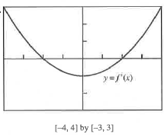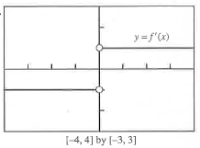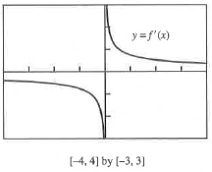

***The Relationship between Antiderivatives and Integrals* – Finding the Derivative of an Integral**

**The Fundamental Theorem of Calculus, Part 1**

If *f*  is continuous on , then the function



has a derivative at every point *x* in , and



The power of the statement above cannot be overstated (a rigorous, algebraic proof can be found on pages 294-295 of our textbook if you are interested). This astonishing connection between differentiation and integration, in the words of the authors of our textbook, “fueled the scientific revolution for the next 200 years, and is still regarded as the most important computational discovery in the history of mathematics.” Due to this importance, the discovery is called the **Fundamental Theorem of Calculus**.

*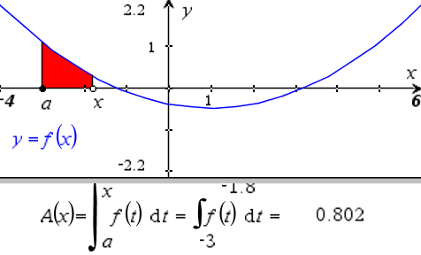Part 1 of the Fundamental Theorem of Calculus says that the definite integral of a continuous function is a differentiable function of its upper limit of integration.*

So what is?? Let’s explore.

The graph at the right is a quadratic function . Below you see the function , which is the accumulated area under the curve of . The area at any given point is a function of ***x*** (NOT *t*), and the value of the area is shown.

Watch as I manipulate both *a* and *x*

Page 3

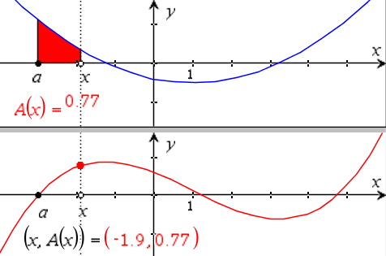Now, look at the graph to the right. It is a graph of  where is the accumulated area under the curve of . What is the degree of the ? Why should this not be surprising?

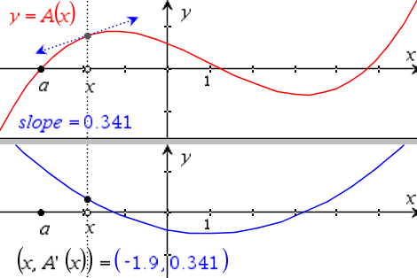Now we’ll graph . As I drag point *x* along you see the tangent lines at different values of *x*. The graph below is , the graph of the slopes of the tangent lines of *x*. What do you notice about the graph of? What conclusion can we draw?

**Example 1**

1. Find . b. Find .

**Example 2**

Find if .

OVER 🡪

Page 4

**Practice 2**

1. Find if .

2. Find if .

3. Find if .

4. Find if .

Page 5

**Example 3**

*We will need to use your rules of integration to rewrite these before using the FTC, Part 1.*

1. Find if . b. Find if .

**Example 4**

Find a function with derivative  that satisfies the condition .

OVER 🡪

Page 6

**Practice 3**

Construct a function that has a derivative of , and .

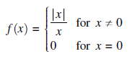

**Mixed Review**

**2016 AP Exam *NO CALCULATOR***

