AP Calculus AB Name__________________________________

Lesson 6-4: *The Fundamental Theorem of Calculus, Part 2* Date _________________________________

**Learning Goals:**

* *I can apply the Fundamental Theorem of Calculus.*
* *I understand the relationship between the derivative and definite integral as expressed in both parts of the Fundamental Theorem of Calculus.*

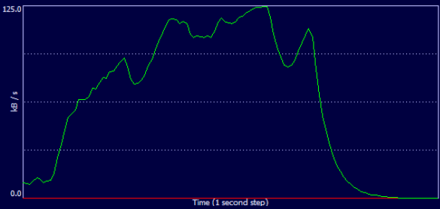

The graph above is of function , which represents the download speed (in kB/s) as a function of time (in seconds) for a particular file. The file took a total of 3 minutes to download, so the graph represents .

1. While we have no way to evaluate it exactly, explain what represents in the context of this

problem. Include units in your answer.

2. What would , the antiderivative of , represent in the context of this problem.

3. If we knew that and , how many kB of data were downloaded over the

two minutes pictured in the graph?

4. How does your answer to problem (1) relate to your answer to problem (3)??

OVER 🡪

Page 2

**Fundamental Theorem of Calculus, Part 2**

If *f* is continuous at every point of , and *F* is any antiderivative of *f* on , then



This part of the FTC is also called the **Integration Evaluation Theorem**

*Proof:*

Let be *any* antiderivative of *f*.

(1) Then 

(2) We know that 

(3) But 

(4) So 🡪 

(5) Substituting the conclusion from (4) into (1) 🡪

(6) Since *x* is an arbitrary value, we can conclude 

What this theorem tells us is that the definite integral of any continuous function *f* can be calculated without taking limits, calculating Riemann Sums, or any of the other tedious methods – as long as an antiderivative of *f* can be found.

**Example 1 – Evaluating Integrals**

*Evaluate the following integrals using antiderivatives*

  

* Note that in the above examples we are *evaluating integrals using antiderivatives*, which is different than *finding the antiderivative* . . .

Page 3

**Area**

We already know that the definite integral can be interpreted as the *net* (signed) area between the graph of a function and the *x*-axis. We can therefore compute areas using antiderivatives, but we must again be careful to distinguish net (signed) area from *total* area. In our textbook, the word “area” will be taken to mean total area.

*How to Find Total Area Analytically*

To find the area between the graph of ** and the *x*-axis over the interval analytically:

1. Partition with the zeros of *f.*

2. Integrate *f* over each subinterval.

3. Add the absolute values of the integrals.

*How to Find Total Area Numerically (with your calculator)*

To find the area between the graph of ** and the *x*-axis over the interval numerically

****** Evaluate . (Use the absolute value template!)

**Example 2**

Find the area of the region between the curve , , and the *x*-axis analytically

NO CALCULATOR!

**Example 3**

Find the area of the region between the curve , , and the *x*-axis using your calculator.

OVER 🡪

Page 4

**Practice 1**

*Evaluate each integral using FTC part 2 without using your calculator. Check your answer using your calculator.*

1.  2. 

**Example 4** *(two ways)*

If *F* is the antiderivative of such that, find .

Page 5

**Practice 2 (***use the FTC!***)**

1.If *F* is the antiderivative of such that, find . ***Calculator active*!**

2. If *f* is the antiderivative ofsuch that , find . ***NO CALCULATOR!***

OVER 🡪

Page 6

**Practice 3 *NO CALCULATOR***

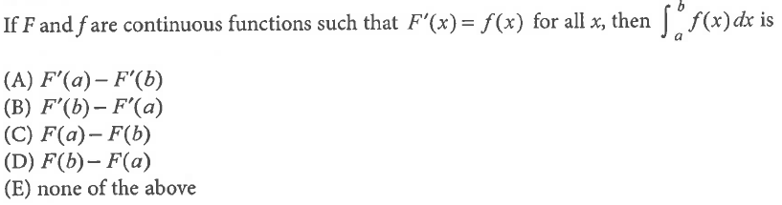

1.

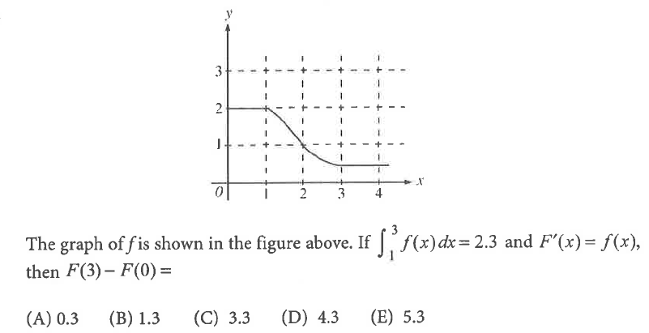

2.

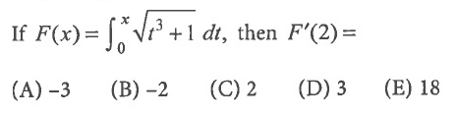

3.

4. Find the average value of on .

(A)  (B)  (C)  (D)  (E) correct answer not given

Page 7

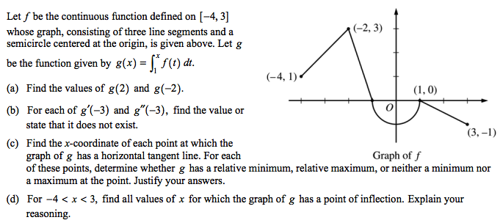**Practice 4 (NO CALCULATOR)**

OVER 🡪

Page 8

**Practice 5** (*note how you need FTC in part d!!*) – **CALCULATOR ACTIVE!**

