AP Calculus AB Name__________________________________

Lesson 6-4 FTC, Part 1 Learning Check (with review) Date _________________________________

***NO CALCULATOR***

1. If, then  _________

(A)  (B)  (C)  (D) 

2. , then  _________

(A)  (B)  (C)  (D) 

3. TRUE OR FALSE. Let . If , then is positive. _________

Justify your answer.

OVER 🡪

4. At , the linearization of is _________

(A)  (B)  (C) 

(D)  (E) 

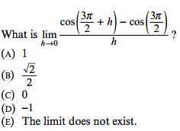5. _________

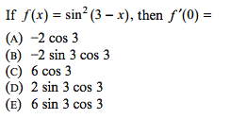

6. _________