AP Calculus AB Name__________________________________

Lesson 6-4 FTC, Part 2 Learning Check Date _________________________________

***NO CALCULATOR***

1. Find  2. Find 

|  |  |  |
| --- | --- | --- |
|  |  |  |
| 0 | 11 | 3 |
| 2 | 15 | 2 |
| 4 | 16 | -1 |
| 6 | 12 | -3 |
| 8 | 7 | 0 |

3. The table shows some values of continuous function *f* and its first derivative. Evaluate 

(A)  (B)  (C) 3 (D) 4 (E) None of these

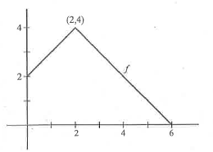

4. Let . Find 

(A) 22 (B) 38 (C) 58 (D) 70 (E) 74

OVER 🡪

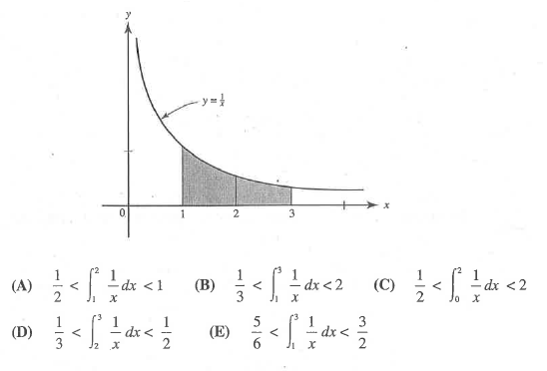

5. The area of the shaded region in the figure is equal to exactly . If is approximated using

right and left Riemann sums with two intervals, which inequality follows?

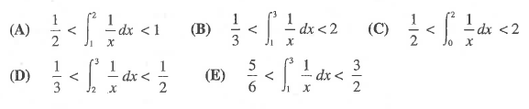

6. Let . Find the (equation of the) linear approximation for at .

7. **Calculator Active.** If *F* is the antiderivative of  and, find .