AP Calculus AB Name__________________________________

Lesson 6-5: *Trapezoidal Approximations* Date _________________________________

***NO CALCULATOR!***

**Learning Goal:**

* *I can approximate a definite integral by using trapezoidal approximations.*

1. The below table give the velocity of an object over time:

|  |  |  |  |  |  |
| --- | --- | --- | --- | --- | --- |
| *time* (seconds) | 0 | 1 | 5 | 6 | 8 |
| *Velocity* (m/sec) | 0 | 2 | 3 | 5 | 9 |

Since the velocity is constantly increasing, we can estimate the position at **by finding .

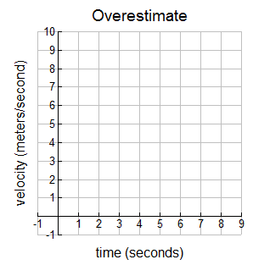Find an overestimate and an underestimate for  using either the right or left Riemann sum.

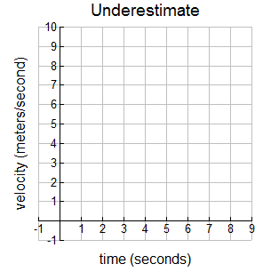

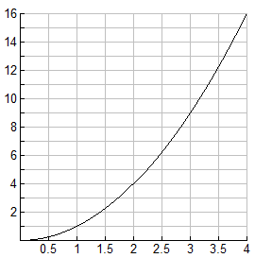

2. Use the midpoint Riemann sum method and 4 equal subintervals to find . Check the accuracy of your approximation by evaluating the definite integral analytically.

OVER 🡪

While the left, right, and midpoint Riemann sums all approach the value of the definite integral as the number of subintervals approaches infinity, it is rare that we can actually efficiently make enough subintervals to get a great approximation. It seems silly to only use rectangles to make approximations. Other geometric shapes with known areas can do the job more efficiently. The most obvious shape is a trapezoid.

If is partitioned into *n* (not necessarily equal) subintervals, the graph of *f* can be approximated by a straight line segment over each subinterval, thereby creating trapezoids. In other words, if is partitioned into *n* subintervals , then approximate *f* over by drawing straight line segments connecting 

3. Again see the below table give the velocity of an object over time:

|  |  |  |  |  |  |
| --- | --- | --- | --- | --- | --- |
| *time* (seconds) | 0 | 1 | 5 | 6 | 8 |
| *Velocity* (m/sec) | 0 | 2 | 3 | 5 | 9 |

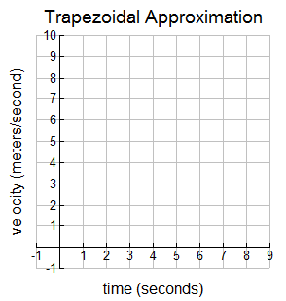

Estimate using a trapezoidal approximation.

*Area of a Trapezoid =  - or use squares & triangles!*

4. Use the trapezoidal approximation method and 4 equal subintervals to find . Check how close

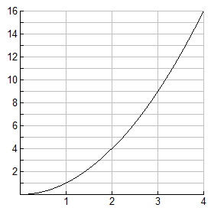 the approximation is by evaluating the integral on your calculator.