Math 4 Honors Name ______________________________

Lesson 7-1: *Power, Product, Quotient & Chain Rules*  Date _______________________________

**Learning Goals:**

* *I can use the Power, Product, Quotient & Chain Rules to find the derivatives of more complicated functions.*
* *I can analyze functions using the derivative and the P, Pr, Q & C Rules.*

In Unit 6, you learned the basics of the derivative and were limited to only being able to find the derivative of functions by using the Power Rule. The Power Rule is awesome! However, it has its limitations. In this self-guided activity, you will find additional rules for derivatives that will allow you to find the derivatives of much more complicated functions.

To begin your self-guided tour, please go to the Math 4 Honors website and scroll down to the “Power, Product, Quotient & Chain Rules” in the Unit 7 section. There you will find links to aid you in the following activity.

I. Click on **“The Product Rule”** link and complete the following example. You will also learn the rule for the derivative of the natural log function.

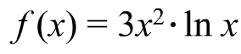

Write in factored form:

***Product Rule:***If ** _________________________________

***Natural Log Rule:*** If ** __________

II. Click on **“The Quotient Rule”** link and complete the following example. You will be working out “*PROBLEM* *3*”.



***Quotient Rule:***If ____________________________________



OVER 🡪

Page 2

III. Do a search of your own to find the derivative of .

***ex* *Rule:*** If  (Yes, it is that simple!)



Try the example to the right

on your own. Then check your

answer on the *Symbolab*

Derivative Calculator website.

IV. Click on **“The Chain Rule”** link and complete the following.

***Chain Rule:***Suppose that we have two functions *f(x)* and *g(x)* and they are both differentiable.

Then *D*{*f*(*g*(*x*))} = _____________________________

This is the formal definition. It is sometimes easier to think of the functions *f* and *g* as ``layers'' of a problem. Which is the “outer” layer? _______ Which is the “inner” layer? _______

* Describe the process in words:

In the space below, complete *PROBLEMS* 1 – 4, 7 and 10.

Page 3

**Practice: For each function, find the first derivative.** *Check your answers using the posted answer key.*







Another version of the ***Chain Rule***:



OVER 🡪

Page 4

**Homework, Day 1: Find the first derivative for each function.**

*SHOW ALL WORK ON ANOTHER PIECE OF PAPER.*

1.  6. 

2.  7. 

3.  8. 

4.  9. 

5.  10. 



11.

***Analyzing functions using the derivative and the P, Q & PR Rules:***

[](http://www.google.com/url?sa=i&rct=j&q=no+calculator+sign&source=images&cd=&cad=rja&docid=gnVHTT3Uk89qIM&tbnid=otinCzVeU2ti5M:&ved=0CAUQjRw&url=http://www.goblues.org/academics/placement/geom_placement_test.htm&ei=wF5xUb-dD8-34AOZ64DQBg&bvm=bv.45373924,d.dmg&psig=AFQjCNGeUK66UZaHTamn7GdL-PDli8rc-Q&ust=1366470598790938)



**Example #1:** Consider the following *rational* function:

1. Find the zero(s) of the function.
2. Find the vertical asymptote(s).
3. Find the horizontal asymptote(s).
4. Find the relative max and/or min.
5. For what values of *x* is the function increasing? Decreasing?

1. Find the point(s) of inflection. Page 5
2. Determine concavity.

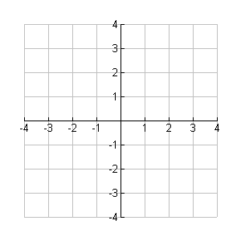

h. Sketch a graph of the function.

**\*\*\*After you are done sketching your graph, check it with your calculator.**



**Example #2:** Consider the following polynomial function:

1. Write the equation of the line tangent to the graph of the function at the point (2, 81).

b. What are the coordinates of the points where the function has horizontal tangents?

OVER 🡪

Page 6

**Homework, Day 2:**  *SHOW ALL WORK ON ANOTHER PIECE OF PAPER.*

1. Consider the following function:



1. Find the zero(s) of the function.
2. Find the vertical asymptote(s).
3. Find the horizontal asymptote(s).
4. Find the relative max and/or min.
5. For what values of *x* is the function increasing?

Decreasing?

1. Find the points of inflection.
2. Determine concavity.
3. Sketch a graph of the function.

2. Consider the function: 

1. Write the equation of the line tangent to the graph of the function at the point (3, 4096).

b. What are the coordinates of the points where the function has horizontal tangents?

3. Differentiate each function below.

a.  b. 

c.  d. 



e.  f.

g. 

Page 7

**Homework, Day 3:**  *SHOW ALL WORK ON ANOTHER PIECE OF PAPER.*

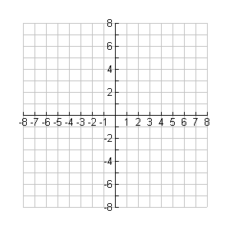1. Consider the following function: 

1. Find the zero(s) of the function.
2. Find the vertical asymptote(s).
3. Find the horizontal asymptote(s).
4. Find the relative max and/or min.
5. For what values of *x* is the function increasing?

Decreasing?

1. Find the points of inflection.
2. Determine concavity.
3. Sketch a graph of the function.

2. Consider the function: 

1. Write the equation of the line tangent to the graph of the function at the point (4, 3).
2. Where does the tangent line cross the *x-*axis?

3. Differentiate each function below.

a.  b. 



c. d. 



e. f.

OVER 🡪

Page 8

**Homework, Day 4:**  *SHOW ALL WORK ON ANOTHER PIECE OF PAPER*.

Some additional rules, courtesy of the ***Chain Rule***:

1. Find . **[Tastefully Simplify]**

a.  g. 

b.  h. 

c.  i. 

d.  j. 

e.  k. 

f.  l. 

2. Find  for the following:

a.  g. 

b.  h. 

c.  i. 

d.  j. 

e.  k. 

f.  l. 