AP Calculus AB Name__________________________________

Lesson 7-2: *Antidifferentiation by Substitution* Date _______________________________

**Learning Goal:**

* *I can compute indefinite and definite integrals by the method of substitution.*

**Review**

1. Find the particular solution to the following differential equation: 
2. Evaluate 

**Definition: Indefinite Integral**

The family of all antiderivatives of a function is the **indefinite integral of *f* with respect to *x*** and is denoted by .

If *F* is any function such that , then , where *C* is an arbitrary constant, called the **constant of integration.**

We have been finding antiderivatives for quite some time now, so the problems above should hardly seem new. However, those antiderivative problems were always chosen carefully to avoid some of the more difficult aspects of finding antiderivatives. We will now delve into some of those more difficult problems.

OVER 🡪

Page 2

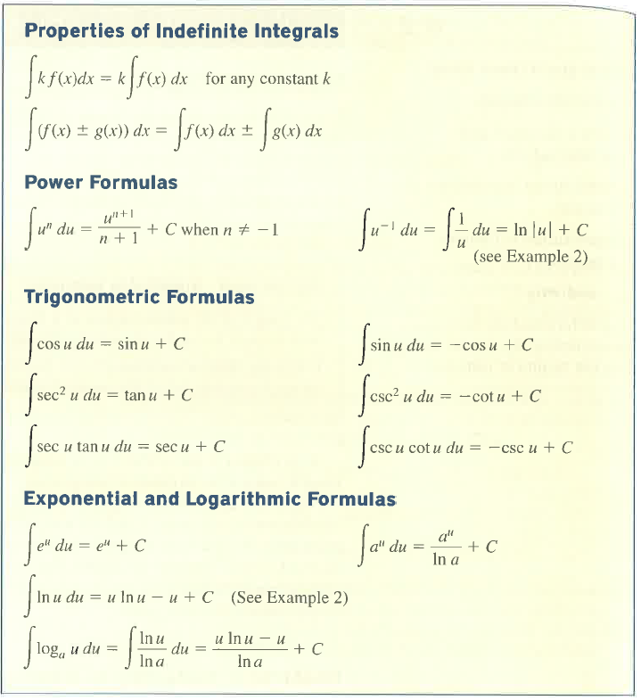**Properties of Indefinite Integrals**

**Antidifferentiation by Substitution**

**Examples**

1. Evaluate 

Page 3

1. Evaluate 
2. Evaluate 
3. Evaluate 

OVER 🡪

Page 4

**Practice**:

1. Evaluate . Let .
2. Evaluate . Let .
3. Evaluate .
4. Evaluate .
5. Evaluate .

Page 5

1. Evaluate 
2. Evaluate 
3. Evaluate 
4. Evaluate 
5. Evaluate 

OVER 🡪

Page 6

**Evaluating Definite Integrals Using Substitution**

**Example**

1. 

**Practice**

1. 

Page 7

1. 
2.  *** *careful with the absolute value!*
3. Let  and let . Find each of the following antiderivatives in terms of *x*.

*\*\*\*Pay attention to the differential!*

1. 

OVER 🡪

Page 8

1. 
2. 

**2016 AP Exam Practice**

***No Calculator***

