Math 4 Honors Name ___________________________

Lesson 7-2: *Rules for Trigonometric Derivatives* Date ___________________________

**Learning Goal:**

* *I can use the rules for the derivatives of trigonometric functions.*

**DAY 1:** Lesson 7-1 introduced you to many more rules for finding the derivatives of additional functions. Now you’re probably saying to yourself, “What are the rules for the trigonometric functions?”



* To begin answering the question, you are going to use the function of your calculator . . . .

Make sure your calculator is in RADIAN mode.

Complete the table below. *Round to the nearest 1000th.*

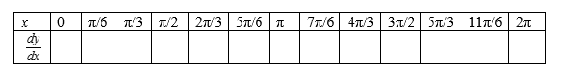

Now make a scatterplot. Does the curve look familiar?

What equation fits the scatterplot?

Complete the following: If , then _________________.

Now repeat the process above to find the derivative of the cosine function. *Be careful….*



Complete the following: If , then _________________.

***Notes:***

***Examples: Differentiate the following.***

1.  2. 

3.  4. 

5. 

OVER 🡪

Page 2

**DAY 2**

In this section, you are going to derive the derivative rules for tangent, cotangent, secant & cosecant.

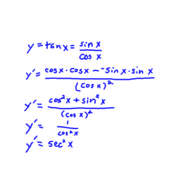The one for tangent has been done for you. Use it as a guide to derive the rules for the 3 that remain.

Summarize the derivative formulas in the table below.

|  |  |  |
| --- | --- | --- |
|  |  |  |
|  |  |  |
|  |  |  |
|  |  |  |

***Call the Heinl over for approval before you go on to the examples.***

***Examples: Differentiate the following.***

1.  2. 

3.  4. 

OVER 🡪

Page 3

**Homework, Day 1:**  *SHOW ALL WORK ON ANOTHER PIECE OF PAPER.*

**For 1 – 14, find :**

1. 
2. 
3. 
4. 

**Solve the following problems.**

**15.** Find the *maximum* height of the curve

above the *x*-axis.

**16.** 

**a.** What is the domain of *f* ?

**b.** Find *f* ' (*x*).

**c.** What is the domain of *f* '?

**d.** Write the equation of the line tangent to *f* at *x* = 0.

1. 

**6.** 

**7.** 

**8.** 

**9.** 

**10.** 

**11.** 

**12.** 

**13.** 

**14.** 

OVER 🡪

Page 4

**Homework, Day 2:**  *SHOW ALL WORK ON ANOTHER PIECE OF PAPER.*

**For 1 – 13, find .**

**Solve the following problems.**

**14.** A particle moves along a line so that at any time *t* its position is given by 

**a.** Find the velocity at time *t.*

**b.** Find the acceleration at time *t.*

**c.** What are all values of *t*, 0  *t* 3, for which the particle is at *rest*?

**d.** What is the *maximum* velocity?

**15.** 

**a.** Find the zeros of *f.*

**b.** Find the asymptotes.

**c.** Find *f* '(*x*).

**d.** Find the critical points

**e.** Find where the function is increasing and where it is decreasing.

**f.** Find *f* ''(*x*).

**g.** Find the points of inflection.

**h.** Graph the function.

**1.** 

**2.** 

**3.** 

**4.** 

**5.** 

**6.** 

**7.** 

**8.** 

**9.** 

**10.** 

**11.** 

*f*(*x*)

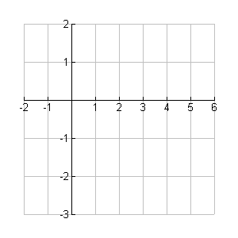

**12.** 

**13.** 