Math 4 Honors Name ______________________________

Lesson 7-3: *Implicit Differentiation* Date ______________________________

**Learning Goal:**

* *I can use implicit differentiation to find the derivative of equations that are written implicitly.*

**$ y' = 6x - 7 \cos(7x+5) $$ y = 3x^2 -\sin(7x+5) $Implicit differentiation** is nothing more than a *special case* of the well-known Chain Rule for derivatives. The majority of differentiation problems in first-year calculus involve functions *y* written EXPLICITLY as functions of *x*.

For example, if , then the derivative of *y* is .

However, some functions *y* are written IMPLICITLY (it is not solved for either variable). A familiar example of this is the equation *x*2 + *y*2 = 25, which represents a circle of radius five centered at the origin.

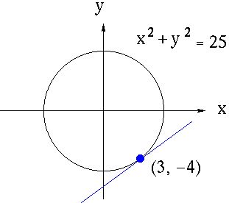Suppose that we wish to find the slope of the line tangent to the graph of this equation at the point (3, -4). Solve this problem with your group members.

Here’s how to solve this problem using *implicit differentiation*:

*x*2 + *y*2 = 25

*** It is important to note that the derivative expression for *explicit* differentiation involves *x* only, while

the derivative expression for *implicit* differentiation may involve BOTH *x* AND *y* .

OVER 🡪

Page 2

**Examples:**

A. Find:  B. Find:  C. Find: 

D. Find:  E. Find: 

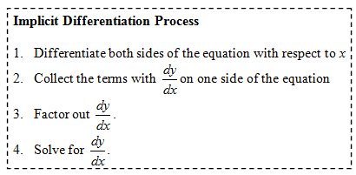

**Day 1 Practice:** Find .

1.  2. 

3.  4. 

Page 3

**Day 2 Examples:**

1. Assume that *y* is a function of *x* . Find  and for .

2. Write the equations of the tangent and normal lines (in *point-slope form*) to:

*x*2 + (*y* − *x*)3 = 9 at the point (1, 3).

OVER 🡪

Page 4

*Show all work on another sheet of paper.*

**Homework: Day 1**

**Find** .

1.  4.

2.  5. 

3.  6. 

**Multiple Choice. *Show your work.***

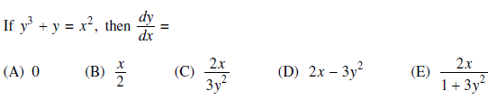

**Homework: Day 2**

**Find** .

1. 
2. 
3. 

**Find the first and second derivatives.**

1. 

**Write the equations of the tangent and normal lines (in *point-slope form*) to the curve at the point indicated.**

1. 
2. 

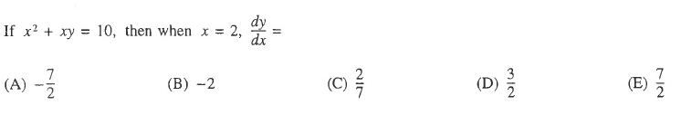**Multiple Choice. *Show your work.***