AP Calculus AB Name_________________________________

Lesson 7-1 Learning Check Date ________________________________

***All problems*** ***are CALCULATOR ACTIVE!!***

**Multiple Choice.**

|  |  |  |  |  |  |  |
| --- | --- | --- | --- | --- | --- | --- |
|  | 0 | 3 | 6 | 9 | 12 | 15 |
|  | 4 | 8 | 6 | 9 | 10 | 10 |

1. The data for the acceleration *a*(*t*) of a car from 0 to 15 seconds are given in the table below. If the

velocity at is 5 ft/sec, which of the following give the approximate velocity at using

trapezoidal approximation.

(A) 47 ft/sec (B) 52 ft/sec (C) 120 ft/sec (D) 125 ft/sec (E) 141 ft/sec

2. The rate at which customers arrive at a counter to be served is modeled by the function *F* defined by

for , where is measured in customers per minute and *t* is measured

in minutes. To the nearest whole number, how many customers arrive at the counter in during the 60

minute period?

(A) 720 (B) 725 (C) 732 (D) 744 (E) 756

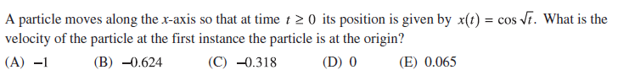

3.

OVER 🡪

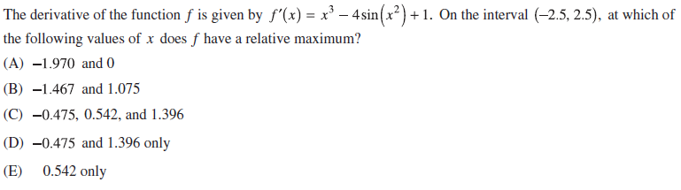4.

**Free Response.**

5. Given , do the following:

(a) Determine when the particle is moving to the right, left, and stopped

(b) Find the particle’s displacement for the given time interval. If , what is

the particle’s final position?

(c) Find the toal distance traveled by the particle.