Math 4 Honors Name ________________________________

Lesson 8-1: *What is the Total?*  Date _______________________________

**Learning Goal:**

* *I can use a rate of change graph to calculate total change over some time interval.*

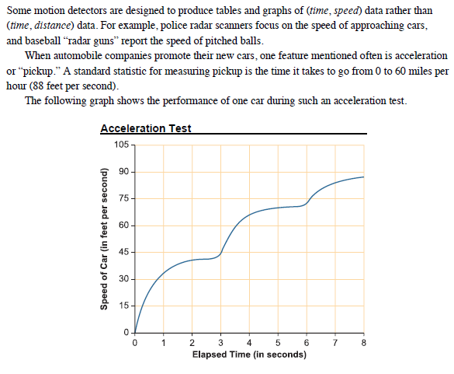

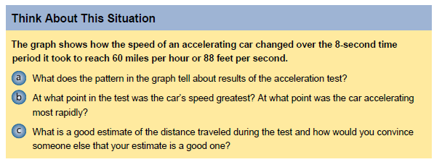

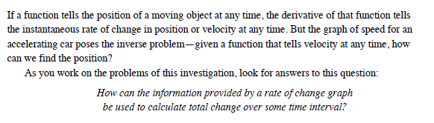

OVER 🡪

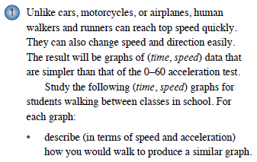 Page 2





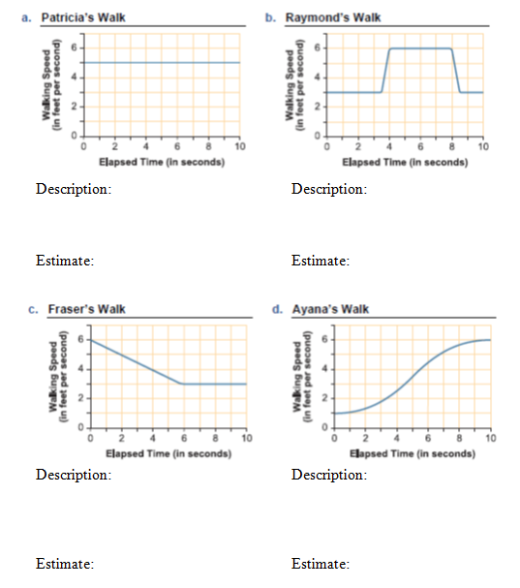

Page 3

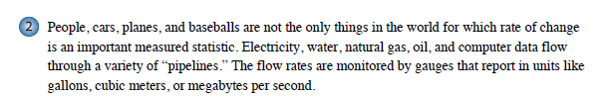

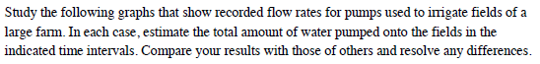

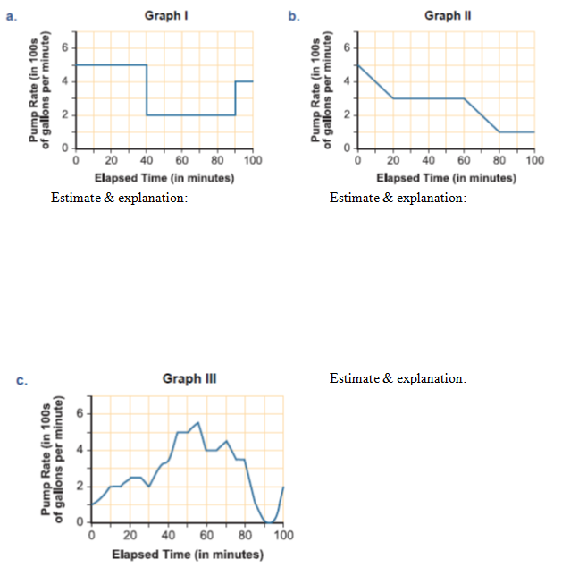

OVER 🡪

 Page 4

