AP Calculus AB Name__________________________________

Lesson 8-2 Learning Check **NO CALCULATOR** Date ________________________________

**Multiple Choice.**

1. Let *R* be the region in the first quadrant bounded by the *x*-axis, the graph of and the line .

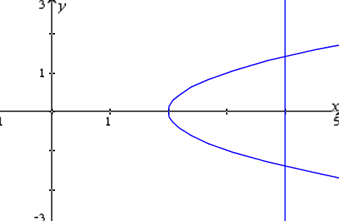 Which of the following integrals gives the area of *R*?

(A) (B)

(C) (D)

(E)

2. Which of the following gives the area of the region between the graphs of $y=x^{2}$ and $y=-x$ from

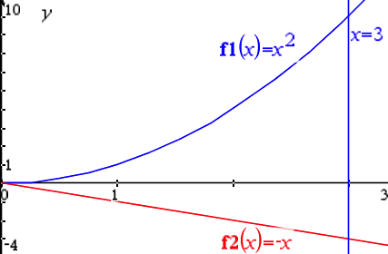 $x=0$ to $x=3$.

(A) 2 (B) $\frac{9}{2}$ (C) $\frac{13}{2}$

(D) 13 (E) $\frac{27}{2}$

OVER 🡪

**Free Response – *NO CALCULATOR!!***

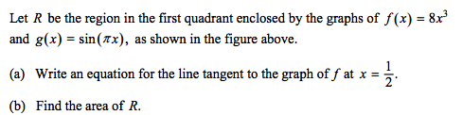

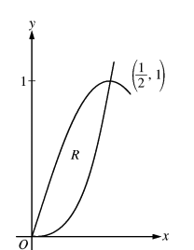3.

4. SKIP PART (B)

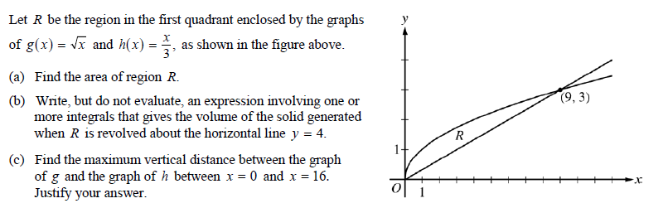

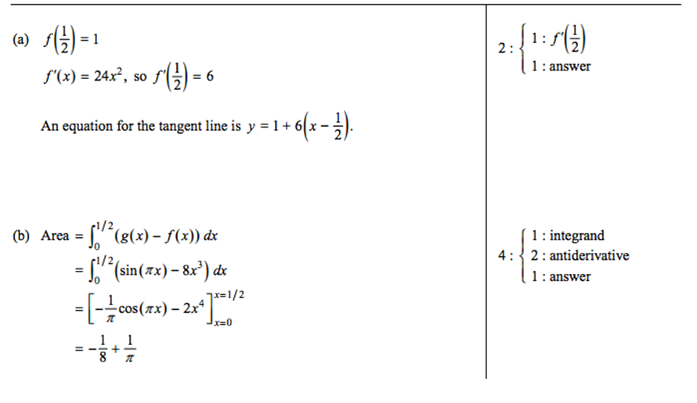3.

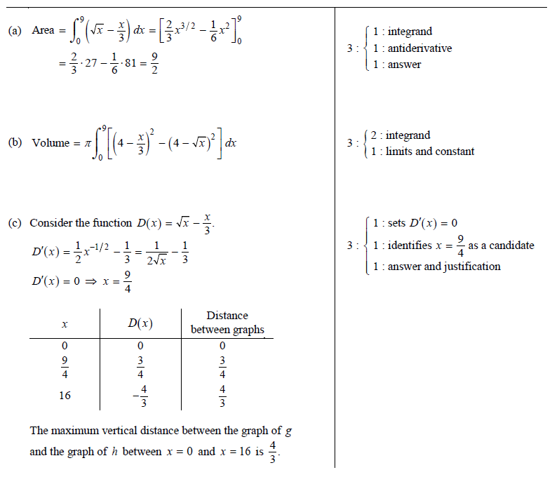4.