AP Calculus AB Name__________________________________

Lesson 8-2: *Areas in the Plane* Date _________________________________

**Learning Goal:**

* *I can use integration to calculate areas of regions in a plane.*

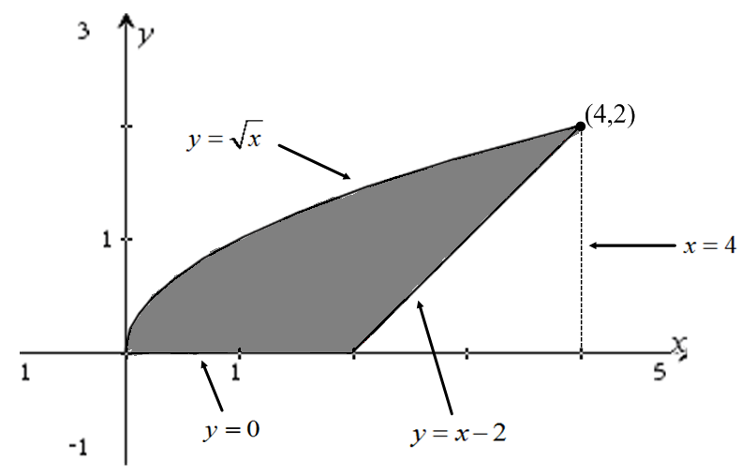

1. Use your knowledge of integrals and basic geometry to find the area of the shaded region in the figure to the right on the interval . *Hint*: *an integral and subtract a basic geometric shape . . .*

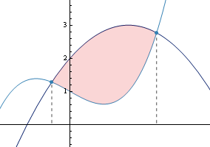What if the shaded area had a bit more of an irregular look, like the figure to the right, so that we could not use basic geometry to help us out? How could we find the area of this region? The answer lies in the box below.

**Definition: Area Between Curves**

If *f* and *g* are continuous with throughout , then the **area between the curves and from *a* to *b*** is the integral of from *a* to *b*,



*Note that since , this area will always be nonnegative.*

OVER 🡪

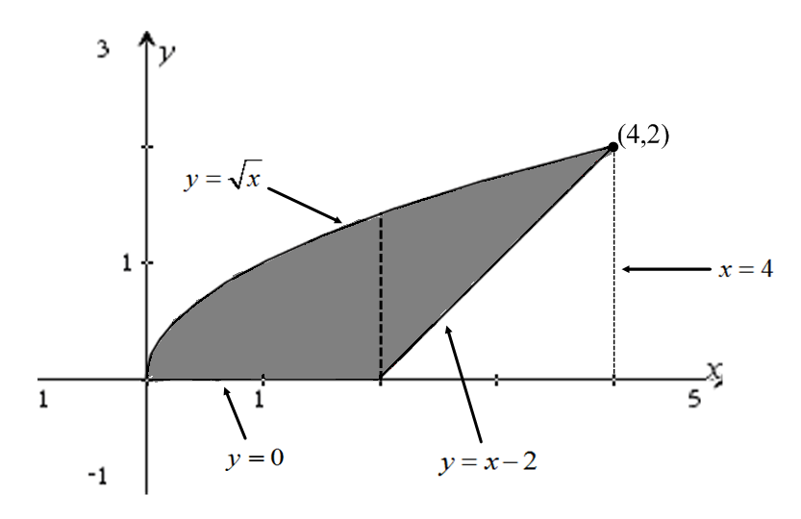 Page 2

Let’s use this definition to find the area of our original figure.

Note that to use the definition above, our area must be bounded by the same two functions throughout the whole region. That is not the case with our figure. While the figure is bounded above by on the entire interval , it is not bounded below by the same function throughout the interval. From it is bounded by  (the *x*-axis) and from it is bounded by the line . If needed, draw several Riemann sum rectangles to convince yourself of this fact. So to use the above definition, we must split out region into two parts, and use the rule on each part.

Let’s start with the region .

2. For the region , the function bounds the region from above and bounds the region

from below. Use the above definition to find the area of the bounded region from .

3. Repeat the same process for , noting that the region is now bounded below by .

4. Total up the values from 2 and 3. Make sure you get the same area as you did for problem (1).

Page 3

Let’s try to use the method from problems 2-4 on a problem where it is not just a neat mathematical trick,

but where it is necessary.

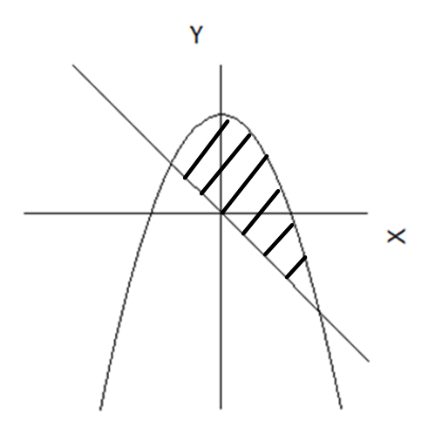5. **NO CALCULATOR.** Find the area of the region bounded by .

6. **CALCULATOR ACTIVE.** Sketch a graph below of the functions . Find the

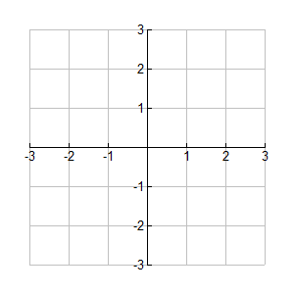 area of the region bounded by those two graphs (the region that included (0, 0). Show your set-up, but

use your calculator to do all graphing and calculations.

OVER 🡪

Page 4

Sometimes, functions are easier to define in terms of *y* than in terms of *x*. See the example below.

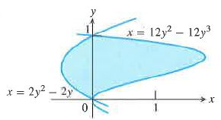While it would be possible to split this graph into two parts (the *y*-axis would be the split) and integrate each part separately with respect to *x*, that would involve rearranging the functions so that they are defined as functions of *y*. That is possible, but often it is simply easier to integrate with respect to *y*.

To integrate with respect to *y*, think of a Riemann sum with the rectangles being horizontal instead of vertical. Algebraically, integrating with respect to *y* is no different – just a matter of using a different letter. However, when finding the region bounded by two curves the bounds on the integral now come from the *y*-axis, “above” now becomes “to the right” and “below” becomes “to the left”. So the area of the shaded region above would be found with the following integral:



7. Use the above integral to find the area of the given region.

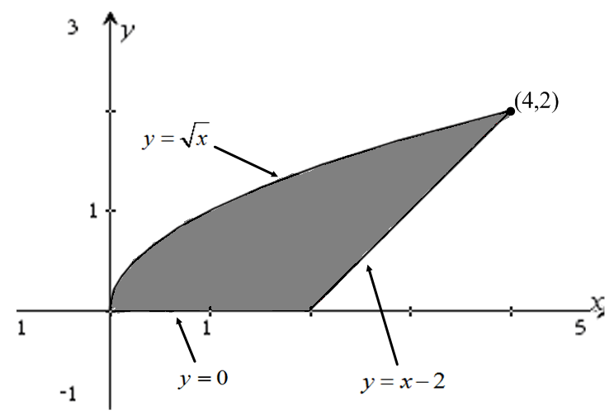Sometimes you will have a choice as to whether you want to integrate with respect to *x* or with respect to *y*. Let’s go back to our original example. When we integrated with respect to *x*, we had to split the region into two parts. However, if we integrate with respect to *y*, the region is bounded “above”/to the right by and “below”/to the left by  over the entire interval on *y* . There is no need to split the figure into two different regions (draw horizontal rectangles to convince yourself of this fact).

8. If we integrate with respect to *y*, what will be our

bounds of integration?

9. To integrate with respect to *y*, we need to have our functions written with *x* in terms of *y* (as opposed to

*y* in terms of *x* as they are written now). Solve for *y* in both equations in order to write the functions

with *x* in terms of *y*.

Page 5

10. Use the functions from problem (9) to find the area of the region. Be sure you get the same answers as

you did in problems (1) and (4).

**CALCULATOR ACTIVE FOR 11-14**

**\*** *Be sure to store any values that are not rational numbers – do NOT use rounded numbers in your calculations!*

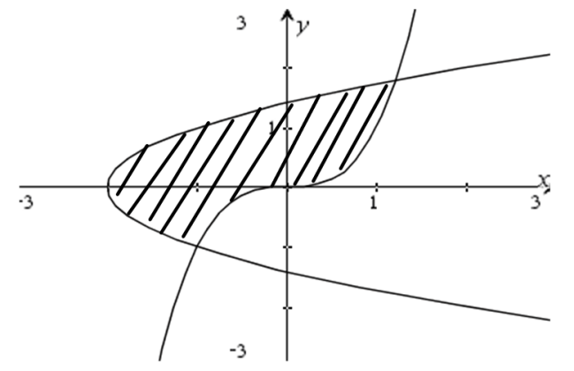

The shaded region to the right is bounded by and 

11. Find the area of the shaded region by integrating with respect

to *y*. Show your set-up.

12. Explain why in this particular case it is much more efficient to integrate with respect to *y*. What would

you have to do if you were to integrate with respect to *x*?

OVER 🡪

Page 6

13. Find the area enclosed by the graphs of the following two curves. Sketch a graph below before

integrating. Show all set-up.





14. *Use symmetry* to find the area between the following two curves. Sketch a graph below before

integrating. Show all set-up.



