Math 4 Honors Name ________________________________

Lesson 8-2: *Velocity & Net Change* Date _______________________________

**Learning Goals:**

* *I can use graphs to determine both rate and direction of change in a quantity.*
* *I can use directional rate graphs to calculate the net change in position of a moving object or the net flow in a pipeline.*

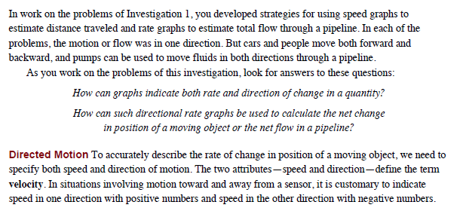



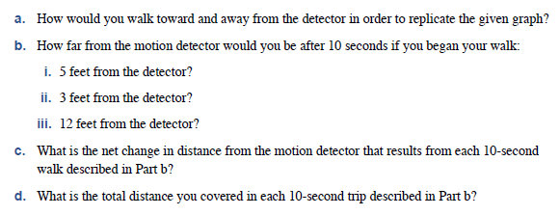

OVER 🡪

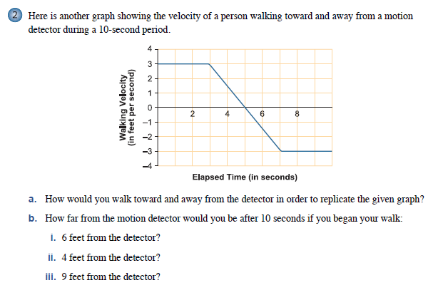 Page 2

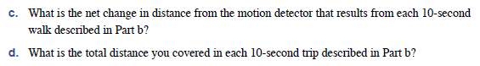

**HOMEWORK: Lesson 8-2** Page 3

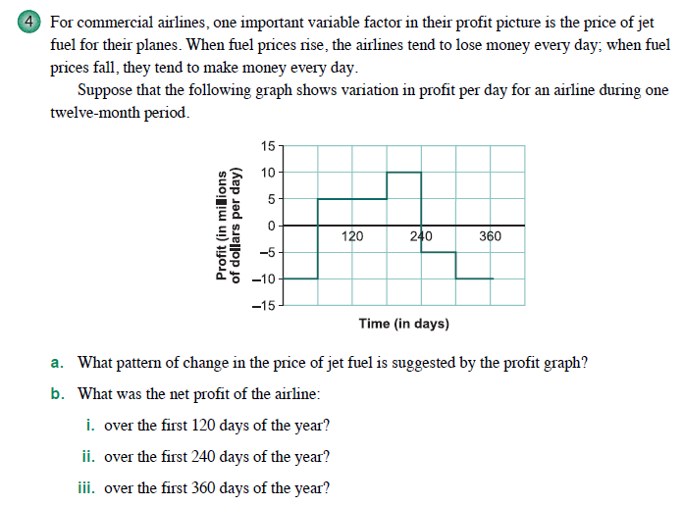

OVER 🡪

Page 4

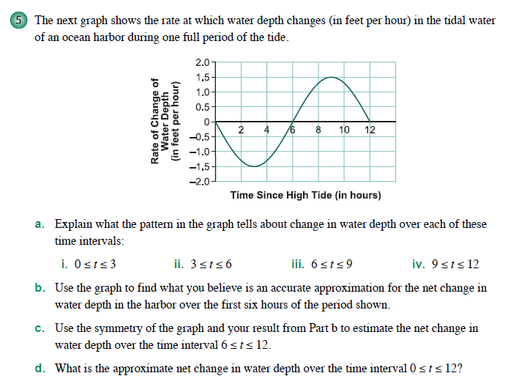

HW: CYU, p. 532 and

OYO, pp. 538 – 548 / 4, 5

**Algebraic Maintenance!**

