AP Calculus AB Name__________________________________
Lesson 8-3, Parts 1 & 2 Learning Check Date ________________________________

For now, skip problems (1c), (2c), and (3b) – we will come back to them later.
Attempt all remaining parts!

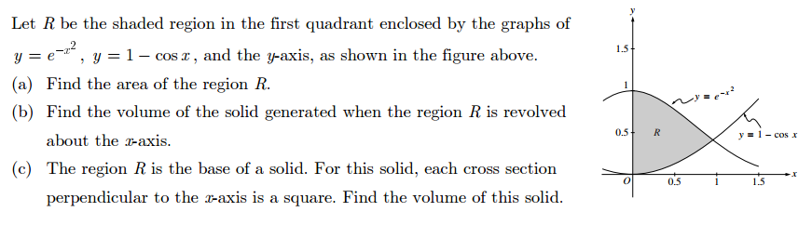
CALCULATOR ACTIVE
1.

OVER
Page 2
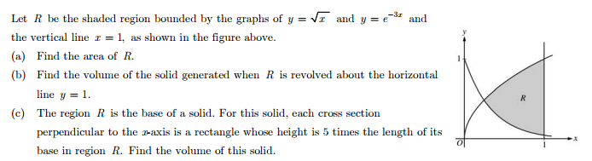
CALCULATOR ACTIVE
2.

Page 3
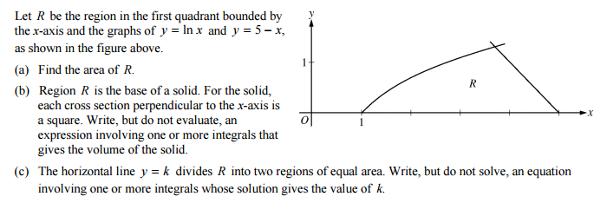
CALCULATOR ACTIVE
3.

AP Calculus AB
8-3 Volumes of Revolution Learning Check ANSWERS

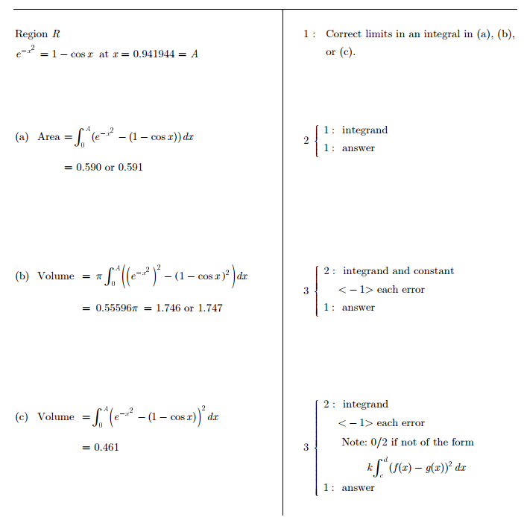
1.

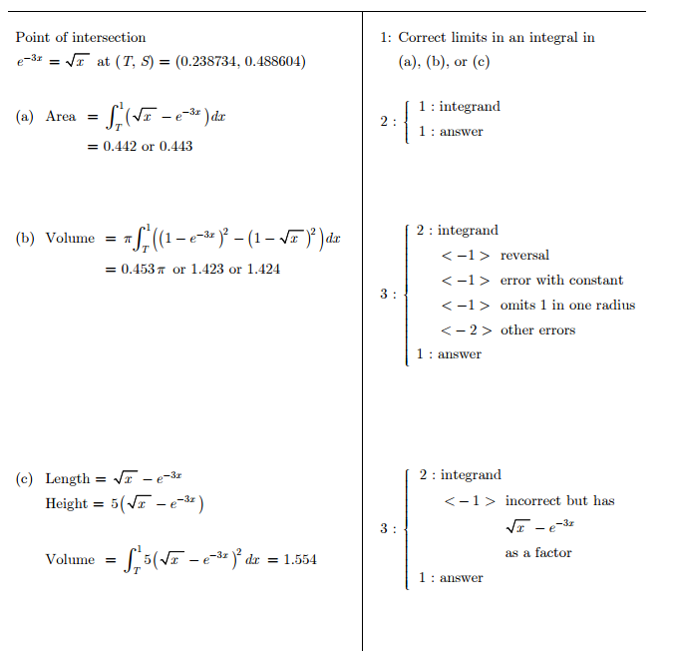
2.

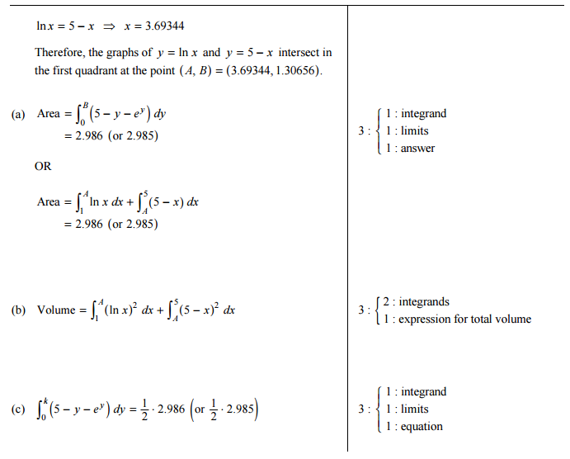
3.

