AP Calculus AB Name__________________________________

Lesson 8-3: *Volumes, Part 1* Date _________________________________

**Learning Goal:**

* *I can use integration (by disk or washer) to calculate volumes of solids*

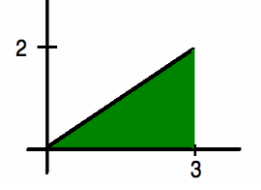So far we have used integration methods to find areas either under a curve or in a given region bounded by two curves. For instance, we can use integration to find the shaded area under the curve  .

Of course we could find this area geometrically, but we are also now mathematically sophisticated enough to realize that the definite integral also finds the area under this curve.

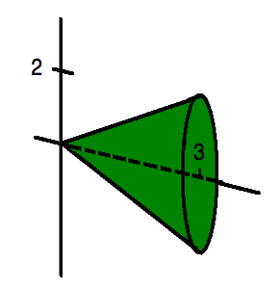Let’s take the shaded region and rotate it about the *x*-axis. The resulting 3-dimensional solid would look like this:

So now your curiosity is probably piqued! If we can use integration to find the area under a curve, shouldn’t we also be able to use integration to find the volume of a solid?!?! The answer is YES!

To find this volume, we need to take vertical “slices” of our solid (*dx* wide and tall) and add them up.

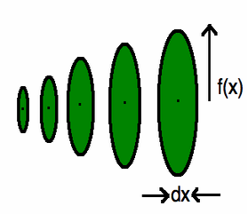

OVER🡪

Page 2

Adding up all of these separate volumes would be quite tedious, but thankfully calculus comes to the rescue!

**DEFINITION Volume of a Solid**

The **volume of a solid** of known integrable cross section area  from  is the integral of *A* from *a* to *b*,



* An explanation of the reasoning behind this formula using Riemann Sums is on page 399 in our text.

In our solid, each cross section is a circle. The formula for the area of a circle is .

In our cross sections, the radius is the function  that we rotated about the *x*-axis.

So the formula for the area of our cross section would be .

We want the volume from  on the *x*-axis.

Hence, to find the volume of our solid we evaluate



Of course, in our case the solid was a cone with radius of 2 ( evaluated at 3) and a height of 3. Using the formula for the volume of a cone , we confirm our answer: 

*Isn’t it exciting that you can now use calculus to verify basic geometry formulas!!*

Technically, what we just did (the calculus part, not the geometric confirmation) is find the area of a **solid of revolution** by using a **slice** or **disk method.**

A **solid of revolution** is simply a three dimensional solid that is generated by revolving a two-dimensional solid around an axis (often the *x*- or *y*- axis, but not always). One possible way to find the volume of such a solid is by the **disk method**, in which we find a function for the area of a cross section and then integrate that function using the “ends” of the cross section as the limits of integration.

Let’s try a bit less straightforward of an example.

**Example 1**

The region between the graph of and the *x*-axis over the interval  (pictured below) is revolved about the *x*-axis to generate a solid. Find the volume of the solid.

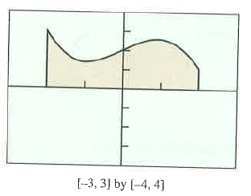

OVER 🡪

Page 3

You may be asking yourself, what does this region look like when you revolve it about the *x*-axis. Can you picture it? If you can, it may be helpful, but ultimately it is important to understand that **it doesn’t matter**

**what it looks like!** You can use calculus to find the volume even if you can NOT picture the shape! The key is realizing that when you are revolving about the *x*-axis, the cross section will be a *circle*!

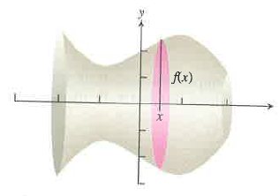If we revolve about the *x*-axis, we will produce a figure that has circular cross sections with radius . So the area of the cross section will be . Since we are revolving the function over the interval , those become the bounds for our integration. So the volume is calculated by the integral



Evaluate this integral using your calculator.

So since a solid of revolution has a circle for a cross section, the general formula for finding the volume of a solid of revolution is:

If you need to visualize a few rotations in order to help yourself picture how this process works, go here:

<https://www.geogebra.org/material/simple/id/1111807#material/40798>

**Practice 1**

Find the volume of the solid generated by revolving the function from around the *x*-axis. Sketch  from  to help you get started. NO CALCULATOR.

**Practice 2**

Find the volume of the solid formed by rotating the region bounded by the graphs of , and around the *x*-axis. Sketch the region to help you get started. **CALCULATOR ACTIVE**.

OVER 🡪

Page 4

**Example 2**

Find the volume of the solid formed by revolving the region bounded by and  about the ***y*-axis**. NO CALCULATOR

**Practice 3**

Find the volume of the solid created by rotation of the region bounded by , , and about the *y*-axis. NO CALCULATOR

Page 5

Lesson 8-3: *Volumes, Part 2*

In part 1 of this lesson we learned how to find the volume of a solid of revolution generated by a solid that was revolved around an axis. The solids that we looked at were always whole – meaning that they did not have any holes or areas missing. If you are not sure what this means, let’s take a look at the following example.

**Example 1**

Determine the volume of the solid of revolution determined by revolving the portion of the region bounded by and that lies in the first quadrant about the *y*-axis.

The given region that we are rotating, along with what the rotated region will look like, is shown below. While we said you do not need to be able to picture what the region looks like, for the first time we see this type of problem it will be helpful to be able to “picture” what we are integrating.

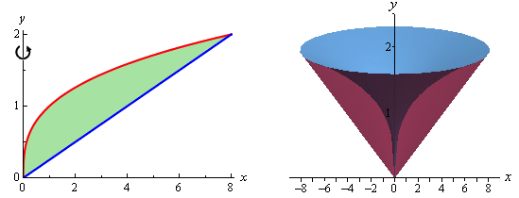

Note in the graph of the region (on the left), there is space between the region and the *y*-axis (the axis of revolution in this case). That means that our solid is not “whole” – think of it as a solid cone with part of the middle hollowed out. So when we are finding the volume, we are finding the volume of the “outer walls” of the figure. Shown below are a few sketches that might help you visualize the figure. On the right is a sketch of a typical cross section. Note that the equations have been written in terms of *y* because since we rotated about the *y*-axis we will need to be integrating with respect to *y*.

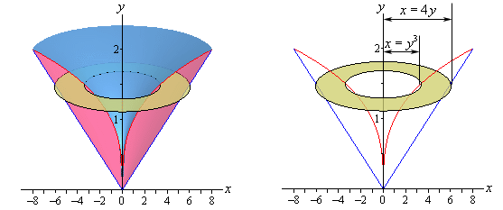

OVER 🡪

Page 6

To find the volume of solids of revolution such as in this example, we will be using what is generally referred to as the **washer method** (because the cross sections look like washers . . .)

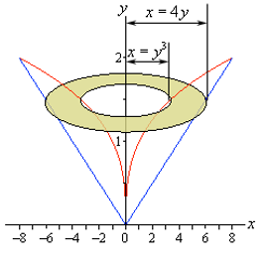

To find the volume of the above figure, we will find the volume of the “whole” solid, then subtract the volume of the “inner” solid (the hollowed out part).

The “whole” solid is generated by the outer function (). Set up and evaluate an integral and find the volume of the outer solid (use your calculator for the integration). You may have to go back and look at the original region in order to find the bounds of integration, but leave your answer in terms of .

The “inner” solid (the hollowed out part) is generated by the inner function (). Set up and evaluate an integral that finds the volume of the inner solid. The bounds of integration should be the same as above.

Now subtract the “inner” from the “outer” and you’ll have the volume of the solid!

What you have just done is find the volume of a solid of revolution using the washer method!

The general formula for finding the volume of a solid of revolution using the washer method is:

Again, while visualizing is not important it can sometimes help with initial understanding. Take a look at this website to help visualize washer rotations:

<http://www.mathdemos.org/mathdemos/washermethod/gallery/gallery.html>

Page 7

**Practice 1 – CALCULATOR ACTIVE**

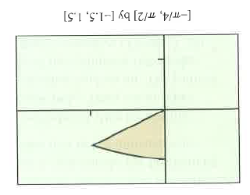The region in the first quadrant enclosed by the *y*-axis and the graphs of and is revolved about the *x*-axis to form a solid. Find its volume.

**Practice 2 – CALCULATOR ACTIVE**

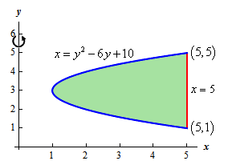Find the volume of the solid of revolution generated by rotating the region bounded by and about the *y*-axis. Do the integration using your calculator.

Page 8

Lesson 8-3 *Volumes, Part 3*

So far in this lesson we have rotated around only the *x*- and *y*-axis. Often (especially on the AP Exam!) we will want to rotate our region around some other (generally horizontal) line. Finding these volumes is very similar to the disk and washer methods we have learned so far. See the example below.

**Example 1**

Determine the volume of the region bounded by  and  that is rotated about .

Again, while it is not necessary in order to find the volume, the rotated region is also shown.

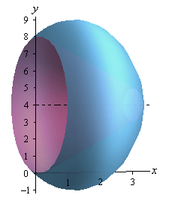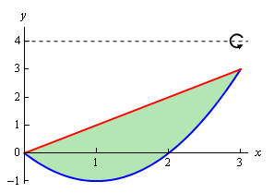

Since we are rotating about a horizontal axis, we know that the cross section area will be a function of *x*.

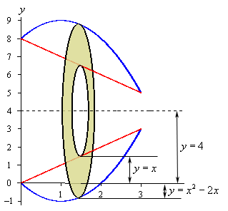The cross section in this case will again be a washer. However, we will have to be a bit more careful selecting our bounds of integration when rotating about a line that is not an axis. See the cross section below.

Let’s start with the inner radius. Note that the line determines the inner radius, but the inner radius is NOT *x*. The distance from the inner radius to the *x*-axis is *x*, but we want the distance from to the line .

The distance from the axis of rotation () and the *x*-axis is 4, and the distance from the inner radius () and the *x*-axis is *x*, so the distance from the axis of rotation to the inner radius must be .

Similarly, the distance from the axis of rotation to the outer radius is .

Page 9

Looking back at the original region, the bounds on the integration will when the two graphs intersect:



Hence, using the washer method, the integral to find the volume of the solid of revolution is



Evaluating this integral on our calculator we get units3.

*\* For all practice problems, set-up the integral and then use your calculator to perform the integration*

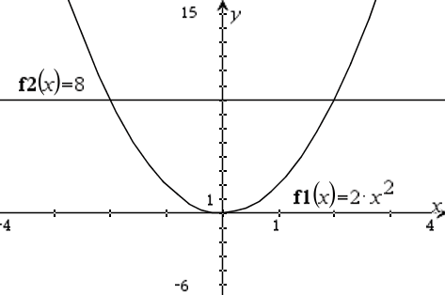**Practice 1**

Find the volume of the region bounded by and around the line 

**Practice 2**

Find the volume of the region bounded by and around the line 

OVER 🡪

Page 10

**Practice 3**

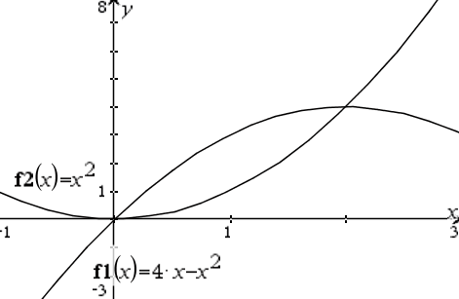Find the volume of the solid of revolution generated by revolving the region bounded by *y* = *x*2 and *y* = 4*x* – *x2* the line *y* = 6.

**Practice 4**

Determine the volume of the solid generated by rotating the region bounded by and 

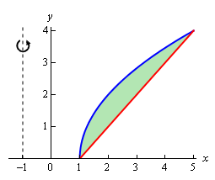about the line .

Page 11

**Practice 5**

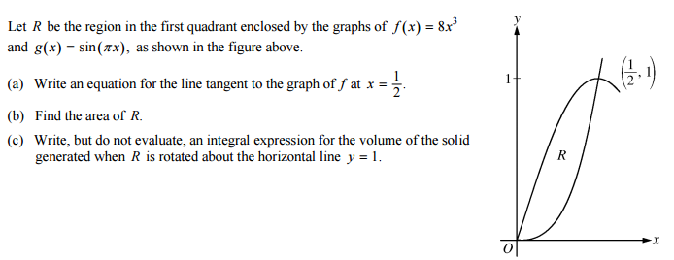Below is the AP Free Response problem from the previous learning check. Part (c) was omitted at the time because we did not know how to conquer it quite yet. Now we do. Answer part (c) below.

**Further practice** 🡪 The Heinl will give you a worksheet.

The final topic that is on the AP Exam is finding the volume of a solid that is NOT generated by revolving a region around an axis. In these types of problems, a two dimensional graph is given to you and then you are told what geometric shape the cross sections are. For these problems, you must use the given region to find the area of the cross section and then integrate it (or at least set up an integral) based on the bounds that are given or that you must find.

**Example 2**

In the below problems, find a formula for the area of the cross sections of the solid that are perpendicular to the *x*-axis. Then set-up an integral that would find the volume of the solid.

The solid lies between planes perpendicular to the *x*-axis at . The cross sections perpendicular to the *x*-axis between these planes run from the semicircle to the semicircle .

1. 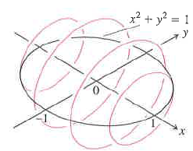 The cross sections are circular disks with diameters in the *xy-*plane.

OVER 🡪

Page 12

1. 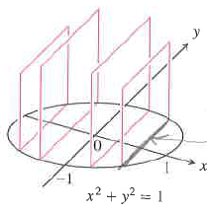The cross sections are squares with bases in the *xy-*plane.
2. The cross sections are equilateral triangles with bases in the *xy-*plane.

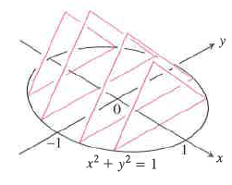

**Practice 6**

In the below problems, find a formula for the area of the cross sections of the solid that are perpendicular to the *x*-axis. Then set-up an integral that would find the volume of the solid.

The solid lies between planes perpendicular to the *x*-axis at . The cross sections perpendicular to the *x*-axis between these planes run from the semicircle to the semicircle .

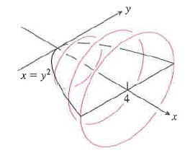

1. The cross sections are circular disks with diameters in the *xy*-plane.

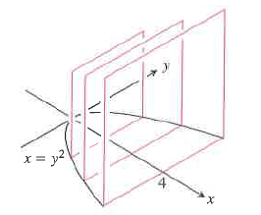

1. The cross sections are squares with bases in the *xy*-plane.

***AP Calculus***

***Volume of Solids of Revolution***

***Disk/Washer Method***

***Type of*** Perpendicular to the axis

***Rectangle*** of revolution

***“Parts” to*** *R,* the outer radius

***find*** *r,* the inner radius



***Horizontal***

***Axis of Revolution***



***Vertical***

***Axis of Revolution***

