Math 4 Honors Name ________________________________
Lesson 8-3: The Definite Integral Date _______________________________

Learning Goals:
- I can find and interpret the meaning of the definite integral of a function f(x) over an interval [a, b].
- I can find approximate and exact values of definite integrals.

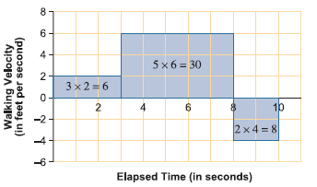
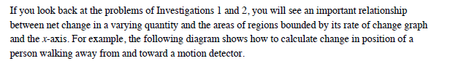

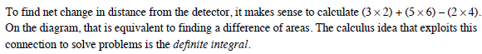

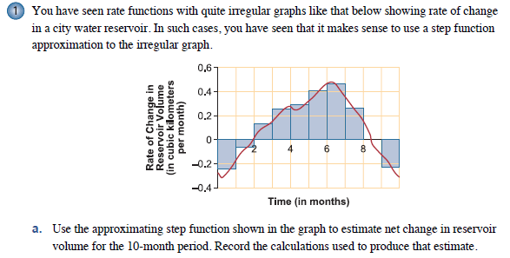

OVER
Page 2
***Very important! Please read this carefully!***
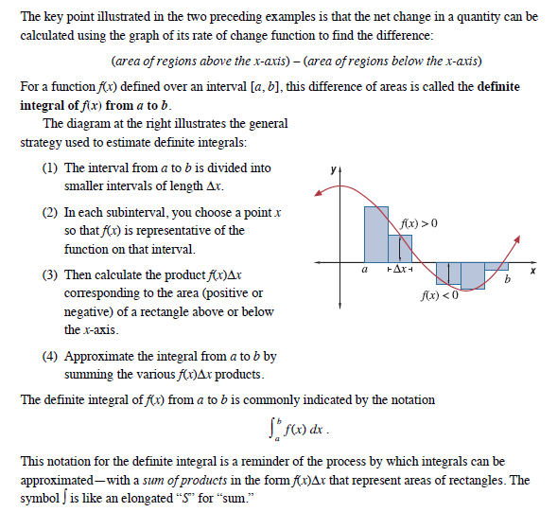

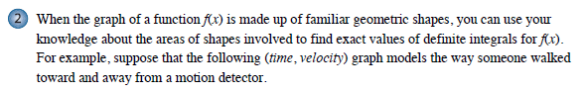

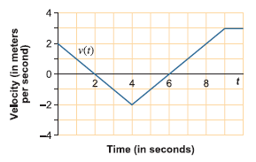

- Evaluate the definite integral and explain what
the results tell about the walker’s distance
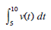
from the motion detector.

b. What is the total area between the graph of v(t) and the t-axis and what information about the walker’s trip is given by that number?

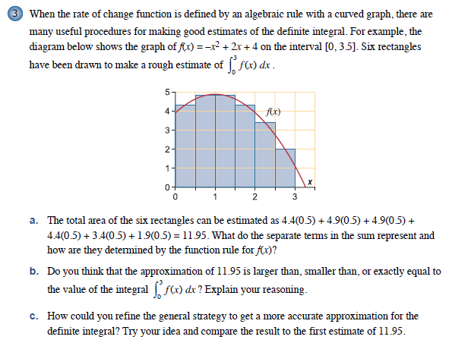
Page 3

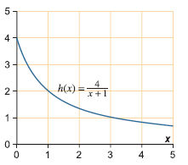
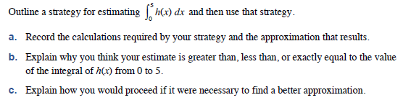

OVER
Page 4

6. Our calculators have multiple ways of calculating an integral. Here’s one way:

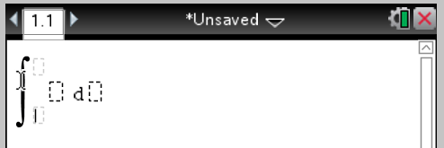
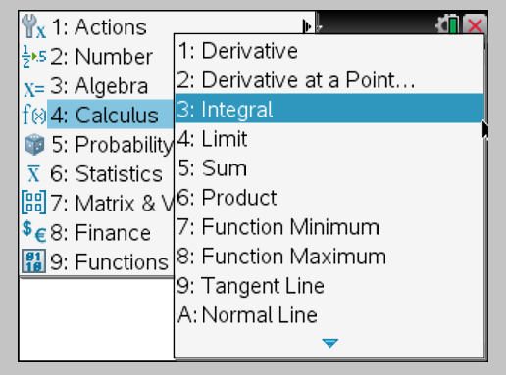

***Check your answers to parts a, b, and c from #5 to see how accurate your estimates are.

Page 5
HOMEWORK: Lesson 8-3
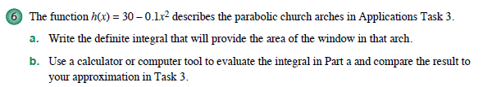

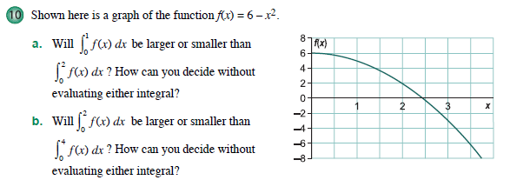

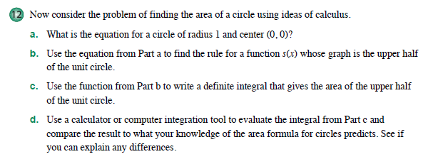

OVER
Page 6

