Math 4 Honors Name _____________________________

Lesson 8-4: *The Fundamental Theorem of Calculus* Date ___________________________

**Learning Goals:**

* *I can use the General Power Rule for Integration to find the antiderivative of a function.*
* *I can use the Fundamental Theorem of Calculus to evaluate a definite integral.*
* *I can find the area between two curves using integration.*

Differential calculus was primarily concerned with the slope of a line tangent to a curve at a given point. This was helpful in a variety of problems including computing instantaneous velocity and acceleration. *Integral calculus is concerned with the area between that curve and the x-axis*. When you *differentiate* an equation you get the slope. When you *integrate* you get the area between equation and the *x*-axis. Up until this point, we have been approximating the area under irregular curves using Riemann Sums. Next, we will look at an algebraic method to help find the *exact values.*

Must use “*F”* not “*f*”

**The Fundamental Theorem of Calculus:**

Suppose that is continuous on the interval and let be an *antiderivative* of .



***Note: is called the net change

from *x* = *a* to *x* = *b*. It is abbreviated by the

symbol: 

Then,

**Antiderivatives:**

How do we find the antiderivative of a function? Study the next two examples of indefinite integrals & see if you can determine the process.

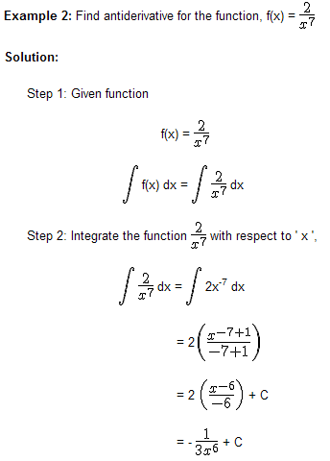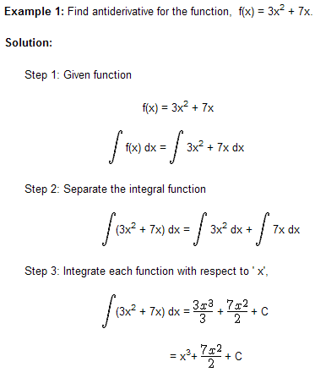

How would you generalize the process?

What’s up with “*C*”?

How can you determine if you have found the correct antiderivative?

OVER 🡪

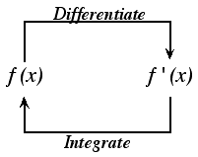Differentiation and integration are inverses of each other. Page 2

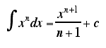 In case you weren’t able to generalize the process . . . .



**The General Power Rule for Integration:**  =

**Examples:** Integrate the functions with respect to *x*. In other words, find .



\*\*\**Don’t forget the “C”!*

1.  2. 

http://tutorial.math.lamar.edu/Classes/CalcI/ComputingIndefiniteIntegrals_files/eq0010M.gif 3. 4. 

http://tutorial.math.lamar.edu/Classes/CalcI/ComputingIndefiniteIntegrals_files/eq0011M.gif

5. 6. 

Page 3

Some other special rules for integration:

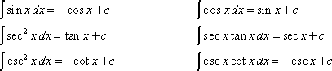

http://tutorial.math.lamar.edu/Classes/CalcI/ComputingIndefiniteIntegrals_files/eq0006M.gif

**Examples:** Evaluate the following definite integrals.

1. 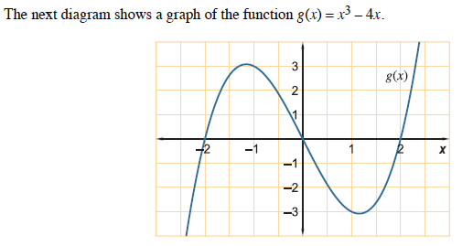Revisit problem #5 from Lesson 8-3 & use the **FTC** to answer parts a, b, & c. Compare these results to your original estimates.



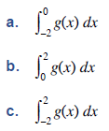

http://tutorial.math.lamar.edu/Classes/CalcI/DefnofDefiniteIntegral_files/eq0005M.gif



1. 3.

4. Find the area under the curve 5. Find the area bounded by

 from *x* = 0 to *x* = 2. the graphs of  and .

OVER 🡪

Page 4

**HOMEWORK.** *Please show all work on another piece of paper.*

**Evaluate the following.**

1.  2.  3. 

4.  5.  6. 

7.  8.  9. 

**Draw sketches for each of the following. Then solve.**

10. Find the area under the curve  from *x* = 1 to *x* = 3.

11. Find the area bounded by  and the *x*-axis.

12. Find the area bounded by the graph of , the *x*-axis, and the lines *x* = -1 and *x* = 2.

13. Find the area of the region bounded by and *y* = 0.

14. Find the area of the region bounded by  and .

15. Find the area of the region bounded by , *y* = 0, *x* = 0, and *x* = 2.

16. Find the area of the region bounded by  and *y* = 4.

17. Find the area under the curve  from *x* = 0 to *x* = 4.

18. Find the area of the region bounded by , *x* = 0, and *y* = 2.