AP Calculus AB Name__________________________________

Lessons 3-1, 3-2, 5-3 Part 2 Warm-up Date ________________________________

**Example:** Find the derivative of the given function. Use Number Line Analysis (NLA) to determine on what intervals the **derivative** is positive.

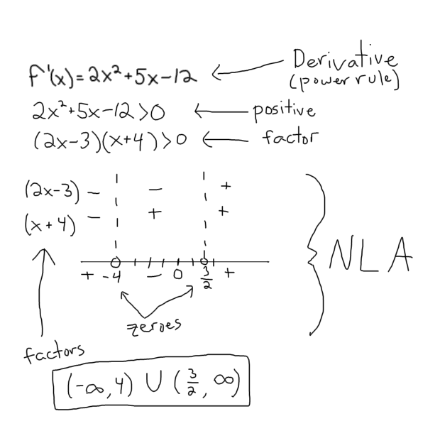

**Now you try:** Find the derivative of the given function. Use NLA to determine on what intervals the **derivative** is positive and on which intervals it is negative.



***Challenge:*** *Without graphing in your calculator, determine the coordinates of the relative max. How do you know this is the relative max?*