AP Calculus AB Name______________________________

Lessons 3-1, 3-2, 5-3: *Relating the Graphs of Part 2* Date ______________________________

**Learning Goals:**

* *I can use the first and second derivative tests to determine local extreme values of a function.*
* *I can determine the concavity of a function and locate points of inflection by analyzing the second derivative.*

***Directions*: Below are passages from a textbook (not our text book) about relating the graphs , along with questions and practice problems. Work through the following problems in your group, asking for help when necessary!**



*\* Note: The in the text are placed where it is suggested that you “check this fact yourself” – meaning it is a good place to stop and assess if you understand what you are reading!!*

**The Geometry of Derivatives**

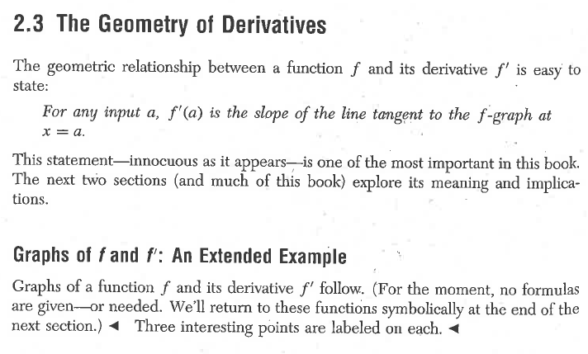

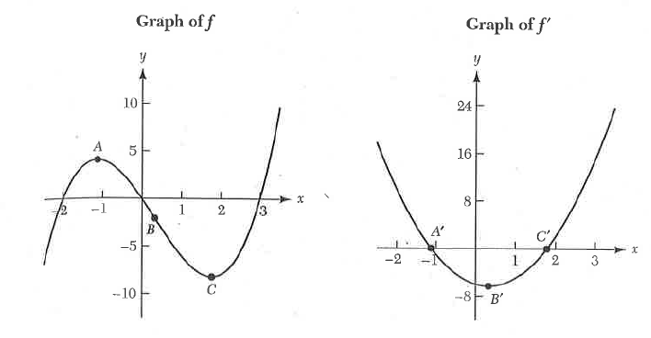

*Based on our prior learning, why are the points labeled on each graph “interesting”? How are the points A and C related to ? We will learn about the relationship between B and in this packet . . .*

OVER 🡪

Page 2

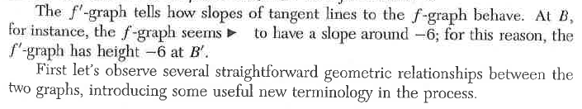

*Why does the graph of have a height of when the graph of f has a tangent line with a slope of ?*

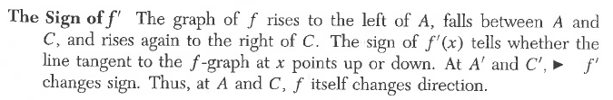

*Why does f change directions when changes sign? Explain in terms of the meaning of a derivative.*

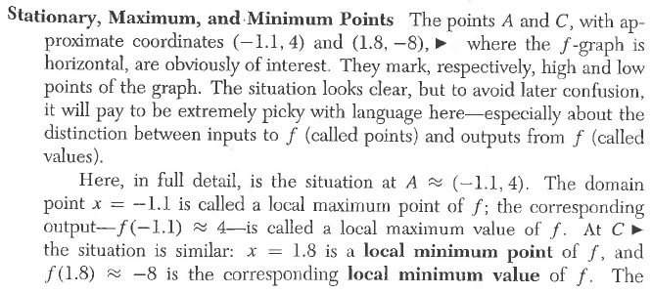

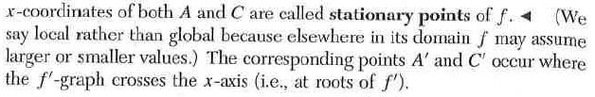

*What is the difference between a* ***local minimum point*** *and a* ***local minimum value****? Why do you think the author makes a point of being “picky” with the vocabulary?*

Page 3

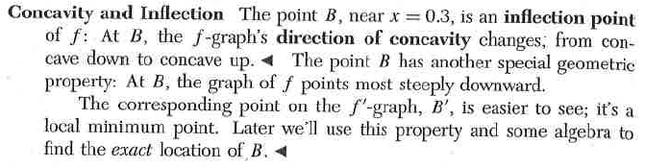

*One informal way to explain concavity is to think of concave up as where the graph “holds water” and concave down as where the graph “spills water”. Give a definition of concave up and concave down in your own words.*

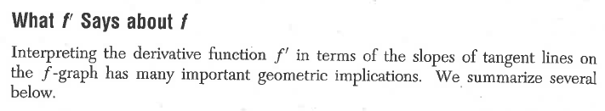

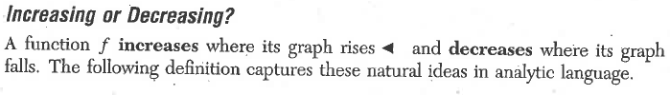

**Definition:** Let *I* denote the interval .

A function is **increasing** on *I* if 

A function is **decreasing** on *I* if 

*Explain what means.*

*Explain what and means.*

*In your own words, what does it mean for a graph to be increasing? For a graph to be decreasing?*

OVER 🡪

Page 4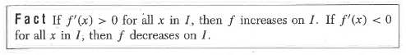

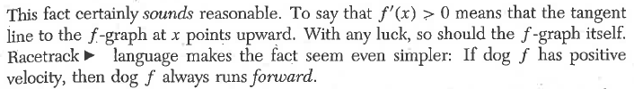

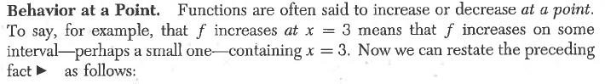

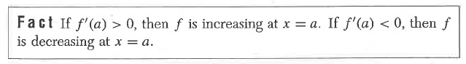



The converse of the above fact is as follows

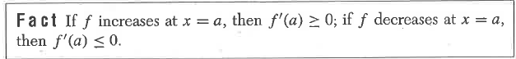

*Explain in your own words what the previous two “Facts” tell us about the relationship between the graph of a function and the graph of the functions derivative*.

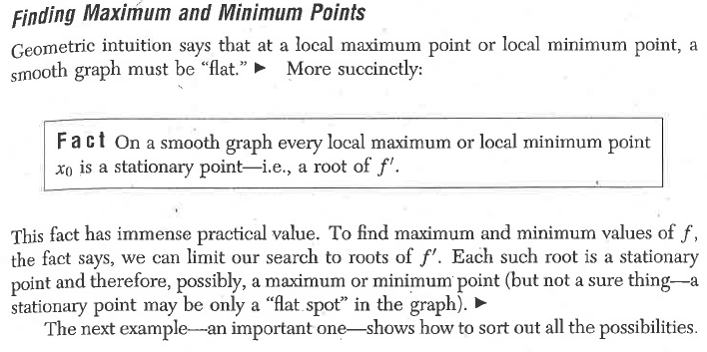

Page 5

*Explain what the above “Fact” means in terms of finding local maximum/minimum points of graphs using the calculus we’ve learned – how can we find local maximum and minimum points of any function f? How can we tell if the point is a maximum or minimum?*

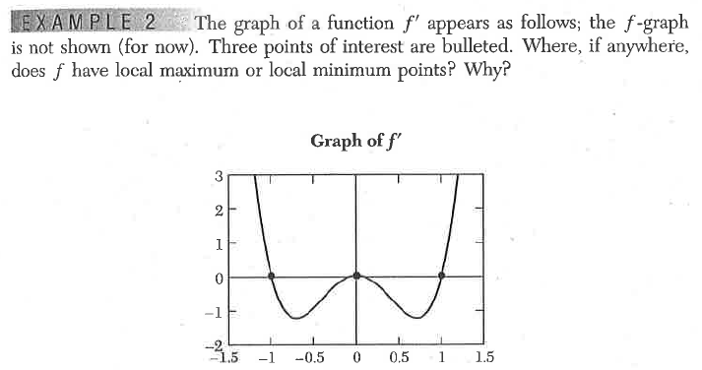

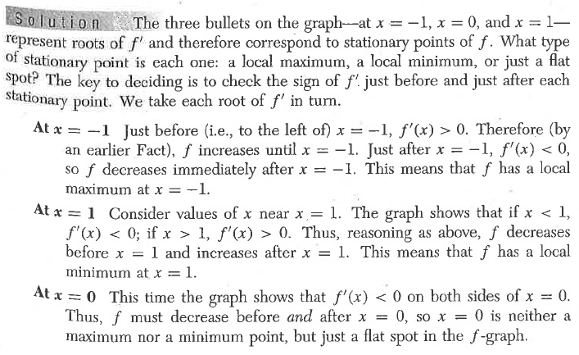

***Note above the explanation for why f does NOT have a local max/min at x = 0!! This is more in depth than we discussed in the previous investigation. Be sure to understand what is happening to the graph of f at x = 0.***

OVER 🡪

Page 6

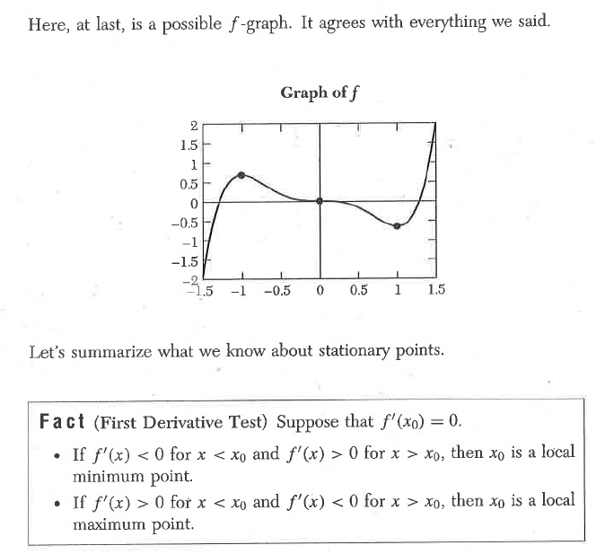

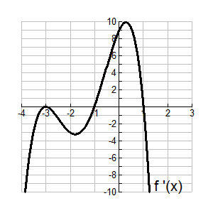**Practice:** Given the below graph of, find all the local maximum points, minimum points, and “flat spots” of 

**Check your answer with The Heinl before you move on to the next page!**

Page 7

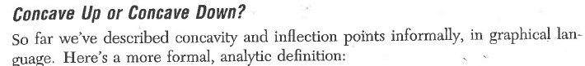

**Definition:** The graph of *f* is **concave up** at *x = a* if the derivative functionis increasing at *x = a*.

The graph of *f* is **concave down** at *x = a* ifis decreasing at *x = a*.

Any point at which a graph’s direction of concavity changes is called an **inflection point**.

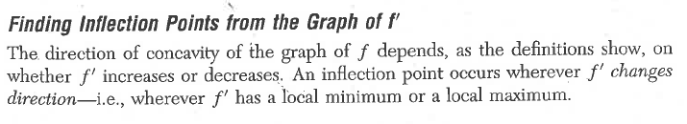

**Example:** We know that the derivative of the sine function is the cosine function. That is, if , then . Based on this knowledge, discuss the concavity of the sine function. Find all inflection points and describe them in derivative language.

**Solution:** Note the graphs of andbelow.

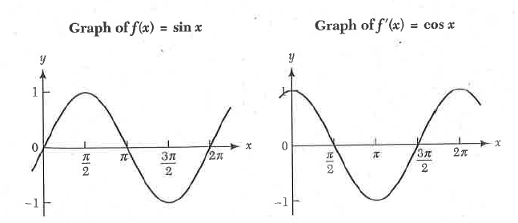

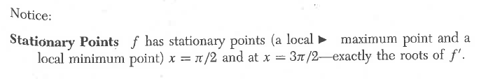

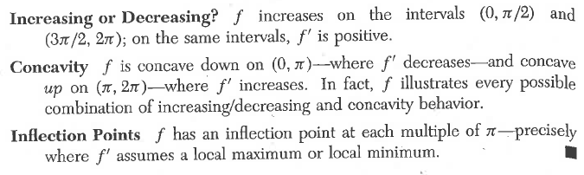

*Annotate (make notes on) the graphs above that illustrate the stationary points, increasing and decreasing intervals, concavity, and inflection points.* OVER 🡪

Page 8

*If has a local maximum or minimum, what is the value of?*

*Based on your answer to the above question, how can you find inflection points using the second derivative?*

*What do your inflection points tell you about the graph of f?*

**Practice:** The graphs of *f* andare reprinted below. They again illustrate the definition of concavity given above.

*Explain, referencing the labeled points on the above graphs, how the graph of illustrate the stationary points, increasing and decreasing intervals, concavity, and inflection points of the graph of f*.

Page 9

*Fill in the below table based on what you have learned about the first and second derivative:*

**Conditions on the Description of Graph of**

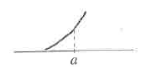**Derivatives  **

 

Make a sketch:

 

Make a sketch:

 

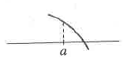

 

**Check your answer with The Heinl before you move on!!**

**Practice:** Sketch a graph of a functionwith all the following properties:

a. 

b. 

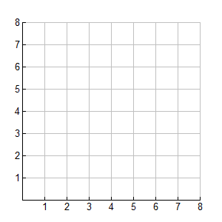c.

OVER 🡪

Page 10

*Previously we described the “First Derivative Test”. Use it as a model to write the “Second Derivative Test”. Check your answer with The Heinl before moving on.*

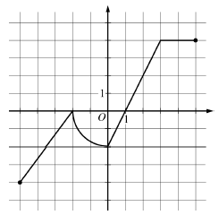

**2017 Exam: FRQ #3 (No calculator)**

Graph of 









AP Calculus AB Name_________________________________

Lessons 3-1, 3-2, 5-3Practice Date ___________________________________

*DO ALL WORK ON A SEPARATE SHEET OF PAPER!*

1. Use the First Derivative test to determine when the following functions are increasing and decreasing

and to find all local extrema:

(a) 

(b) 

2. Use the Second Derivative Test to find inflection points and determine the concavity of the following

functions:

(a) 

(b) 

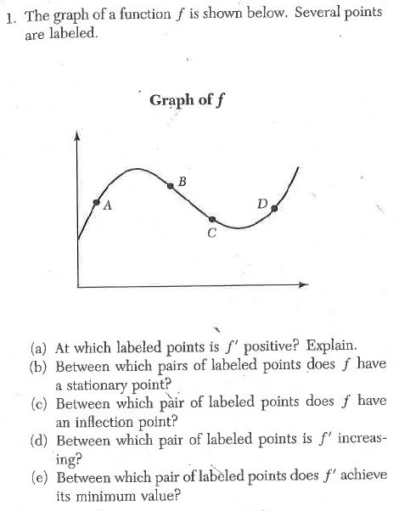

3.

OVER 🡪

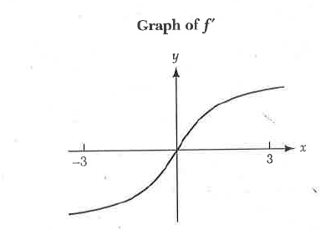

4.The graph of a derivative of the function *f* is shown.

a. The equation can have no more than two solutions on

the interval . Explain why.

b. Explain why *f* cannot have two zeros in the interval 

c. Suppose that. How many solutions does the equation

 have on the interval . Explain.

**In problems 5 and 6, be sure to justify your choice with an explanation**

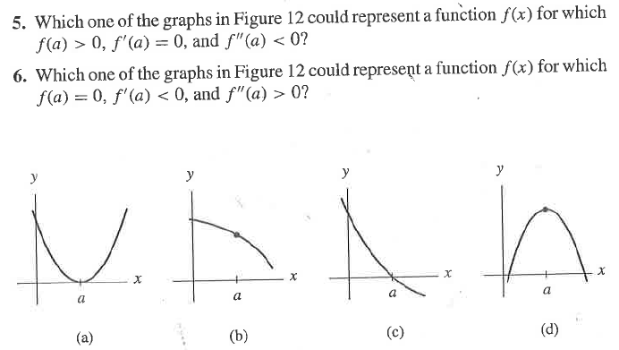

**2016 - 2017 AP Exam Questions**

*No calculator:*

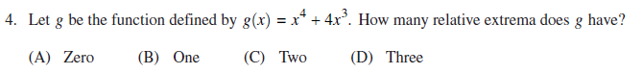

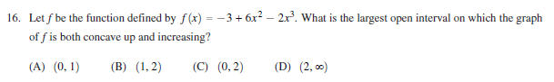

*Calculator Active: Use your calculator as much as possible!*

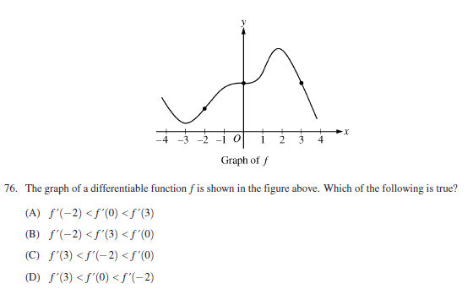

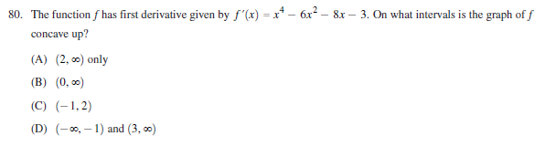

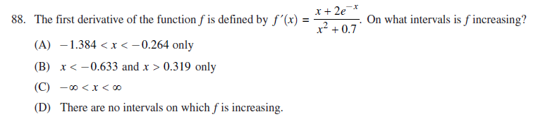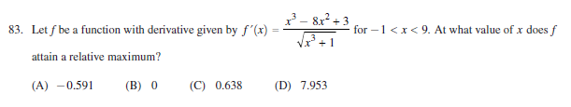

OVER 🡪

