AP Calculus AB Name__________________________________
Lessons 3-1 & 4-3 Learning Check Date __________________________________
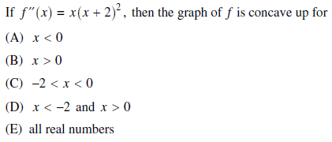
1.

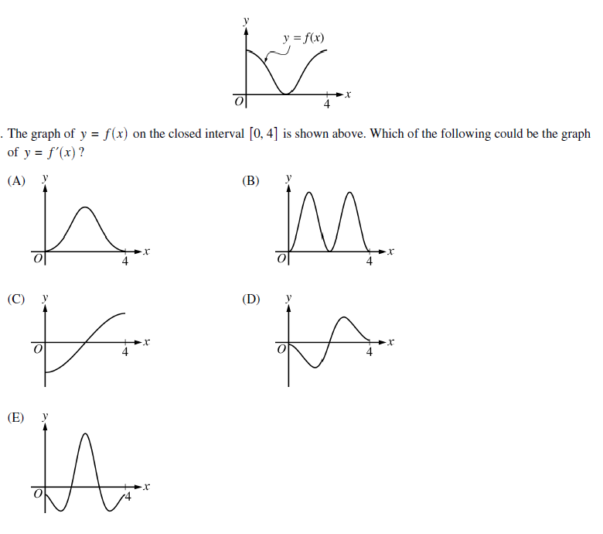

2.

OVER
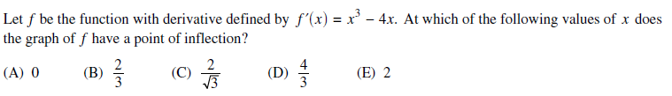
3.

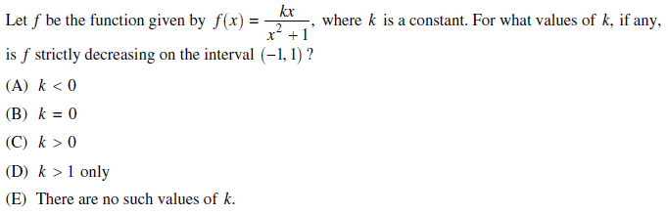
4.

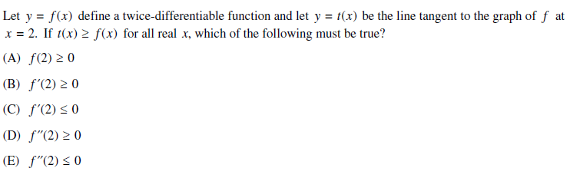
5.

