AP Calculus AB Name__________________________________

Lessons 3-3, 3-5 & 4-4, Part 2 Learning Check Date ________________________________

**NO CALCULATOR**

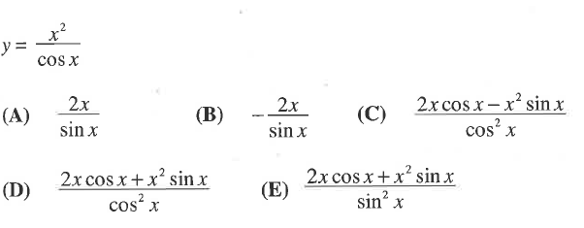For problems 1 and 2, find .

1.

2. 

1.  (B)  (C) 

(D)  (E) 

OVER 🡪

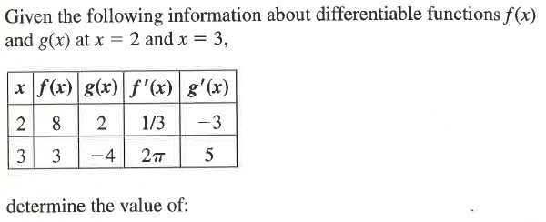3.

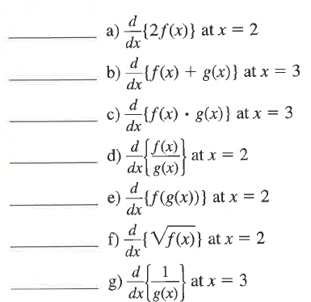

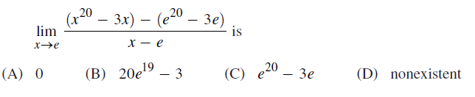4. Review: