AP Calculus AB Name__________________________________

Lessons 3-3, 3-5 & 4-4: *Rules for Differentiation, Part 2* Date _________________________________

**Learning Goal:**

* *I can use rules of differentiation to calculate derivatives of polynomials, rational functions, and , and trigonometric functions.*

Let’s talk about the derivatives of trigonometric functions!

1. In your calculator, in the window  graph.

What do you think is the derivative of ?



2. In your calculator, in the window  graph.

What do you think is the derivative of? This one will take a bit more thinking . . .



3. Given the derivative of the sine and cosine functions above, and the fact that , notice how we are able to use the quotient rule to derive the derivatives for . Use the process for the derivative of tangent as your guide to find the derivative of .

*y* =  *y* = 

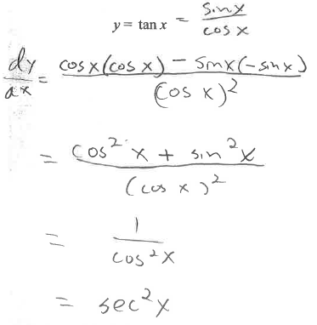

 

OVER 🡪

Page 2

**Derivative of Trigonometric Functions**

*You need to know or be able to derive these!!*













**Practice – Find .**

1. 

2. 

3. 

Page 3

4. Show analytically (NOT using a graph) that the graph of has a horizontal tangent line at **

5. Given , find the equation of the tangent line at . Sketch the graph and the tangent line.

6. If , find .

7. If , find *y.*

OVER 🡪

Page 4

Use the table below for problems 8-11.

|  |  |  |  |  |
| --- | --- | --- | --- | --- |
| ***x*** | ***f(x)*** | ***f'(x)*** | ***g(x)*** | ***g'(x)*** |
| 0 | 4 | -1 | -6 | 7 |
| 1 | 0 | -6 | 0 | 5 |
| 2 | -6 | -5 | 4 | 3 |

*Tables and graphs* ***above*** *problems are standard on the AP exam, so get used to this format . . .*

8. Find . 9. Find .

10. Find . 11. Find.