AP Calculus AB Name__________________________________

Lessons 3-3 & 4-4:*Rules for Differentiation, Part 1* Date _________________________________

**Learning Goal:**

* *I can use rules of differentiation to calculate derivatives of polynomials, rational functions, and .*

I. Some Previously Covered Derivative Rules:

Let *u, v* be differentiable functions, and *c* be a constant.

***Derivative of a Constant Function* *Power Rule***

 

***Constant Multiple Rule The Sum and Difference Rule***

 

Let . Find . [No negative nor rational exponents in your final

answer.] Believe it or not, you will use all of the above rules to find !

II. Product and Quotient Derivative Rules

***The Product Rule***

The product of two differentiable functions *u* and *v* is differentiable, and

 or simply, 

*“First times the derivative of the second plus second times the derivative of the first.”*

OVER 🡪

Page 2

**Example 1**

Let. Find using the **product rule**.

**Practice #1**

Let . Find  using the product rule.

***The Quotient Rule***

At a point where , the quotient  of two differentiable functions is differentiable, and

 or just 

**Example 2**

Let . Find .

Page 3

**Practice #2**

Let . Find .

**Practice #3**

. Find . ***Hint: Try factoring and simplifying first!

**\*\*\*Practice #4 – THIS IS AN IMPORTANT TYPE OF PROBLEM – it is always on the AP test!**

Let 

Let . Find  Let . Find 

OVER 🡪

Page 4

III. The Derivatives of 

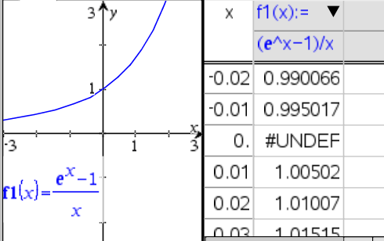You may recall from Math 3 and/or Math 4 that . Another interesting property of *e* is. See the graph and table to the right to “verify”.

Look at the following limit. What does this work tell you?



The derivative of *ex* is simply _________.

**Example 3**

Let. Find .

**Practice #5**

Let . Find .

Page 5

Now that we know the derivative of , it makes sense to learn the derivative of its inverse . Later in the year, when we learn what is called implicit differentiation, we will learn how to derive the derivative of . For now, just understand that



**Practice #6**

Let . Find .

IV. Second and Higher Order Derivatives

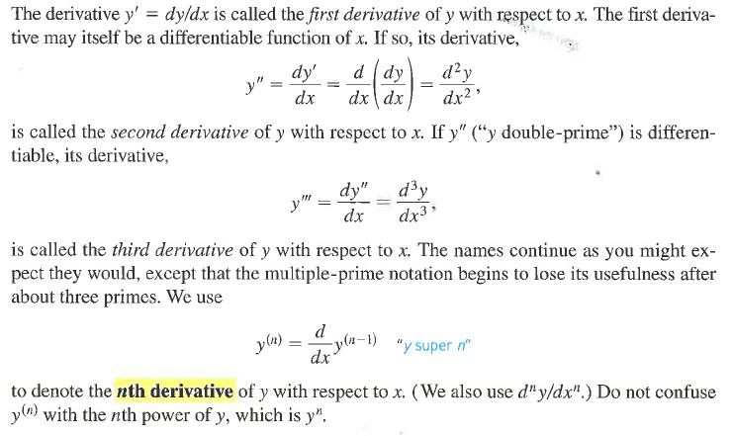

**Practice #7**

Let . Find .

OVER 🡪

V. Mixed AP Exam Practice Problems

1. Evaluate .

A.  B.  C. 6 D.  E. nonexistent

2. Evaluate .

A.  B.  C.  D.  E. nonexistent

***2017 Exam Questions:

