AP Calculus AB Name__________________________________

Lessons 3-3 & 4-4 Derivative Rules Part 1 Extra Practice Date ________________________________

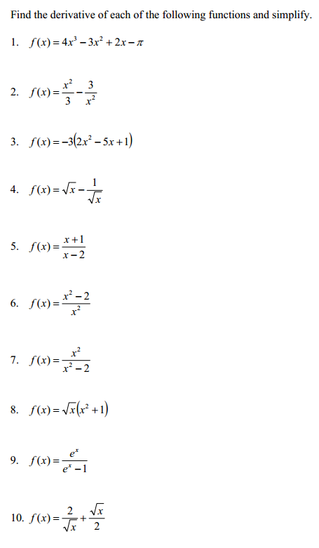

OVER 🡪

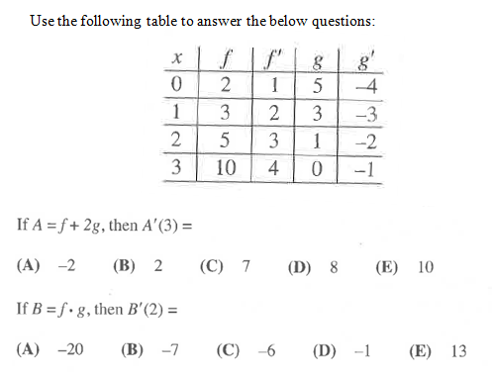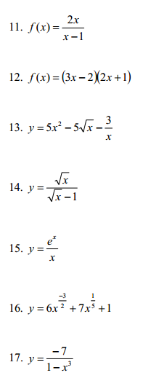

18.

1. If *A* = *g* + 2*f,* then *A*’(1) = B. If *B* = $\frac{f}{g}$, then *B*’(2) =

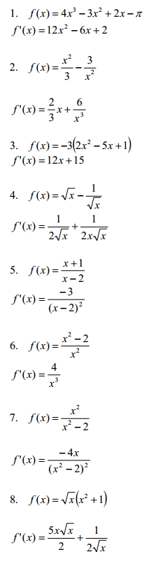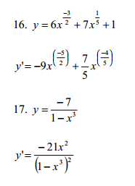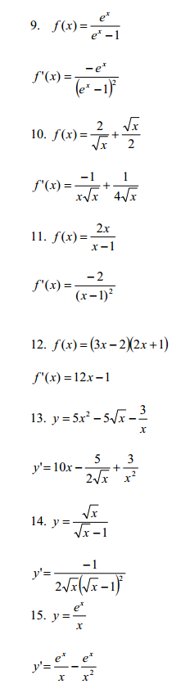**ANSWERS**

−



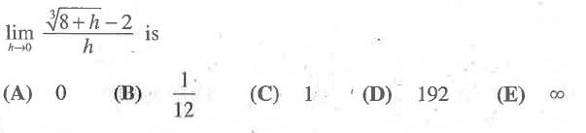Mixed Multiple Choice Practice

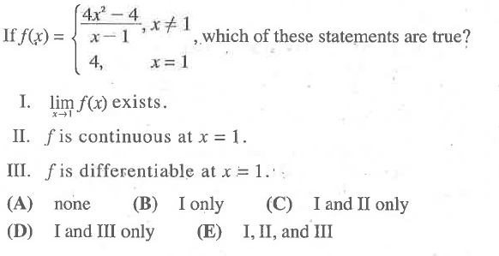

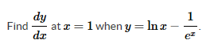

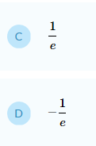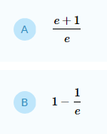



1. 