AP Calculus AB Name____________________________________

Lessons 3-3 & 4-4:*Rules for Differentiation, Part 1* (Extension) Date __________________________________

1. Let *u* and *v* be differentiable functions. If and , find *u* and *v.*

2. Which of the following could be true if 

I. 

II. 

III. 

1. I and II only (B) I and III (C) I only

(D) III only (E) I, II, and III

OVER 🡪

3. If, verify that .

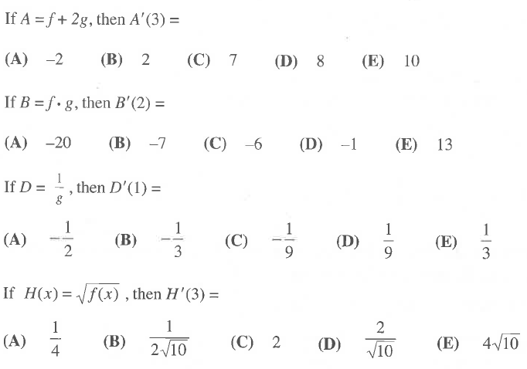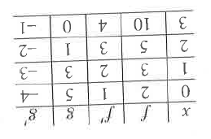4. Use the following table to answer the below questions: