AP Calculus AB Name_________________________________

Lessons 5-1 & 5-2: *Extreme Values & the MVT* Date ________________________________

**Learning Goals:**

* *I can find local or global extreme values of a function.*
* *I can apply the Mean Value Theorem and find the intervals on which a function is increasing and decreasing.*

While we have already covered the first and second derivative test to find extrema and concavity of a function, we did so without some formal definitions. Just to make sure we can keep up the conversation with our mathematician friends, let’s go through those definitions:

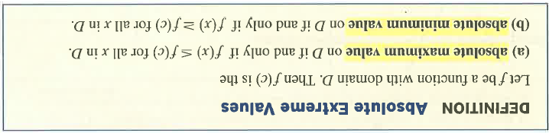

* *note that we usually leave off the term “absolute” or “global”, so “minimum value” it is understood to mean absolute minimum – if referring to local minimums, local or relative needs to be specified.*

Explain the meaning of “for all *x* in *D*.”

**Extreme Value Theorem**

If *f* is continuous on closed interval [*a,b*], then *f* has both a maximum value and a minimum value on the interval (see figure below).

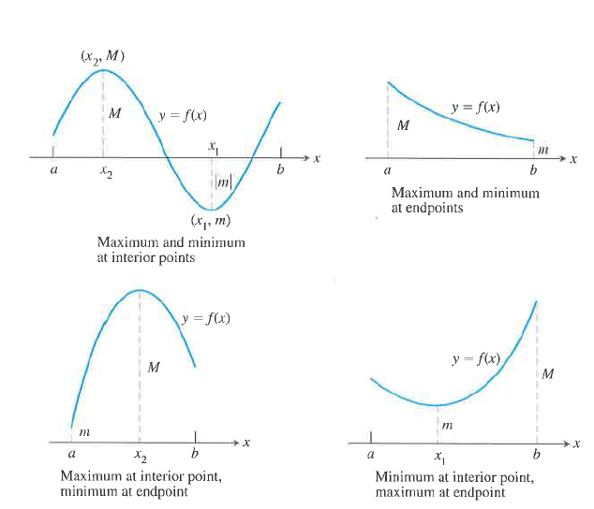

OVER 🡪

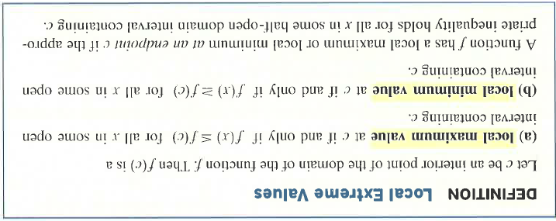 Page2

Note that an absolute extrema is also a local extrema, because being an extreme value overall makes it an extreme value in its immediate neighborhood. Hence *a list of local extrema will automatically include absolute extrema*.

**DEFINITION – Critical Point**

A point in the interior of the domain of a function *f* at which or does not exist is a **critical point**

of *f*.

What do critical points tell you about *f*?

**Practice**

1. Find the absolute maximum and minimum values of on the interval .
2. Find the extreme values of .
3. Find the extreme values of 

Page 3

**THEOREM – Mean Value Theorem for Derivatives**

If is continuous at every point of the closed interval and differentiable at every point of its interior , then there is at least one point *c* in at which



This theorem is another big one – *you will need to be able to refer to it by name*. Do not confuse it with the Intermediate Value Theorem!!

Speaking of the Intermediate Value Theorem, what does the IVT say?

**Example**

Show that the function satisfies the hypothesis of the Mean Value Theorem on the interval [0,2]. Then find a solution to the equation .

**Example**

Why do the following functions fail to satisfy the conditions of the Mean Value Theorem?



OVER 🡪

Page 4

**A Physical Interpretation**

If a car accelerating from zero takes 8 seconds to go 352 feet, its average velocity for the 8-second interval is 352/8 = 44 feet per second, or approximately 30mph. What does the Mean Value Theorem tell us about the speed of the car during that 8 seconds?

In general, what does the Mean Value Theorem say about instantaneous change and average rate of change over some interval?

**A Corollary of the Mean Value Theorem**

*Functions with the Same Derivative Differ by a Constant*

If  at each point of an interval *I*, then there is a constant *C* such that for all

*x* in *I*.

What does the above corollary mean?

Let’s apply the corollary.

Find the function  whose derivative is and whose graph passes through the point .

**DEFINITION – Antiderivative**

A function is an **antiderivative** of a function if for all *x* in the domain of *f*. The process of finding an antiderivative is **antidifferentiation.**

**Example**

Find the velocity and position functions of a pumpkin falling from an initial height of 20 feet with an initial velocity of ft/sec. Remember, the acceleration due to gravity of a *falling* object is feet/sec2

Page 5

**Practice**

*No Calculator*

1. A local minimum value of the function is

(A)  (B) 1 (C)  (D)  (E) 0

2. The tangent to the curve is vertical when

(A)  (B)  (C) 

(D)  (E) none of these

3. The function has

(A) one relative minimum and two relative maxima

(B) one relative minimum and one relative maxima

(C) two relative maxima and no relative minimum

(D) two relative minimum and no relative maxima

(E) two relative minimum and one relative maxima

OVER 🡪

Page 6

4. Let .

(a) Find the coordinates of the relative maximum and minimum points of *f* in terms of *b.*

Identify each specifically.

(b) Show that for all values of *b > 0*, the relative maximum and minimum points lie on a

function of the form by finding the value of *a*.

*Calculator Active*

5. The equation predicts the population of Alaska since the year 1900 (is 1900).

(a) Predict the population of Alaska in 2020.

(b) Find the inflection point of the equation. What significance does the inflection point

have in terms population growth in Alaska?

(c) What does the equation indicate about the population of Alaska in the long run?

Mathematically, why is this true?