AP Calculus AB Name _________________________________

Lessons 4-4 & 4-5 Learning Check Date _______________________________

**NO CALCULATOR (*except problem 3*)**

1. Use the linear approximation of at to estimate the value of the function at.

Explain what you just found.

2. Find the equation of the tangent line to at .

3. Find the minimum distance from the curve to the point .

That is, minimize the distance between .

The distance formula is .

**CALCULATOR ACTIVE.** Justify your solution.

OVER 🡪

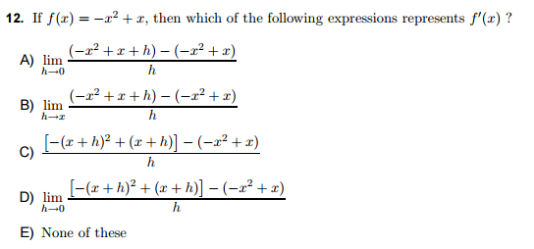4.

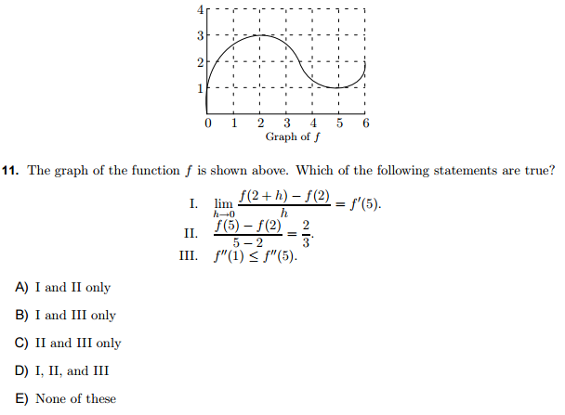5.

 Which of the above statements is/are true for the graph of *f* ?

6. If a function *g* is differentiable on the interval , then which of the following statements must be true?

(A) *g* is not continuous on

(B) *g* is not differentiable on

(C) for some *c* on 

(D) The conclusion of the Mean Value Theorem applies to *g.*

(E) None of these