Math 4 Honors Name ______________________________

Quiz Review: Lessons 6-3 thru 6-5 Date ______________________________

NO CALCULATOR!

1. Refer to the graph of *f* shown at the right.

*Estimate to the nearest 10th.*

1. For what values of *x* is the derivative of *f* positive?

1. For what values of *x* is the derivative of *f* negative?

*x*

1. For what values of *x* is the derivative equal to zero?
2. Using a straightedge, draw the line that is tangent to the graph at *x* = 2.
3. Estimate the derivative of the function when *x* = 2.
4. Estimate the point(s) of inflection. g. Describe the concavity of *f*.

*f*

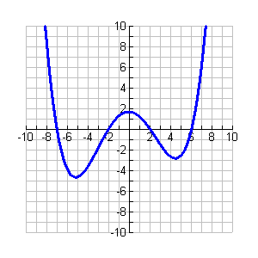

2. **Sample A.P. Exam questions:**

1. .  has a relative maximum at *x* = _______.
2. 0 (B) 2 (C) 2 and 3 (D) 0 and 3 (E) There is no relative maximum.
3.  has a point of inflection located at _______.
4. (0, -1) (B) (1, 1) (C) (2, 3) (D) (1, 0) (E) (-1, 1)

1. Consider the function . On what interval is  increasing?
2. (-∞, ∞) (B) (-∞, 0) (C) (0, ∞) (D) (1, ∞) (E) (-∞, 1)

OVER 🡪

3. Differentiate the following. *For c & d, write your answers in radical form.*

a.  e. 

b.  f. 

c.  g. 

d.  h. 

4. A particle moves on the *x-*axis such that its position at time *t* is given by the function



1. Determine the velocity & acceleration of the particle at time *t.*
2. For what values of *t* is the particle at rest?
3. For what values of *t* is the particle moving to the right?
4. For what values of *t* is the particle moving to the left?
5. What is the total distance it has traveled after 5 seconds?
6. What is the velocity when the acceleration is zero?

5. The graph below is of *f* '(*x*), the first derivative. *f*(*x*)

This is not the graph of *f*(*x*). If *f*(-1) = 2 and

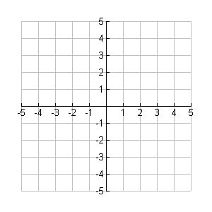 *f* '(*x*) is represented by the given graph.

Graph *y* = *f*(*x*) as best you can.



*f* '

*x*

*x*

Suppose *f*(-3) = -2. What is the equation of the tangent line to the graph of *f*(*x*) at the point (-3, -2)?