AP Calculus AB Name__________________________________
Lessons 7-1 & 7-4 Learning Check Date ________________________________
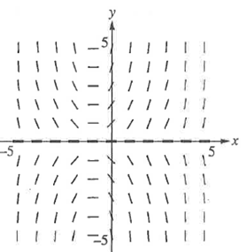
No Calculator.

1.

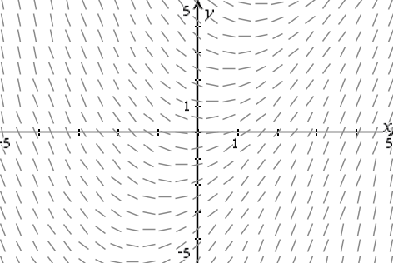

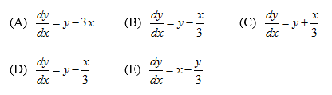
2. Which of the following differential equations would produce the above slope field?

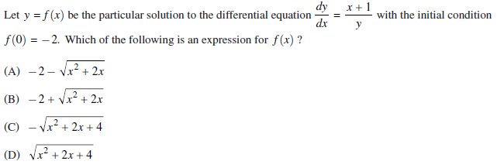
3.

OVER
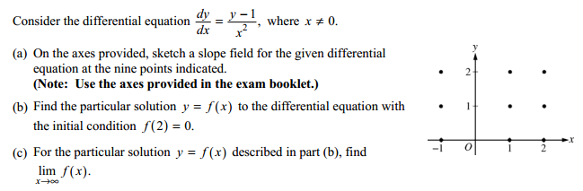
4.

