AP Calculus AB Name__________________________________

Lessons 7-1 & 7-4: *Slope Fields and Separable* Date _________________________________

*Differential Equations*

**Learning Goals:**

* *I can construct antiderivatives using the FTC.*
* *I can construct slope fields and interpret their meaning.*

One of the early accomplishments of calculus was predicting the future position of a planet from its present position and velocity. Today this is just one of a number of occasions on which we deduce everything we need to know about a function from one of its known values and its rate of change.

Equations modeling problems involving motion that involve derivatives are called **differential equations**. Since differential equations continue to arise in all areas of applied mathematics, much research in mathematics has focused on how to solve differential equations. So much so that it is generally the focus on a fourth semester calculus course at most colleges and universities (often called either “Calculus IV”, or simply “Differential Equations”). In this course, we will be spending some time in Chapter 6 just dipping our toes into the metaphorical pool that is differential equations.

**Review**

a. Find all functions *y* that satisfy .

b. Find the **particular solution** to the equation whose graph passes through the point .

c. If and , find .

d. **CALCULATOR ACTIVE**. If and , find . *Hint: Use FTC, part 2!*

OVER 🡪

Page 2

**Slope Fields**

**Vector** -  a geometric object that has magnitude (or length) and direction

During the 1st half of the year, we learned all about a mathematical idea called the **derivative**. We spent a good deal of time focusing on a very important property of the derivative:

**The derivative of a function gives the slope of the function at a point.**

When we work with **differential equations**, we are dealing with expressions in which the derivative appears as a variable. For example, we might be asked to analyze the differential equation:



If we simply replace the variable  in the above equation by what we learned earlier, we get the following statement:



So what? Well, often our usual **goal** when we are given a differential equation is *to find the function whose derivative appears in the equation*. In our example this means that our goal is to find a function *y* for which .

Now you may be one of those clever students who are always one step ahead of the teacher. If so you're probably already having thoughts about how you could easily solve the current example (i.e. find *y*) using integration. Hold that thought! Unfortunately integration isn't something we will always be able to use. Many (most?) differential equations cannot be integrated directly. What we're leading into here is a method that can help us on far more differential equations than can be solved using integration.

It is possible to learn a great deal about a differential equation, even when we don't know how to solve the equation, by looking at a picture of all the slopes of the graph at various points. It is actually quite easy to visualize all of these slopes by sketching the **slope field** of the differential equation (slope fields are sometimes called vector fields, flow fields, or direction fields). The slope field of the differential equation is the vector field defined in the following manner:

*To every point in the domain of f, assign a unit vector with slope. The vector will then point in a direction tangent to the particular graph that passes through the point *

The above definition is basically fancy math talk for drawing the local linearization of the unknown equation at numerous points. By drawing the local linearizations using the given differential equation (i.e. a bunch of little line segments that represent the slope of the graph at that point), we can get a picture of how the graphs of all of the particular solutions to the differential equation look. See the example on the next page.

Page 3

We want to draw the slope field for the differential equation . That means the equation for *y* will have a slope of at any given point on its graph. For example:

* At the point the slope of *y* would be .
* At the point the slope of *y* would be .
* At the point the slope of *y* would be .
* At the point the slope of *y* would be .

(Notice here that the *y*-values of the coordinates do not affect the slope – *that will not always be the case!*)

While the points that were chosen above are somewhat random, if we are a bit more systematic about the points we choose, and we graph all of our vectors (think little local linearizations) on a coordinate plane, a picture of all the solutions to the differential equation will emerge. With the help of technology (<http://www.personal.psu.edu/dpl14/java/calculus/slopefields.html>) this process can be done quickly. See the results below.

Slope field for 

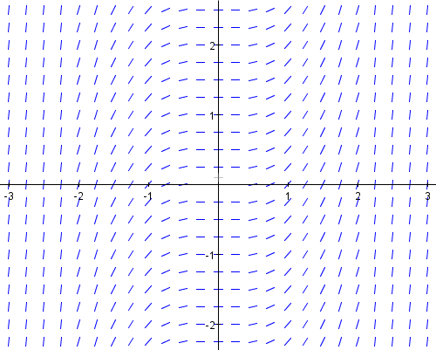

All of those little line segments (technically vectors) seen in the above slope field are tangent to one particular solution to the differential equation .

Here’s what this slope field means:

The antiderivative of is .

To find a particular solution, we would need more information so we can solve for *C.*

So technically there are *infinitely many* solutions to the differential equation 

Take a close look at the slope field above. Can you see graphs numerous functions in the form ?

OVER 🡪

Page 4

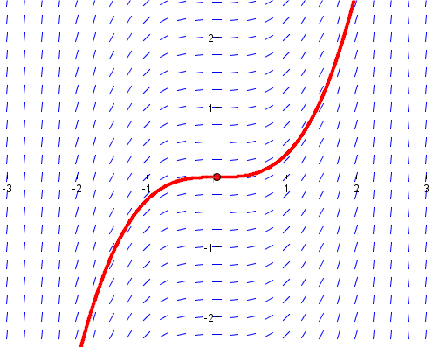For instance, if we knew that the graph of *y* contained the point , and hence making (make sure you understand why that makes ), then the particular solution to is highlighted in the slope field below.

1. Consider the following:
2. What if the graph of *y* contained the point ? Trace the particular solution to  on the above slope field.

b. What if the graph of *y* had an initial condition ? Trace the particular solution to

 on the above slope field.

2. Let’s take a look at another differential equation that we should be able solve analytically:

 ****See next page!!!

Even though you should know what the function *y* is already, fill out the table on the next page and sketch a slope field on the given grid. Note that again the *y*-coordinate does not affect our slopes. When sketching the vectors (little line segments) remember that the slope of your vector does not really need to be exact, it just needs to be correct *relative to the other vectors* that you are sketching. So for instance, a vector with a slope of 4 should appear steeper than a vector with a slope of 2. On the AP Exam, all they generally look for is positive versus negative slopes. *Be sure to carefully calculate and graph negative versus positive slopes/vectors/line segments!* Any slope greater than 1 can be drawn almost vertical. In terms of getting the correct shape of the slope field, try and draw your vectors with a slope of one as a reference. You can get a good picture of the slope field if you pay attention to the sign of the slope and then draw 3 types of slopes – slope of 1, slopes of less than 1, slopes of greater than 1 (and their negative counterparts)

a. Trace the particular solution that contains the point .

. b. Find the antiderivative of . Given your antiderivative, does your slope field seem

correct?

Page 5

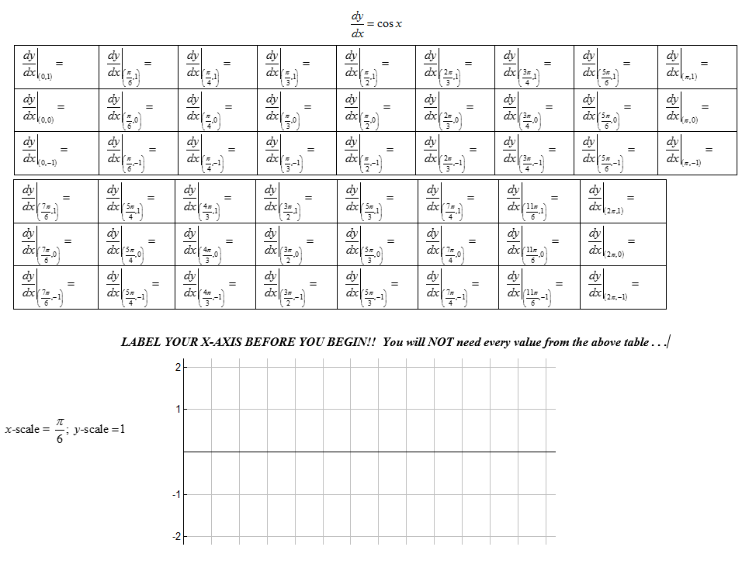

OVER 🡪

Page 6

3. Let’s create a slope field for a function whose antiderivative is not familiar to us.

a. Use the table and grid below to create a slope field for . Not that in this case we WILL

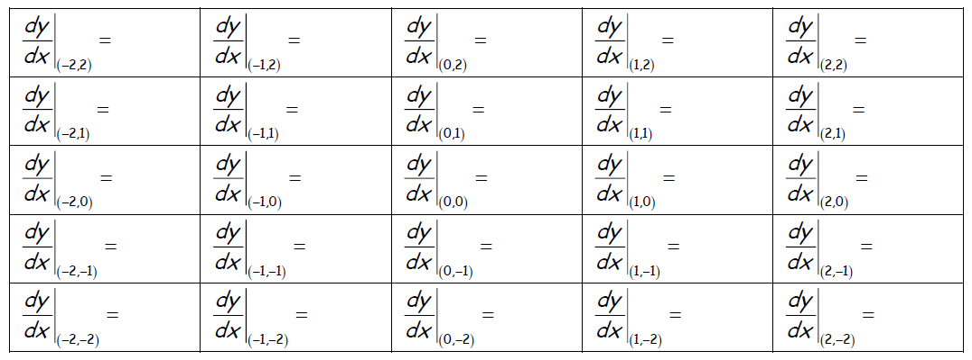have to consider the *y*-value when calculating the slope.

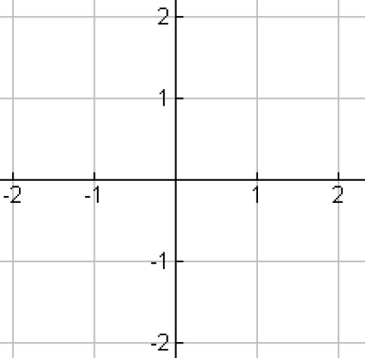

b. Trace the particular solution with the initial condition .

**A Summary of the Steps To Draw a Slope Field:**

1. Put the differential equation in the form 

2. Decide what region of the *x*-*y* plane you want to use; generally no bigger than for both axes

3. Calculate a table of values, one for each grid point 

4. Sketch a vector (little line segment) at each grind point with the corresponding slope from the table.

Page 7

4. Draw a slope field for each of the following differential equations. *Make your tables on a separate*

*Sheet of paper.*

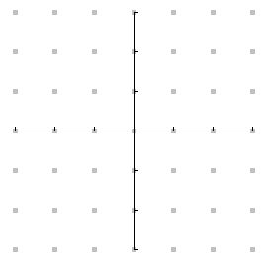a.  b. 



c.  d. In 4(a), draw a particular solution that contains .



In 4(b), draw a particular solution that contains .

In 4(c), draw a particular solution that contains .

5. Match each of the below differential equations with the correct slope field.

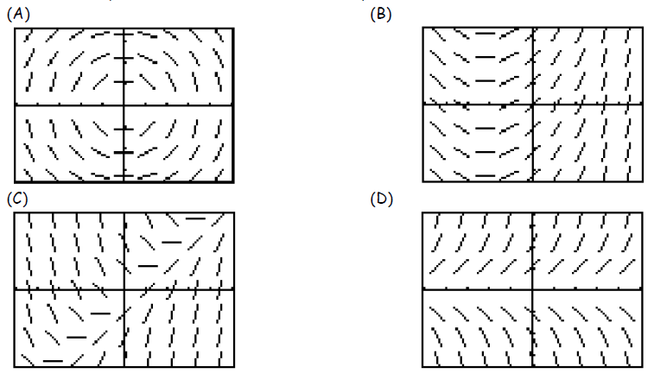a.  _____ b. _____ c.  _____ d.  _____

OVER 🡪

Page 8

6. The computer drawn slope field below is for the differential .

a. Sketch the solution curve through the point .

b. Sketch the particular solution containing .

c. Approximate using the equation of the tangent line to at the point .

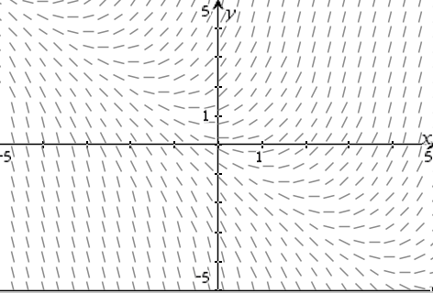

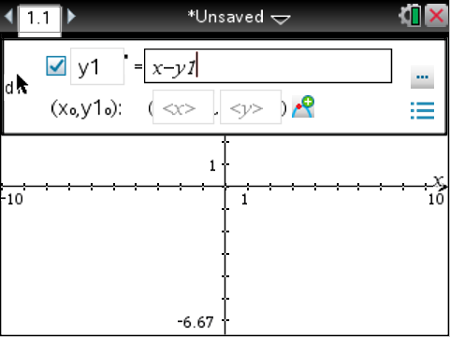d. Check your answers to problem (5) on your calculator. Start a new **Graph** page, then see below.

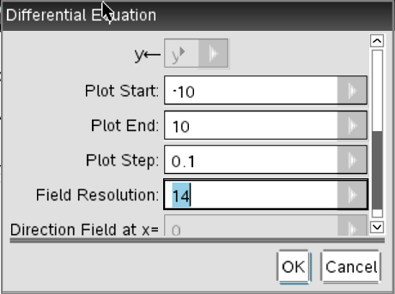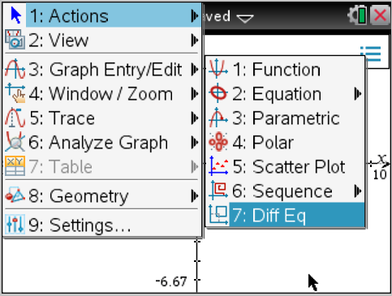

***Note that the equation you are entering is labelednot , so if you want to enter a *y* variable, you

need to enter it as  not simply *y*.

You also may want to click on the edit parameters button (next to the equation entry line) and change the “field resolution” to a larger number so that the vectors are a bit shorter (30 should be fine).

If you enter a coordinate into the field, the particular solution through that point will be highlighted.

Page 9

7. AP Calculus AB Free Response Practice

**Try these two problems INDEPENDENTLY for at least 5 minutes each!! NO TALKING!!**

*Skip part (c) in both problems for now . . . .*

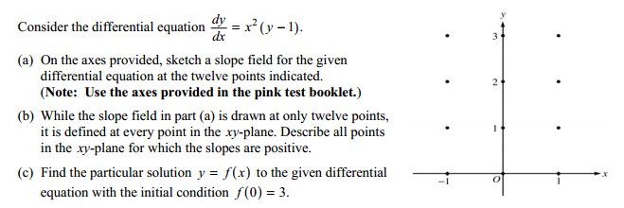

a.

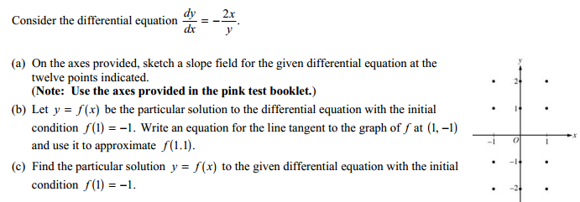

b.

OVER 🡪

Page 10

AP Calculus AB Name__________________________________

Lessons 7-1 & 7-4: *Slope Fields & Separable Differential Equations Addendum*

**Review – NO CALCULATOR**

*Using your properties of exponents and logarithms, remember:*

I.  implies that ${y=e}^{6}.$ II. $e^{x+y}$ can be rewritten as $e^{x}∙e^{y}$.

III.  can be rewritten as .

*Use the above properties to solve for the given variables:*

1. Solve for *y*:

2. Solve for *y*: $ln\left(y-1\right)=5$*x* 🡨 your answer will be an expression!

3. Solve for *y*: 🡨 rewrite your final answer using property (II) above!

4. Solve for *y*:

5. Solve for *y*: 🡨 no properties required, just algebra!

Page 11

**Separable Differential Equations**

A differential equation in the form  is called **separable**. We *separate the variables* by writing it in the form



The solution is found by antidifferentiating each side with respect to its thusly isolated variable.

Steps to solving a differential equation:

1. Separate (the variables)

2. Integrate (with respect to the correct variable)

3. Solve for *y* (dependent variable)

4. Use the initial condition to solve for C (if necessary/possible)

**Example**

Solve the following differential equation if and .

Check your solution by differentiating your answer and making sure your derivative agrees with 

OVER 🡪

Page 12

**Practice**

Use separation of variables to solve the given initial value problem.

1. .

2. .

OVER 🡪

Page 13

3. Solve the differential equation  where *k* is a constant and given the initial condition

. Be sure to *solve for y!!*

4. Go back to the AP Free Response problems from page 9 of this packet. Solve part (c), which requires

separation of variables, in problems (7a) and (7b). ***Note that (7b) is easier, try it first****!*

We will go go through the AP rubric for each problem.

7a. 7b.

OVER 🡪

Page 14

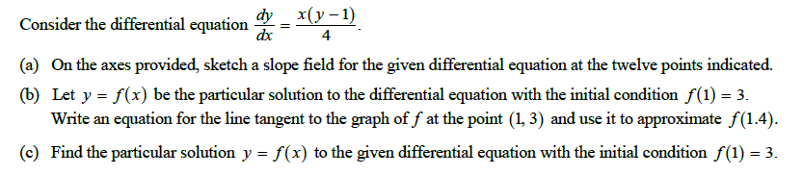5.

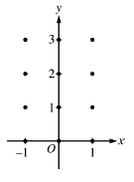 **NO CALCULATOR!!**

Page 15

**The Law of Exponential Change**

If *y* changes at a rate proportional to the amount present (that is, if ), and if , then



The constant *k* is the **growth constant** if or the **decay constant** if 

Note this is just the known formula  - so when you see a differential equation in the form , you are dealing with exponential growth or decay!!

What is the differential equation for a linear function??

Who has taken or is taking AP Chemistry? If you have, you remember that the **half-life** of a radioactive

element is the time required for half of the radioactive nuclei present in a sample to decay and that the half-life is a constant that depends only on the radioactive substance and not the number of active nuclei present in the sample. A formula you used will be developed below . . .

6. Find the half-life of a radioactive substance with decay equation and show that the half-life depends only on *k*. That is, set $y=\frac{1}{2}y_{0}$ and solve for *t*. The only variable on the right side of the equation should be *k*.

OVER 🡪

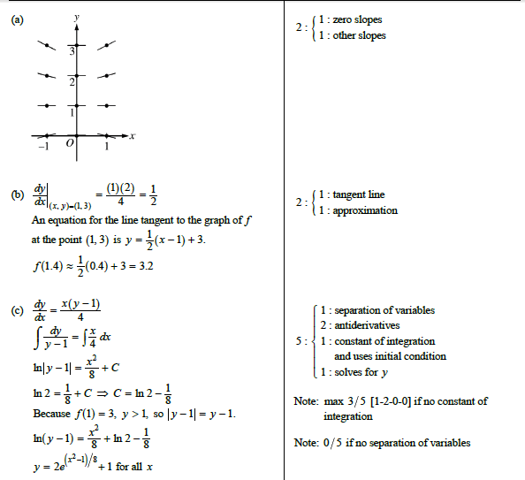 Page 16

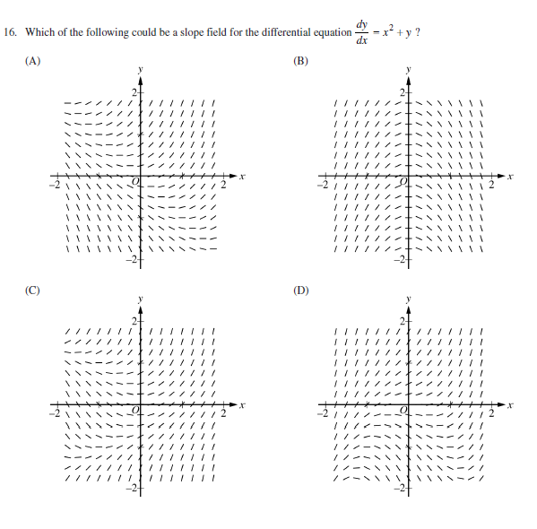**2016 AP exam – No calculator**