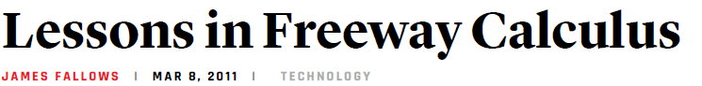
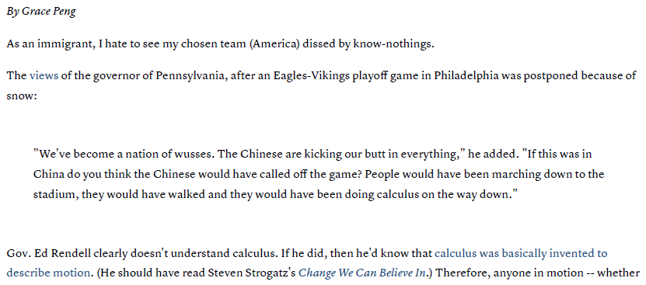
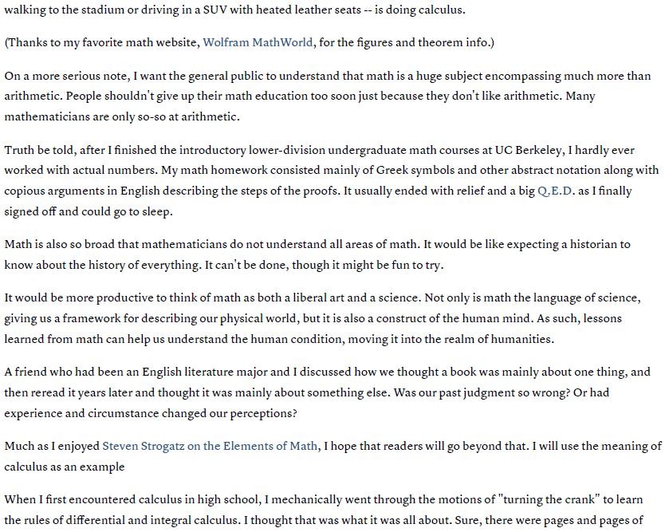

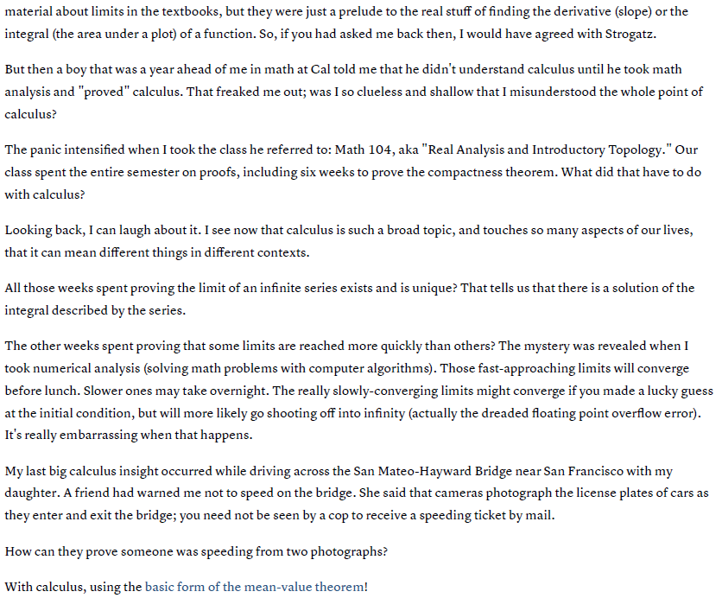
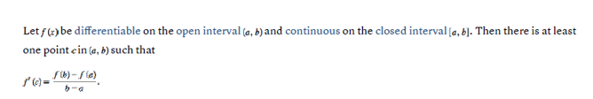
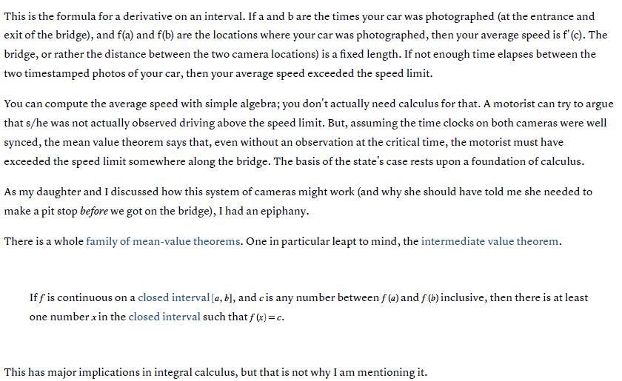
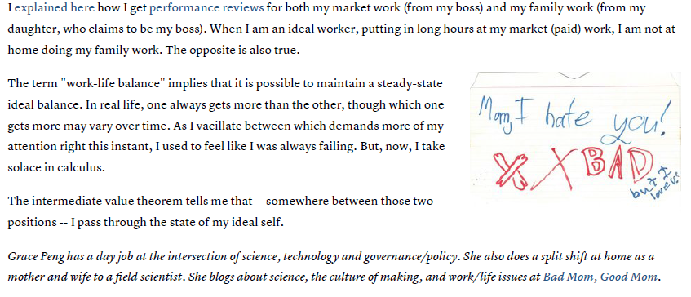

OVER
While driving to Pittsburgh, Ralph passed under an EZ Pass reader as he entered Pennsylvania at 9:00pm. When he exited the Pennsylvania turnpike, the EZ Pass reader recorded the time at 10:00pm. The two points at which the EZ Pass reader recorded his times are 80 miles apart. The speed limit on the PA turnpike is 65 miles per hour. Explain why Ralph could receive a speeding ticket in the mail (even though a police officer never witnessed him breaking the speed limit).

Suppose you left your home one morning and drove straight through to your cousin’s house 300 miles away, arriving 6 hours later. What does the Mean Value Theorem say about your speed along the way?

