MESOPOTAMIA

STANDARD: Early civilizations with unique governments, economics, social structures, religions, technology, and agricultural practices and products flourished as a result of favorable geographic characteristics.

I CAN:

- I can explain why civilizations developed near rivers. (THIS)
- I can describe how the environment helps shape human civilizations.
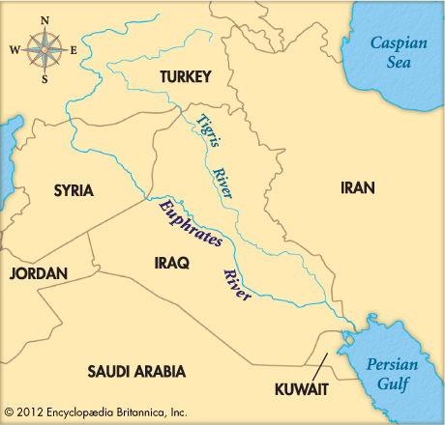
- I can explain the cultural practices of Mesopotamia and how they have influenced our society today. Cultural practices include:
- Class structure
- Religious Beliefs
- Government/laws
- Writing
- Economic Systems
- Agricultural contributions/ technology
- Scientific contributions/ technology

MESOPOTAMIA Vocabulary

Mesopotamia – the land _________________ the ________________.

Fertile Crescent- _______________________________ for Mesopotamia - the rich land between the Tigris and Euphrates Rivers
Fertile- soil rich in ________________________ and __________________________
Silt- Small particles of rich, _________________ ____________.
Irrigation- to bring ____________________ to _______________________________
City-state- a central city and its surrounding ______________.
Sumerians- the first inhabitants of _______________________.
Empire- nation or group of __________________________, ruled by one emperor
Emperor- ruler of an ________________________________.
Hammurabi- _______________________ with a code of ________ - early government
Class system- system in which a society is _____________________________ into several social groups, usually by ____________________________
Cuneiform- Sumerian’s first system of __________________________; wedge-shape symbols on _______________ _______________
Scribe- a professional ___________________.
Polytheism- belief in many ________________________________ .
Ziggurat – a _______________ shaped structure with a ________________ on the top for religious worship.
Contributions- something people __________________ or ___________________ and passed on (wheel, writing, religion)
Specialization - focusing on one specific _______________ or _____________.
Surplus – an amount that has been ____________ ___________ after a need has been met.

MESOPOTAMIA Vocabulary

Mesopotamia - the land BETWEEN the RIVERS.

Fertile Crescent - ANOTHER NAME for Mesopotamia - the rich land between the Tigris and Euphrates Rivers.
Fertile - soil rich in NUTRIENTS and RESOURCES.
Silt - Small particles of rich, FERTLE SOIL.
Irrigation - to bring WATER to DRY LAND.
City-state - a central city and its surrounding LAND.
Sumerians - the first inhabitants of MESOPOTAMIA or THE MIDDLE EAST.
Empire - nation or group of CITY-STATES, ruled by one emperor
Emperor - ruler of an EMIPRE.
Hammurabi – 1st EMPEROR with a code of LAWS - early government.
Class system - system in which a society is SEPARATED into several social groups.
Cuneiform - Sumerian’s first system of WRITING; wedge-shape symbols on CLAY TABLETS.
Scribe – a professional WRITER.
Polytheism - belief in many GODS.
Ziggurat - a PYRAMID shaped structure with a TEMPLE on the top for religious worship.
Contributions - something people DID or MADE and passed on (wheel, writing, religion)
Specialization - focusing on one specific JOB or SKILL.
Surplus - an amount that has been LEFT OVER after a need has been met.

