Math 4 Honors Name ______________________________
Millennium Force Activity Date due ___________________________

In 2014, Cedar Point’s attendance of 3,247,000 visitors was ranked 15th out of the top 20 amusement and theme parks in North America. (The Magic Kingdom at Disneyworld in Florida topped out at 19,332,000, which was #1 in the world!) As you may know, Cedar Point is known for its 16 roller coasters – in particular, the Millennium Force, which has been voted the number one steel roller coaster in the world in Amusement Today’s Golden Ticket awards every year since 2001. In 2015, it was ranked #1 yet again! In this activity, you are going to apply the skills you have learned thus far in Unit 2 to write a function that will best fit the first & second hills (the two highest ones) of the Millennium Force. On the day that this is due, you will submit your equation via the Navigator system, and you will be able to see how well it matches the actual picture.

Directions:

- Below is a photo of the Millennium Force superimposed on the rectangular coordinate plane. Throughout this activity, you will have to select control points. Only choose points whose x-coordinates are between -4 and 13. At times you will have to estimate both x- & y- values – that’s OK! Estimate to the 10^{ths} place when you have to do so.
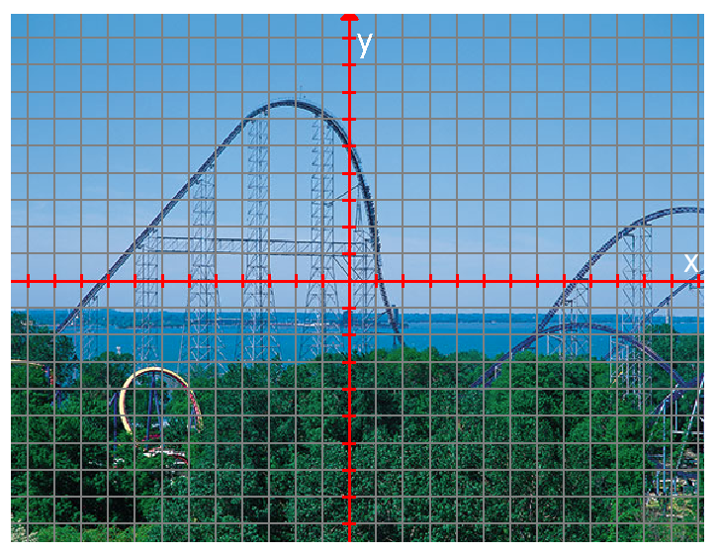

2. Choose the minimum number of control points needed to do a cubic regression. Mark and label them on the graph. Enter the control points into the lists in your calculator and do a cubic regression. Make a scatterplot of the data and see how well the curve fits the data.

List your test points here: ________________________________________________________

Record your equation below (round the coefficients to the nearest 10,000th): _____________________________________________________________________

Describe the end behavior of your equation:
(Use the correct limit notation.)

OVER
Page 2

3. Graph your equation (on your calculator) along with your control points. What do you think? Discuss strengths and weaknesses of your model.

4. Choose one more control point. Mark and label it on the graph as well. Use your control points to write a system of linear equations whose solution will provide coefficients in the expression for a quartic function whose graph passes through the control points.

5. Use matrices to solve your system from #4. Record your matrix equation below along with the solution matrix.

Page 3

6. Record your quartic polynomial equation below (round the coefficients to the nearest 10,000th):

_____________________________________________________________________

- Graph your equation in your calculator along with the test points. What do you think? Discuss strengths and weaknesses of your model.

- Describe the end behavior of your equation:
(Use the correct limit notation.)

7. Write a piecewise function that will connect the lift hill, from x = -12 to x = -4, to your quartic function.

Miscellaneous Info:
This activity is worth 40 points and must be complete by the beginning of the class on ______________. Late work will automatically cost you ½ of the points.

READ AND FOLLOW DIRECTIONS!!!!

OVER
Millennium Force Activity Rubric

CATEGORY | 10 | 8 |  | 6 |  | 4
Mathematical Concepts | Explanation shows complete understanding of the mathematical concepts used to solve the problem(s). | Explanation shows substantial understanding of the mathematical concepts used to solve the problem(s). |  | Explanation shows some understanding of the mathematical concepts needed to solve the problem(s). |  | Explanation shows very limited understanding of the underlying concepts needed to solve the problem(s) OR is not written.
Mathematical Terminology and Notation | Correct terminology and notation are always used, making it easy to understand what was done. | Correct terminology and notation are usually used, making it fairly easy to understand what was done. |  | Correct terminology and notation are used, but it is sometimes not easy to understand what was done. |  | There is little use, or a lot of inappropriate use, of terminology and notation.
Mathematical Errors | All of the steps and solutions have no mathematical errors. | Almost all of the steps and solutions have no mathematical errors. There may be one or two minor errors. |  | Most of the steps and solutions have no mathematical errors. There are more than two minor errors |  | Almost all steps have minor errors OR there are major mathematical errors.
Completion | All problems are completed. |  | All but one of the problems are completed. |  | All but two of the problems are completed. |  | Several of the problems are not completed.

Total Points: ________ / 40

