Opossum
Didelphis virginiana
Tracks and sign  Range: Eastern U.S. and west coast  Habitat: Forests, farmlands, woodlands, riparian areas, cities  Size: Up to 7 pounds  Young: One to 14 young per litter.  Tracks: Five toes on front foot, five toes on hind foot. Hind foot with opposable thumb.  Stride: 4-9 inches  Diet: Insects, fruit, small mammals, carrion, lizards, eggs | Narrative  Opossums are the only North American marsupials. A marsupial is an animal with a pouch, like a kangaroo.  Opossums have pointed noses and naked tails. They are the only North American mammals with prehensile (grasping) tails. The tail is used to assist in climbing. It also stores extra fat reserves, enabling the animal to survive lean times.  Opossums have opposable thumbs on their hind feet which help them to grip branches and climb. They are the only non-primates with opposable thumbs.  Opossums have the most teeth of any North American mammal.  Early morning is the best time to find their tracks. The trails in fine, dry soil tend to age quickly, especially along riparian areas. Opossums can be found in many environments, including cities and wilderness. They are opportunistic feeders and can utilize many of the scraps people throw away, thus they are often found raiding pet food dishes and garbage cans.  When baby opossums are born, each one weighs 1/200 of an ounce, is less than ½ inch long, and lacks fully developed hind limbs. Up to 14 young are born after only 12 to 13 days of gestation. Of these 14 young, only about nine survive. The entire litter could fit into a teaspoon. They climb into the mother's pouch, where they remain for about ten weeks. When they are big enough, they ride around on their mother's back.  When attacked, an opossum can play dead, or "play possum." When using this defensive strategy, they drool and emit an unpleasant smell which discourages predators. They also climb to escape danger. When threatened, they will hiss and show their 50 sharp teeth.  They nest in abandoned burrows or fallen trees. Opossums eat a variety of foods and are able to adapt to many different environments, from cities to wilderness.  Their tracks show five toes on the front foot and five toes on the rear, including the opposable thumb. The thumb lacks a claw.
 | Copyright © Kim A. Cabrera 2004

Opossum Tracks and Sign
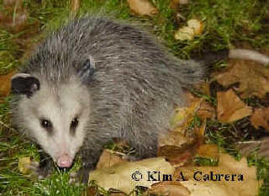 | 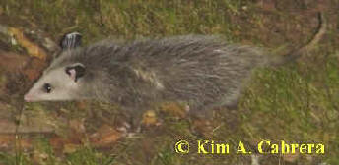
Opossums
Front track  1.5 in. L x 2 in. W | 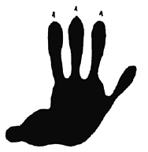  Hind track  2.5 in. L x 2.5 in. W  Opposable thumb
Opossum tracks. Opossums have an opposable thumb on the hind foot that helps them with climbing.
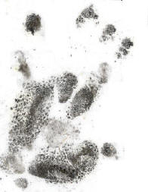  Hind track with thumb | 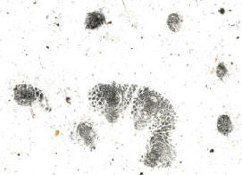  Front track
Opossum tracks from baited soot plates. These are the actual "fingerprints" made by the opossum itself as it walked through the soot, then onto clean paper.
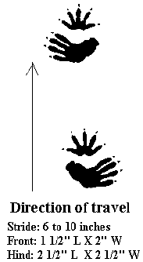 | 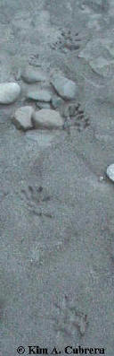
Opossum trail diagram | Opossum trail in sand
 | 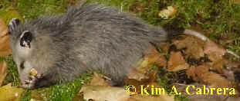
Another hind track from baited soot plate. Notice the whorl pattern in the palm. It looks much like the whorls in human palms and fingerprints. | Opossum eating
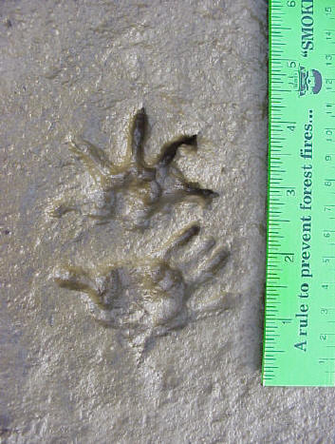 | 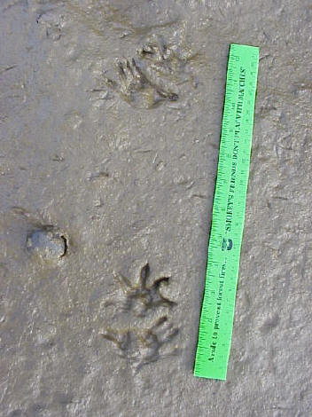
Pair of opossum tracks | Opossum trail in mud
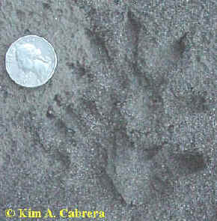 | 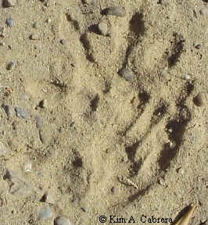
Opossum tracks in different substrate types.
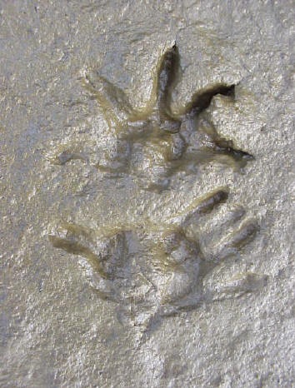 | 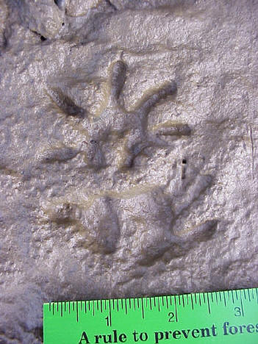
Tracks in deep mud where there is some distortion | Tracks in more shallow mud that held details
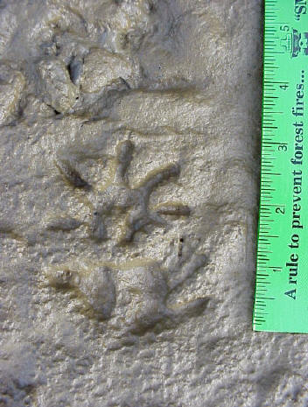 | 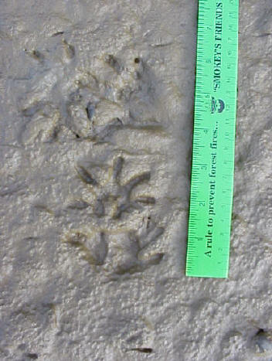
Nice pair of opossum tracks | The older set of tracks above the opossum tracks are those of a raccoon
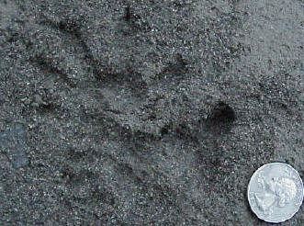 | 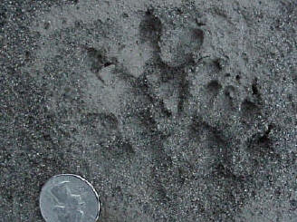
Sets of opossum tracks in coarse sand
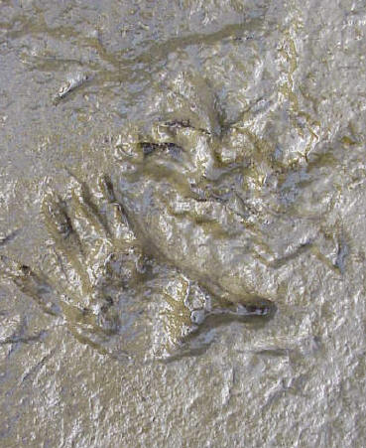 | 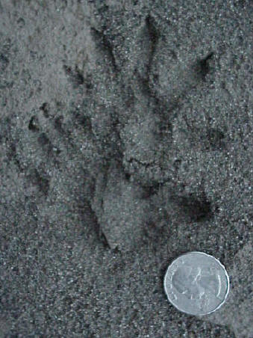
Very wet mud nearly obliterated the details of the front track. It also distorted the thumb on the hind track | Firm, coarse sand held the details better.
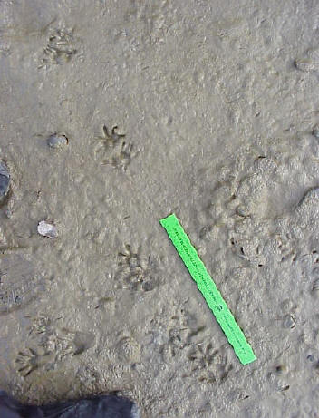 | 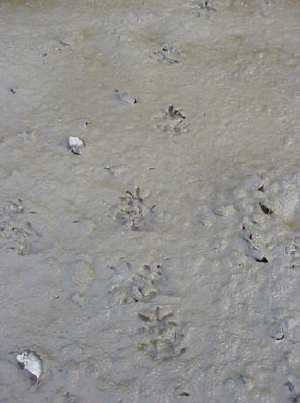
Opossum trails in mud. On both photos, raccoon trails cross those of the opossum
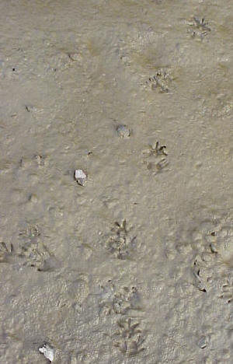 | 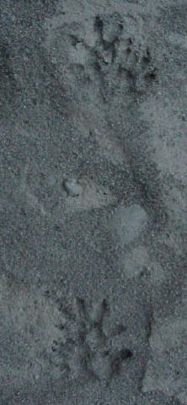
Opossum and raccoon trails | Opossum trail
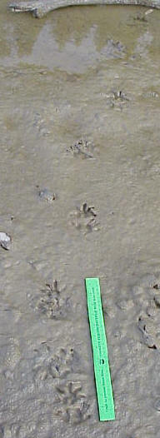 | 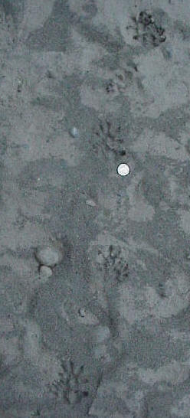
This opossum went into the water and its tracks are still visible in the water | Opossum trail
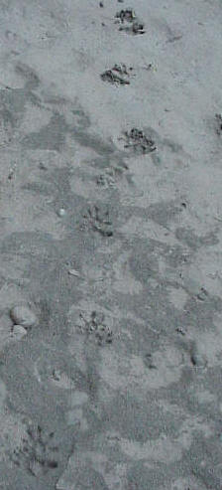 | 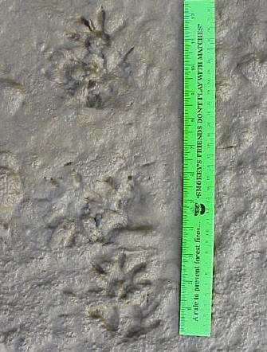
Opossum trails
On the left is the trail pattern of an opossum in river sand. The tracks nearly overlap each other in the alternating pattern that is typical of a walking opossum. The opposable thumb is very prominent in some of these tracks.
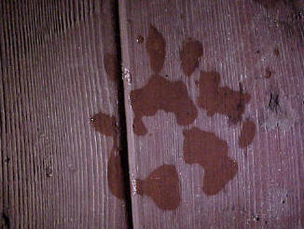 | 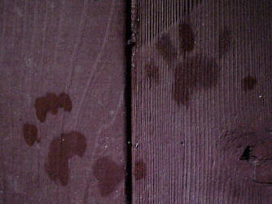
Wet opossum tracks on wood. Notice the nice outline of the thumb in the photo on the right.
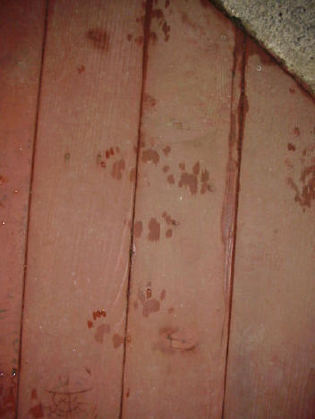
Wet opossum trail on wood
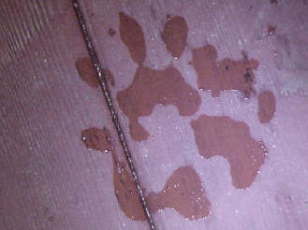 | 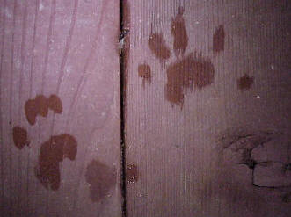
More wet opossum tracks
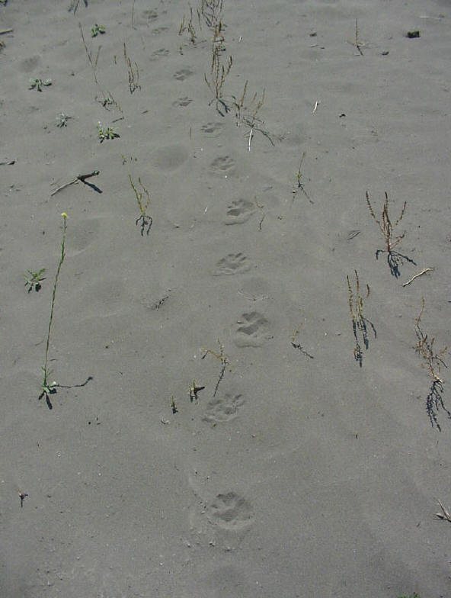
Opossum trail in dry sand. Knowing the trail pattern and stride helps identify tracks such as this that can be unclear due to the substrate.
Copyright © Kim A. Cabrera 2004

