1. Go to parametric mode on your calculator

a. Using parameter and window indicated below sketch the graph ( **accurately** )

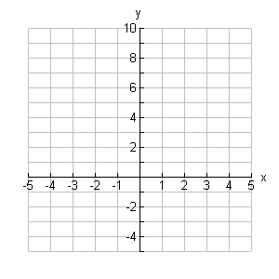





b. Is the graph a function ?

c. Express the parametric equation as a

function of *y*  in terms of *x* .

If *x*  and *y*  are given as functions



over an interval of *t –*values , then the points  is a parametric curve.

d.  called ______________ _______________.

e.  called ______________ ________________.

2. Let  and 

a. Set calculator in radian mode and let 

b. Hit zoom Zsquare and sketch result below.

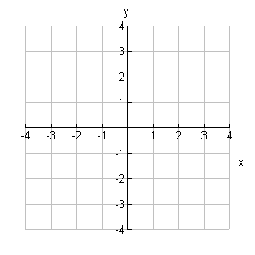

c. Graph the above equations using your calculator on the following intervals for *t*  and watch.

.

d. Write the parametric equations in Cartesian form by starting with



3. a. Describe 

b. Write the answer in standard form.

4. Consider 

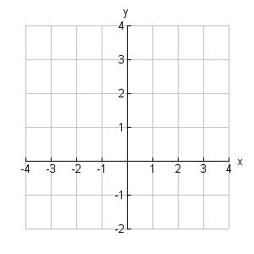 a. Graph this on the window 

b. Indicate the direction it is traced by your hand held computer by an arrow on the graph.

5. Go to page 33 in the book and do Exploration 3.

**Prac: 1.4 [ QR( 4 – 6 ) , 1 – 4 , 9 , 12 , 13 , 19 , 21, 29 – 32 ]**