Traveling Stanzas Poetry and Design Project at Kent State University
Traveling Stanzas is a unique collaborative project between the School of Visual Communication Design's Glyphix design studio and the KSU Wick Poetry Center. It combines the creative talents of VCD students with area student writers (grades 3–12) senior citizens, and veterans to promote poetry and design within the community. Poetry is selected from the Wick Poetry Center's outreach program and illustrated by Glyphix student staff members.
During the 2009 spring semester, eight posters were created for display on area buses and businesses. The project was well-received in the community and supported by Akron Metro Transit Authority, the PARTA bus system, City Bank Antiques, and Family & Community Services in Portage County. The project has received some local publicity: the Record Courier ran an article during the summer and the Daily Kent Stater featured a full-page article about the project this fall.
This academic year brings plans for the second edition of Traveling Stanzas with an expanded format. With writing by students, seniors and published authors Dr. Edward Tick and Naomi Shihab Nye on the theme of “peace,” the designs will be produced on posters and greeting cards. This group of “Peace Stanzas” will again be displayed in area buses as well as in businesses and public libraries in northeast Ohio. Plans to further evolve the project include animated e-cards and a multimedia video presentation. The e-cards, which will be distributed from a web site at no charge, can easily be sent anywhere in the world and are part of the ongoing mission of the Traveling Stanzas project to promote literacy, appreciation for design and a positive message to the local community and beyond. The posters and greeting cards will be sold to help sustain the initiative in the future. The College of CCI's new integrated marketing agency, the Tannery (article), will be employed to expand the marketing plan for the sales and distribution of Peace Stanzas products. This will offer the opportunity for further collaboration between KSU students and expand the University's connection to the community.
With this year’s theme of “peace,” Traveling Stanzas seeks to reach a world-wide audience. To increase awareness, displays are planned during Kent State University’s commemorative events of the 40th anniversary of May 4, 1970. In the fall of 2010, the Peace Stanzas project will be displayed at Case Western Reserve University for an International Conference on Peace and War sponsored by the Inamori International Center for Ethics and Excellence.
Assignment #5: Traveling Stanzas
- Visit the website: http://vcd.kent.edu/travelingstanzas/index.html
- Read through the poems and get a feel for how these have been created.
- Our theme this year is Peace
Writing a Poem:

How to Write a Poem
Writing a poem is all about observing the world within or around you. A poem can be about anything, from love to the rusty gate at the old farm. Writing poetry can help you become more eloquent and improve your linguistic style. However, where to start. Although poetry writing is definitely a skill that improves with practice (just like any other type of writing), the information below will get you on the right track.

Part 1 of 3: Getting Creative
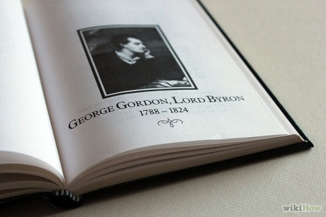
1 Find a spark. A poem might start as a snippet of verse, maybe just a line or two that seems to come out of nowhere, and the remainder of the poem need only be written around it. Here are a few ways to generate sparks:
  - Play "Grand Theft Poetry." Gather a variety of books of poetry by different authors, or print 10 random poems off from the Internet. Then randomly pick a line out of each poem, trying to focus only on the first line you see instead of picking the "best" one. Write all these different lines down on a separate piece of paper, and try to arrange them into a coherent poem. The juxtaposition of two entirely different lines of poetry might give you an idea for your own poem.
  - Write down all the words and phrases that come to mind when you think of that idea. Allow yourself to put all your ideas into words.
  - It may sound difficult, but do not be afraid to voice your exact feelings. Emotions are what make poems, and if you lie about your emotions it can be easily sensed in the poem. Write them down as quickly as possible, and when you're done, go through the list and look for connections or certain items that get your creative juices flowing.
  - Try to fit into a particular scene you want to write about. For example, if you want to write about nature, try to visit a park or a small forest nearby. The natural scenery may inspire a few lines, even if they're not perfect.

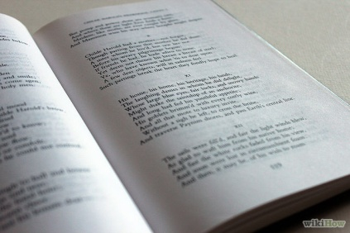
2 Read and listen to poetry. Get inspired by seeking out the work of poets you admire. Explore a wide range of works, from poems that are widely regarded as classics to popular song lyrics. As you interact with more poetry, you'll find your aesthetic becoming more shaped and refined.
  - To train your ear and meet like-minded people, attend poetry readings (check your local college or bookstore's calendar for these, or look for events you can stream online).
  - Find some of your favorite song lyrics and read them like poetry. You might be surprised at how it reads on the page, instead of being spoken or sung aloud.
3 Think about what you want to achieve with your poem. Perhaps you want to write a poem to express your love for your boyfriend or girlfriend; perhaps you want to commemorate a tragic event; or perhaps you just want to get an "A" in your poetry or English class. Think about why you are writing your poem and who your intended audience is, and then proceed in your writing accordingly.
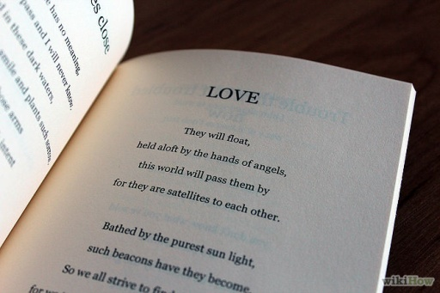
4 Decide which poetry style suits your subject. There are a ton of different poetic styles. ^{[1]}. As a poet, you have a wide variety of set forms to choose from: limericks, sonnets, villanelles, sestinas, haiku ... the list goes on and on.
  - You may also choose to abandon form altogether and write your poem in free verse. While the choice may not always be as obvious as the example above, the best form for the poem will usually manifest itself during the writing process.

Part 2 of 3: Letting the Creativity Flow
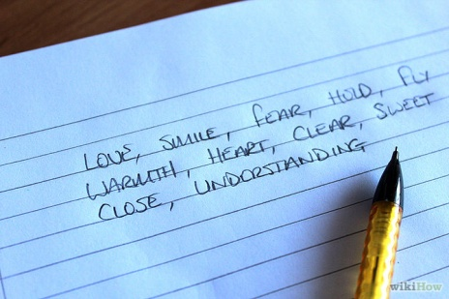
1 Choose the right words. It's been said that if a novel is "words in the best order," then a poem is "the best words in the best order."
  - Think of the words you use as building blocks of different sizes and shapes. Some words will fit together perfectly, and some won't. You want to keep working at your poem until you have built a strong structure of words.
  - Use only those words that are necessary, and those that enhance the meaning of the poem. Choose your words carefully. The differences between similar sounding words or synonyms can lead to interesting word play.
  - A computer spreadsheet such as OpenOffice.org Calc, is very efficient for rearranging words and checking rhythm through columns' alignment. Put one syllable in each cell. You can transfer the text to a word processor for fancier printing when you're done.
2 Use concrete imagery and vivid descriptions. Most poetry appeals to the senses (yes, plural) in some way, in order to help the reader become more fully immersed in the text. Here are some things to consider when you're constructing descriptions.
  - Love, hate, happiness: these are all abstract concepts. Many (perhaps all) poems are, deep down, about emotions and other abstractions. Nevertheless, it's hard to build a strong poem using only abstractions — it's just not interesting. The key, then, is to replace or enhance abstractions with concrete images, things that you can appreciate with your senses: a rose, a shark, or a crackling fire, for example. The concept of the objective correlative may be useful. An objective correlative is an object, several objects, or a series of events (all concrete things) that evoke the emotion or idea of the poem.
  - Really powerful poetry not only uses concrete images; it also describes them vividly. Show your readers and listeners what you're talking about — help them to experience the imagery of the poem. Put in some "sensory" handles. These are words that describe the things that you hear, see, taste, touch, and smell, so that the reader can identify with their own experience.
  - Give some examples rather than purely mental/intellectual descriptions. As a silly example, consider "He made a loud sound", versus "He made a loud sound like a hippo eating 100 stale pecan pies with metal teeth."
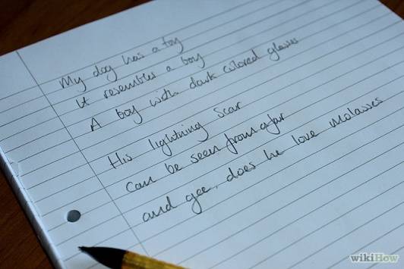
3 Use poetic devices to enhance your poem's beauty and meaning. The most well known poetic device is rhyme. Rhyme can add suspense to your lines, enhance your meaning, or make the poem more cohesive. It can also make it prettier. Don't overuse rhyme. It's a crime.
  - If you are opting for the rhyming route, there are three basic types to choose from: the couplet, tercet, and ballad stanza.
    - The couplet is two phrases that each rhyme at their end.
This will be a couplet when the final word is penned.
      - Did you catch that meter?!
    - The tercet has three lines. 1 and 2 rhyme, as do 4 and 5, 3 and 6. As in,
"My dog has a toy,
it resembles a boy.
A boy with a dark colored glasses.
His lightning scar
can be seen from afar
and gee, does he love molasses."
    - A ballad stanza's second and fourth lines rhyme. For example:
I just met you.
And this is crazy.
So here's my number.
Call me, maybe?^{[2]}
  - Other poetic devices include meter, metaphor, assonance, alliteration, and repetition. If you don't know what these are, you may want to look in a poetry book or search the Internet. Poetic devices can establish a poem, or, if they bring too much attention to themselves, can ruin it.
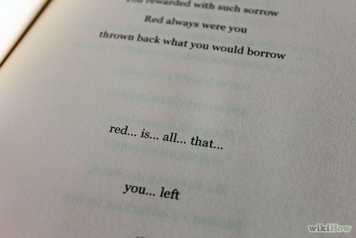
4 Add a "turn" to the end of the poem. Save your most powerful message or insight for the end of your poem. The last line is to a poem what a punch line is to a joke — something that evokes an emotional response. Give the reader something to think about, something to dwell on after reading your poem.
  - Resist the urge to explain it; let the reader become engaged with the poem in developing an understanding of your experience or message.

Part 3 of 3: Bringing It to Life
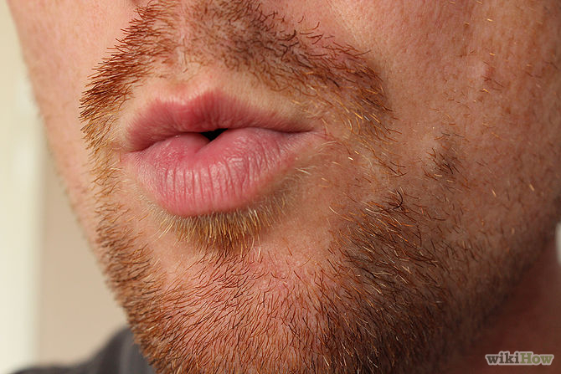
1 Listen to your poem. While many people today have been exposed to poetry only in written form, poetry was predominantly an oral art for thousands of years, and the sound of a poem is still important. As you write and edit your poem, read it aloud and listen to how it sounds.
  - A poem's internal structure commonly focuses on rhythm, rhyme, or both. Consider classic styles like sonnets and Greek epics for inspiration.
  - A lot of spoken English is based on iambic pentameter, in which speech follows an alternating pattern of stressed and unstressed syllables for a total of 10 syllables. A lot of poetry written in iambic pentameter, such as that of Shakespeare, begins with an unstressed, one-syllable word such as "an" or "the" to start the alternating pattern.
  - This is where poems can become songs. It is easier to find a tune for regular meter, so maybe you want to cut words out or put some in to get the same number of syllables in each line. Memorize it. If you believe it, then maybe someone else will learn it and love it before it is a song.
2 Edit your poem. When the basic poem is written, set it aside for awhile and then read the poem out loud to yourself. Go through it and balance the choice of words with the rhythm. Take out unnecessary words and replace imagery that isn't working.
  - Some people edit a poem all at once, while others come back to it again and again over time.
  - Don't be afraid to rewrite if some part of the poem is not working. Some poems have lines that simply don't convey an element well, and can be replaced.

