Math 4 Honors Name _________________________________ Polar Graphing Activity Date ______________________________

For years, you have been plotting function equations on a Cartesian coordinate grid. In this activity, you will learn about the polar coordinate system and graphing polar equations. The polar coordinate system consists of a fixed point called the *pole* (similar to the origin in a Cartesian coordinate system) and a fixed ray called the *polar axis*. A polar coordinate graph is usually made on a grid that shows concentric circles that have the pole at the center and rays that begin at the pole and are associated with different amounts of turn. Each point in the polar coordinate system is identified by its distance from the pole, represented by *r*, and an angle of turn from the polar axis, represented by *θ*. The polar coordinates of a point are given in the form [*r*, *θ*]. The coordinate *r* is called the *radial coordinate* and the coordinate *θ* is called the *angular coordinate*. When *θ* is positive, the angle is measured in the counterclockwise direction and when *θ* is negative, the angle is measured in the clockwise direction.

**I.** On the polar grid below, there are four points that have already been graphed.



**1.** The point *A* can be represented by the coordinates or the coordinates . Explain why

these two coordinate pairs represent the same point and give another coordinate pair for this point.



**2.** Point *B* can be represented by the coordinates . Represent point *B* using a positive value for *θ*.

**3.** On a polar graph, a point’s distance from the pole will always be a positive number. Because of this, plotting points with a negative *r* value is not completely straightforward. The point *C* can be represented by the coordinates  as well as . Give **two** different sets of polar coordinates for point D. Make sure one set has a negative radial value.

OVER 🡪

**4.** Plot the following points on the polar coordinate grid on the front of this packet. Page 2



**5.** Explain why every point on a polar coordinate system can be identified with an infinite number of coordinates.

**II.** In the next part of this activity, you will explore graphs of polar equations. A polar equation is a function rule in the form *r* = *f*(*θ*), where *θ* can be measured in radians or degrees.

What is the *independent* variable? What is the *dependent* variable?

***Switch your calculator into degree mode.***

To graph in the polar coordinate system using your calculator, use these settings:

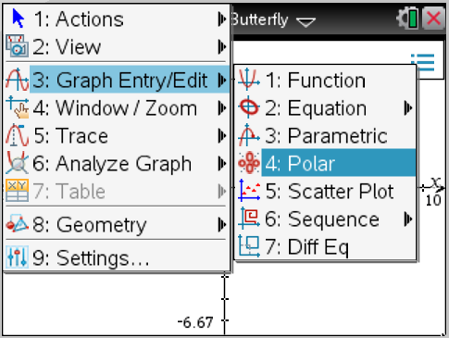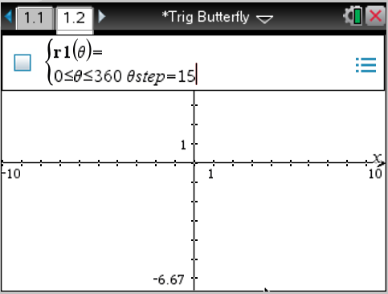

**Use your calculator to explore the following:**

**1.** Consider equations of the form:  Experiment with different values for *a*.

a. What type of figure is created by these equations?

1. How do the figures differ when different trig functions are used (sin vs. cos)?
2. What is significant about the *a*-value?

**2.** Consider equations of the form: . ***Limaçons***

Graph together:  Graph together:  Graph together: 

1. How do the figures differ when different trig functions are used (sin vs. cos)?
2. What is it about the “*a*” & “*b*” values that determines the shape of the graph? (Compare the numbers to each other.)

**3.** Consider equations of the form:  ***Rose Curves*** Page 3

Graph these functions one at a time: 

1. How do the figures differ when different trig functions are used (sin vs. cos)?
2. What determines the length of a petal?
3. What determines the number of petals?
4. 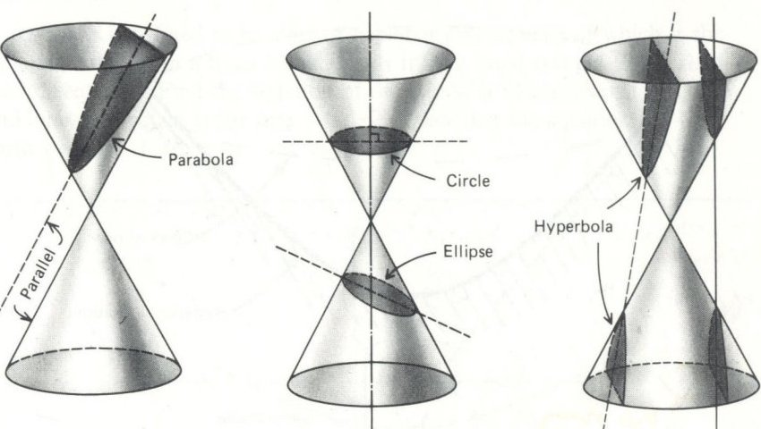In mathematics, a **conic section** (or just **conic**) is a curve obtained by intersecting a cone (more precisely, a right circular conical surface) with a plane. The three conic sections that are created when a double cone is intersected with a plane are:
5. Parabola
6. Circle and ellipse
7. Hyperbola

1. b. c.

Source: <http://project1.caryacademy.org/Earthquakes/2005/HA218/images/conic.jpg>

{x^2\over a^2}-{y^2\over b^2}=1,\; {x^2\over b^2}-{y^2\over a^2}=-1 {x^2\over a^2}+{y^2\over b^2}=1 y^2=4ax ,\; x^2=4ay x^2+y^2=a^2 \, Each of the above curves can be represented in rectangular form as follows:

Circle: Ellipse: Parabola: Hyperbola:

How might you graph these in your calculator? Think polar! Try this:

Reset the window of your calculator to that of the beginning of part II. Graph each of the following, one at a time.



(Ignore any lines; they’re asymptotes)

a. What is the name of the shape for each figure produced?

b. How are these equations related to those of the limaçons?

OVER 🡪

Page 4

1. Graph each equation below.

a.  This is called a ***Bifolium****.* Why do you think?

b.  Tosee this graph better: Change θmax to 3600; then Zoom - Fit.

**FYI -** This called a ***Spiral of Archimedes.***

c.  Use the same settings as those from part b.

This is called the ***Conchoid of Nichodemes.*** What happens if this is in terms of the secant?

**Polar Graphing Practice**

1. What shape is the following graph?  Identify the center and radius. Then convert the equation into rectangular form.

Recall standard form for the equation of a circle: (*x – h*)2 + (*y – k*)2 = *r*2

2. Sketch accurate graphs of the following. **Use a table to help you plot your points.**

*Use a table-step of 15°.*

a.  b.   c.  (Graph 2 revolutions.)

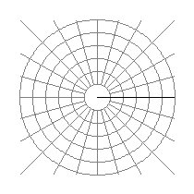

**Form Meets Function: Polar Graphing *Individual* Project**

**DATE DUE:**

You will create a unique design using the graph of a **single polar equation**. Not only will your choice of equation determine your individual design, but also your choice of window settings.

**\*\*\*HAVE YOUR CALCULATOR IN DEGREE MODE\*\*\***

**Directions:**

1. Create a design depicting a recognizable object (as opposed to an abstract design).

**THE SCALE MUST BE THE SAME FOR BOTH AXES.**

2. Make up a *creative* title for your design.

3. Use a single polar equation as the basis for your design. You may choose to embellish the background with other shapes, but the *polar graph must be the focal point* of the design.

4. Accurately plot points for your equation on the polar graph paper provided (plot points at most every 15 degrees). Use a table to help you plot your points. In your table settings, make sure the **Table Step** matches the value of your ***θ*step** so that your plotted points correspond to the graph displayed on your calculator.

5. Fill the *polar grid with your equation* as much as possible, and accent your design with color. Include a scale for the polar axis on your paper. **THE SCALE MUST BE THE SAME FOR BOTH AXES.**

6. Your design should exhibit originality, complexity, and creativity. A simple rose curve, for example, is not a complex design. A flower is not highly creative or original. Experiment!

7. Record the equation and your calculator window settings used to produce the graph – *exactly how they appear in your calculator – parentheses & all!*

**Example:**

*r* = 1.2*sin(*θ*)*cos(5*θ*)+2*cos(*θ*)

*Trigonometric Butterfly*

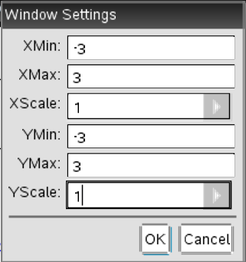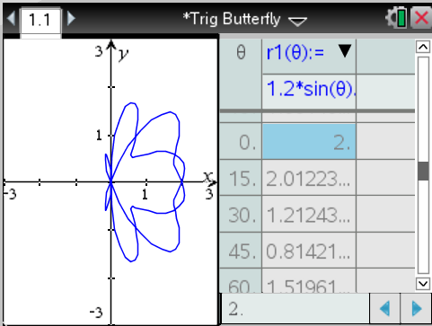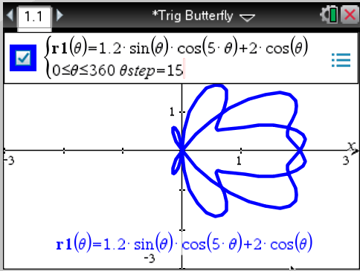

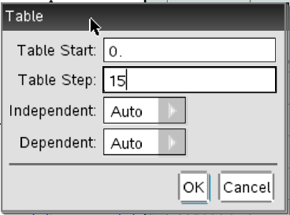

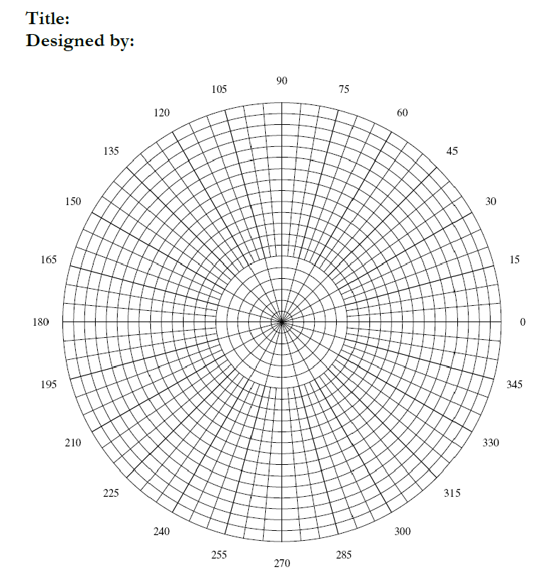**ROUGH DRAFT!!!!!!**

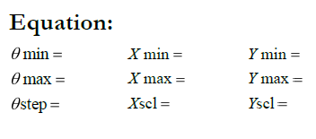

**FINAL DRAFT ON NEXT PAGE**





**Rubric:**

This project is worth a total of 40 points.

|  |  |  |  |
| --- | --- | --- | --- |
| Criteria | Excellent | Satisfactory | Unsatisfactory |
| Design depicts a recognizable object. Title is creative and is appropriate for the design. | 5 | 3 | 1 |
| Single polar equation used as the basis for the design. Design fills most of the graph and is accented through coloring. | 10 | 7 | 4 |
| Equation is correctly graphed and points are accurately plotted using an appropriate scale. Window settings are accurate. | 15 | 10 | 5 |
| Design exhibits originality, complexity, and creativity. | 10 | 7 | 4 |

**TOTAL: /40**