Name__________________________________________________________Date_____________ Mailbox #___
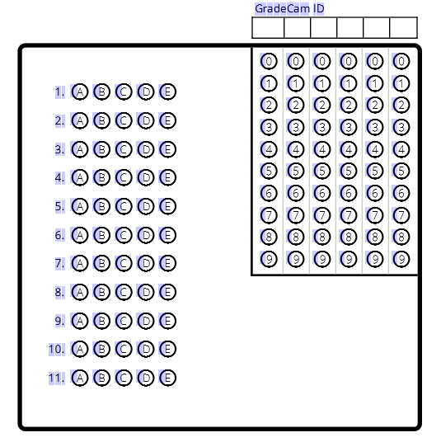
- A group of organisms who breed together &
live in the same geographical region are a(n)
  - Ecosystem
  - Individual
  - Population
  - Biosphere

- Members of two different populations can
mate successfully if they do meet, producing healthy,
fertile offspring, so they belong to the same:

  - Ecosystem
  - Biosphere
  - Species
  - Community

- A complete description of abiotic & biotic requirements
for long-term survival of a population is called its _____?

  - Ecosystem
  - Habitat
  - Resource
  - Ecology

- All the biotic components of an ecosystem are collectively referred to as a _____:

  - Ecosystem
  - Population
  - Habitat
  - Community

- Nonliving components of an ecosystem, like average temperature or rainfall, are called ____.
  - Resources
  - Biotic factors
  - Abiotic factors
  - Organisms

- Any material, biotic or abiotic interaction, or physical condition required by an organism for survival is referred to as a
  - Resource
  - Biotic factor
  - Abiotic factor
  - Ecosystem

- Which is the correct order of organization of an ecosystem, from smallest and least inclusive to largest and most inclusive?

  - Biosphere, individual, community, population, ecosystem
  - Individual, population, community, ecosystem, biosphere
  - Community, biosphere, ecosystem, individual, population
  - Ecosystem, biosphere, individual, community, population

- _________ is defined as the interaction of organisms with each other and with the nonliving parts of their environment:

  - Ecology
  - A habitat
  - A biosphere
  - A population

- The _________________ is actually a huge, global ecosystem because matter and energy are exchanged in biogeochemical cycles that involve the oceans and the atmosphere and because many populations are migratory.
  - Habitat b. Abiotic factor c. Species d. Biosphere e. Resource

- An organism ________________ when it enters INTO a new ecosystem
  - Immigrates
  - Emigrates
  - Hibernates
  - Motivates

- An organism ________________ when it MOVES OUT of an ecosystem.
  - Immigrates
  - Emigrates
  - Hibernates
  - Motivates

