AP Calculus AB Name__________________________________

Prerequisite Skills Reference Sheet Date _______________________________

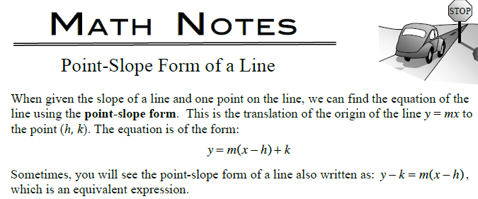

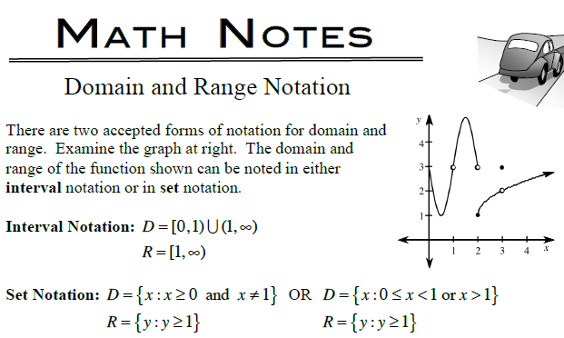

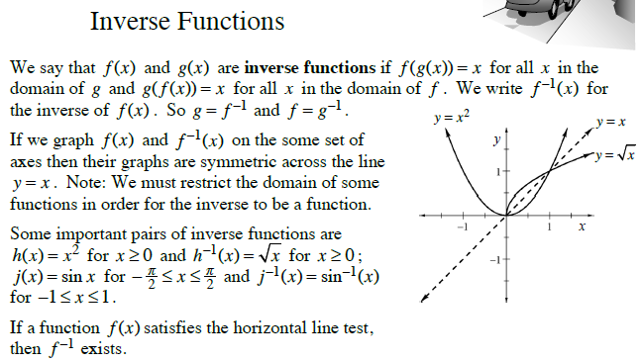

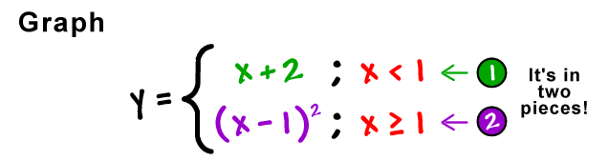**Piecewise Functions**

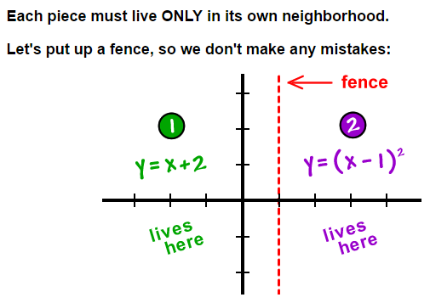

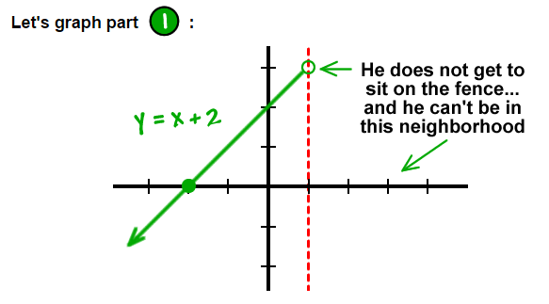

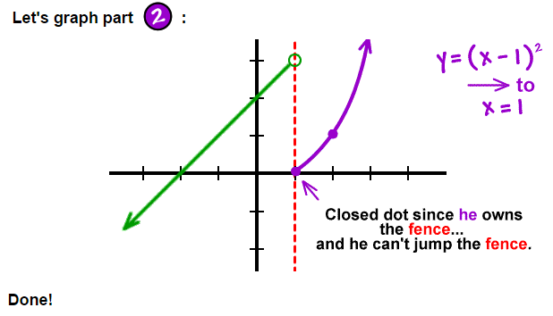

(*Remove the “fence” when you are finished!*)

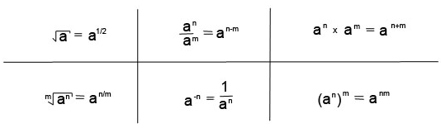**Exponent Rules**

**Natural Log Rules**

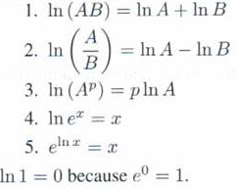

**Reciprocal Trig Functions**

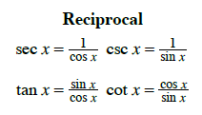

**Curve Analysis**

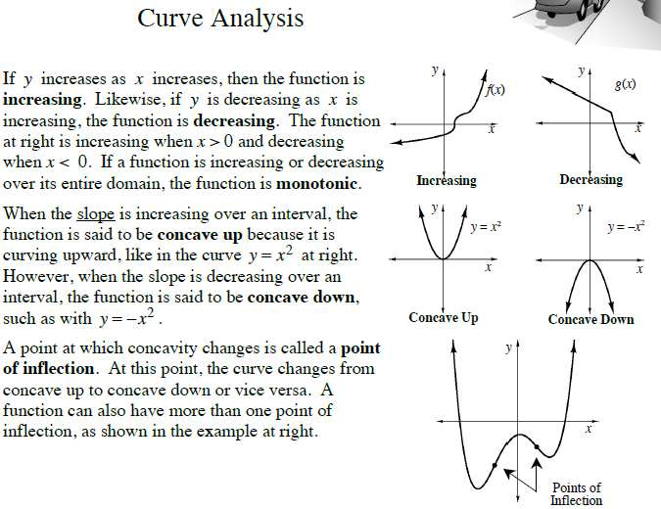

Composition of Functions

