Raccoon
Procyon lotor
Tracks and sign  Range: Most of U.S.  Habitat: Edges of streams and lakes, forested areas, near human habitations  Size: 16-26 inches long  Young: 3-6 born in April or May  Tracks: Five toes on front and hind feet, look like baby tracks  Scat: tubular and blunt on the ends  Stride: 10-18 inches  Diet: Frogs, fish, amphibians, shellfish, insects, birds, eggs, mice, carrion, berries, nuts, vegetation, salamanders, insects, berries, corn, cat food, and human garbage. | Narrative  Raccoons are familiar animals with masked faces and ringed tails. They have five toes on both the front and hind feet. Their long, dexterous fingers enable them to open latches, untie knots, turn doorknobs, and open jars. Their prints look like tiny human baby handprints and footprints.  They are primarily nocturnal and thrive in many cities as well as wilderness areas. In fact, the densest population of raccoons in New York is in New York City. They are very intelligent and adaptable animals.  They are omnivorous and eat a variety of foods, including frogs, fish, amphibians, shellfish, insects, birds, eggs, mice, carrion, berries, nuts, vegetation, salamanders, insects, berries, corn, cat food, and human garbage.  Their tracks are commonly found near water. Where you find water, you find mud, which is an excellent medium for studying tracks. The hind feet in the picture on the left sunk deeper into the mud due to the heavier hind end of the raccoon’s body. It is widely believed that raccoons always "wash" their food. This is not true. They exhibit a behavior called "dabbling" in which they dunk their food in water. This helps enhance their sense of touch and helps them find food underwater by feeling with their sensitive fingers. It also enables them to sort out items that are not edible.  During cold weather, raccoons will sleep for several days, but do not hibernate.  Raccoon scat is tubular and blunt on the ends. Scat may contain parasites that can get into human lungs, so handling it is not advisable.  Three to six young are born in a hollow tree den in April or May. Their eyes open at three weeks. They remain in the den for two months. Young stay with the mother until the following spring.  Raccoons are well known for their curiosity and mischievousness.  Droppings are often left in "latrines" which the raccoon will repeatedly visit. This may be a way of staking out a territory.

Raccoon Tracks and Sign
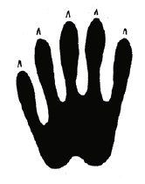  2.5 in. L x 2.5 in. W | 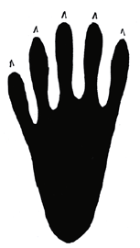  3.5 in. L x 2.5 in. W
Raccoon front track  Appearance of raccoon tracks is similar that of human handprints. Those long finger enable raccoons to get into many things. | Raccoon hind track  Hind tracks look similar to human footprints, but with longer toes. Claws do not always appear in the tracks. The long heel does not always leave an imprint.
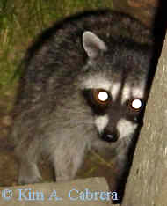 | 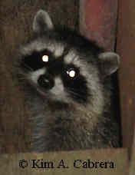
Adult raccoon  Raccoons will often visit homes in search of pet food or other scraps. | Young raccoon  This young raccoon was with the adult to the left. It was more shy and hid under the porch.
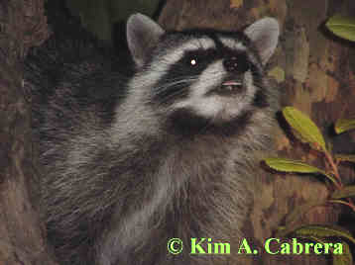 | 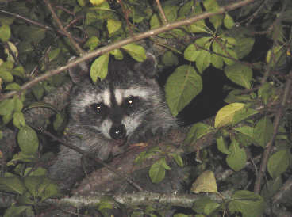
Raccoon sniffing  This raccoon was in a sycamore tree, where it had retreated for safety. | Raccoon in a plum tree  This raccoon visited a campsite that had a plum tree with ripe fruit in it. Its nightly visits were uneventful as it had plenty of food in the tree and didn't need to bother the campers for food.
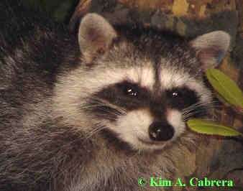 | 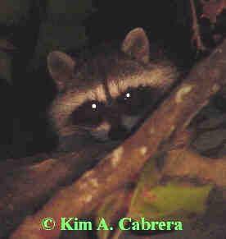
Raccoon face  The masked face is an easy way to identify the raccoon. | Raccoon in a tree  Raccoons are excellent climbers. They sometimes forage for fruit in trees, or use them as handy places to escape from predators. They will also den inside hollow trees.
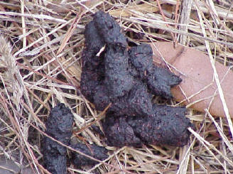 | 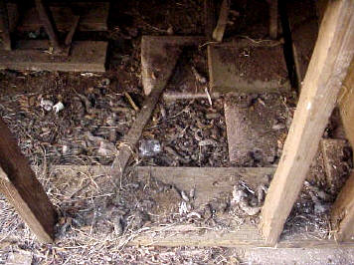
Raccoon scat - feeding on berries  Raccoons scat is usually blunt on the ends and somewhat cylindrical in shape. | Raccoon latrine under a house  Scat accumulations like this are common where raccoons have nearby food sources. These latrines should be cleaned up only by professional wildlife damage people. Raccoon scat can contain the eggs of the raccoon roundworm, which can infect people, and can be deadly.
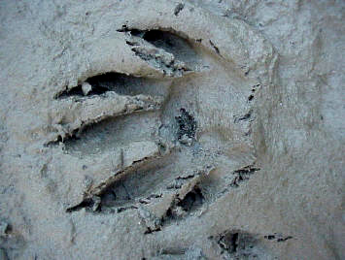 | 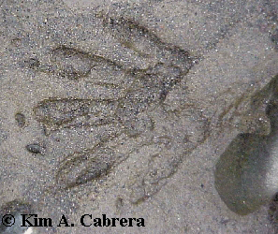
Raccoon track  Nice detailed track in mud. All claws and toes show up. | Raccoon front track  Another track in mud, this time few of the claws are evident.
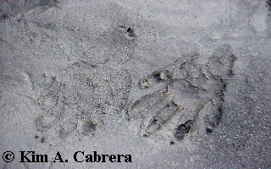 | 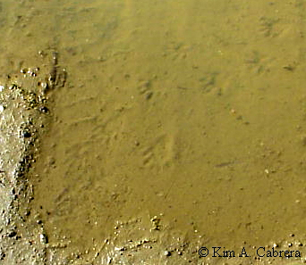
Pair of raccoon tracks  Hind track is on the left. Front track on the right has a longer heel print than normal. This is probably due to the terrain and the speed the animal was traveling. | Raccoon tracks in a puddle  Since raccoons favor environments near water, it is sometimes possible to find their tracks underwater. The raccoon walked from upper right to lower left through this puddle.
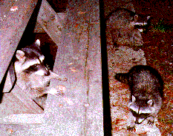 | 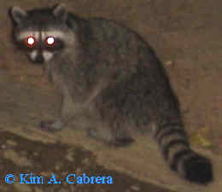
Raccoons raiding a picnic table  This is a common sight in campgrounds. Raccoons and other animals come around after people have settled in for the night. Any food left out may not be there in the morning! | Raccoon at night  Raccoons are nocturnal. It is rare to see them during the daytime.
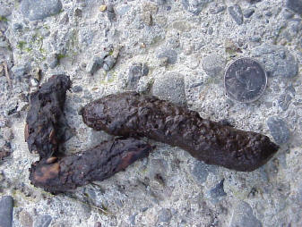 | 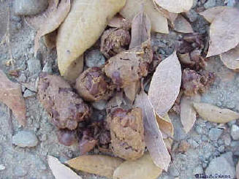
Raccoon scat  This scat was deposited in a prominent location, atop a large rock. Raccoons will mark territory by depositing scat in locations such as this. | Raccoon scat with seeds  The diet of raccoons is highly varied. They can eat just about anything.
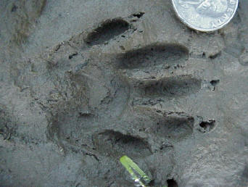 | 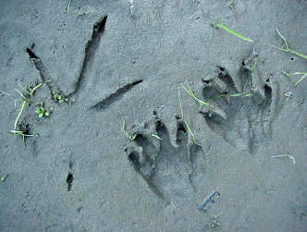
Deep raccoon track in mud  A perfect track in fine mud. Since raccoons spend a lot of time near water, you will find more perfect examples of their tracks just due to the environment. | Raccoon tracks next to great blue heron track  Both of these animals share the habitat of this river bank.
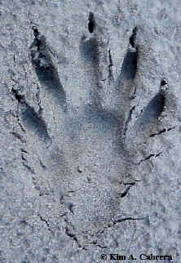 | 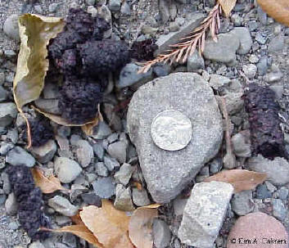
Hind track in sand  Hind track showing all toes, claws, and the long heel pad. | Raccoon scat composed of berries.
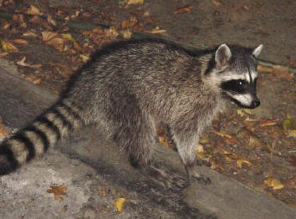 | 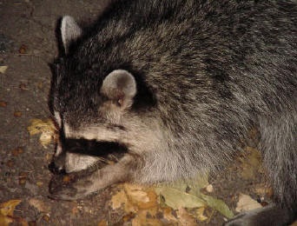
Raccoons on a nocturnal visit to a residence.
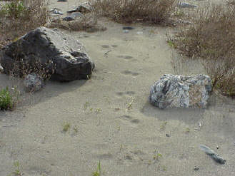 | 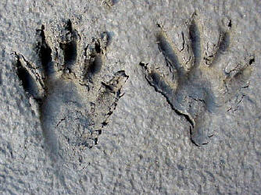
An older raccoon trail through dry sand. The trail is identifiable by the characteristic side-by-side placement of the feet. | Pair of raccoon tracks in sand
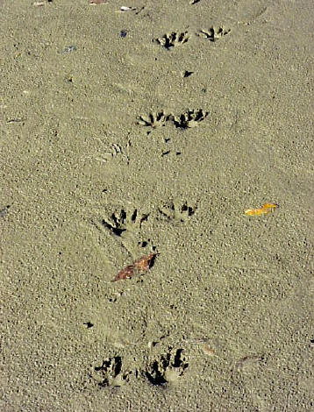 | 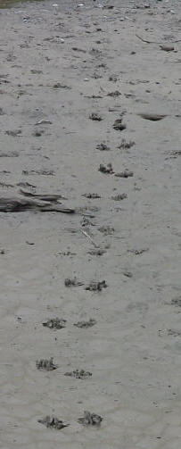
Raccoon trail patterns in mud. Placement of the feet side-by-side is characteristic of raccoons.
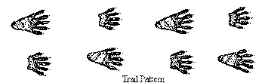 | 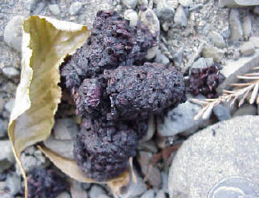
Raccoon walking trail pattern. | Raccoon scat composed of berries and seeds.
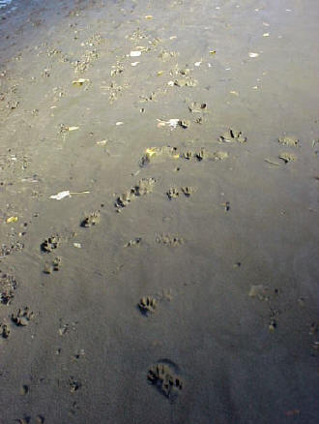 | 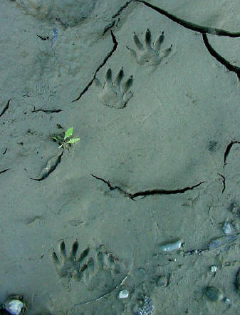
Tracks of a raccoon, dog, and heron in mud. | Perfect set of raccoon tracks in fine mud.
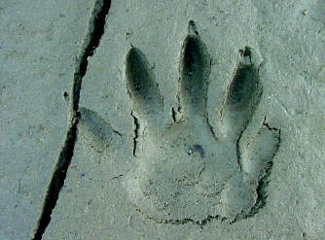 | 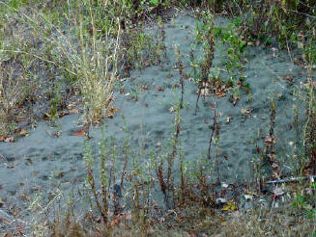
Raccoon track with perfect details. | Regular trail used by a raccoon
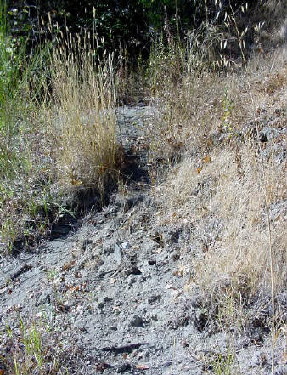 | 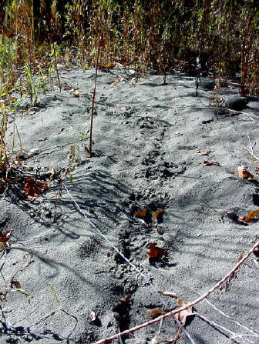
Regularly used raccoon trails.
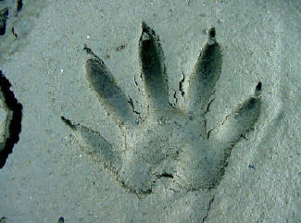 | 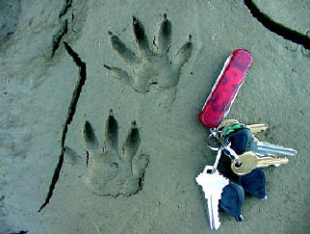
Perfect raccoon tracks.
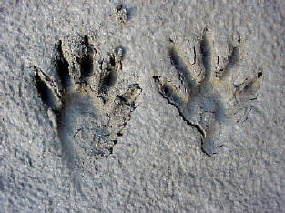 | 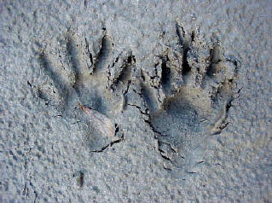
Sets of raccoon tracks in mud.
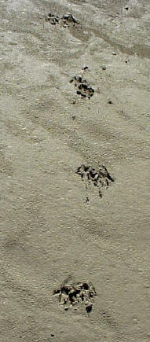 | 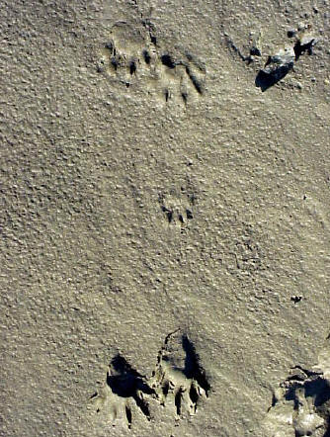
Raccoon trails.
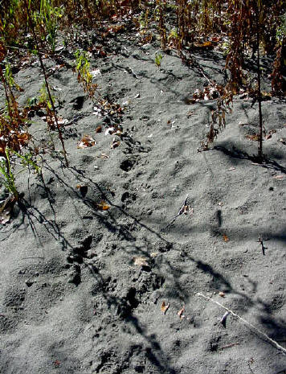 | 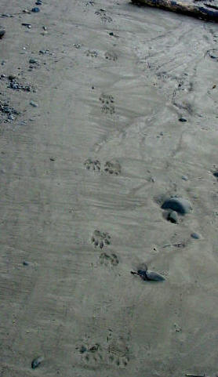
Regularly used raccoon trail. | Raccoon trail along shore.
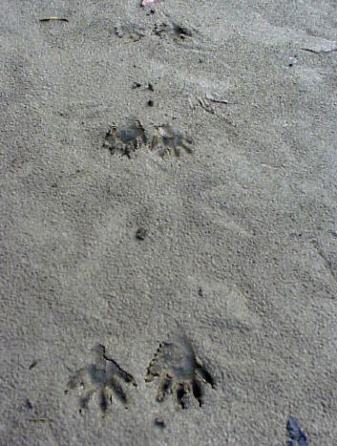 | 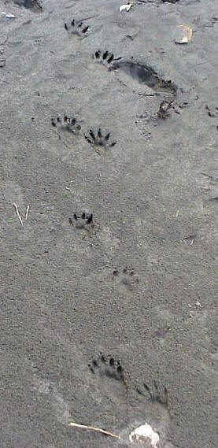
Raccoon trails.
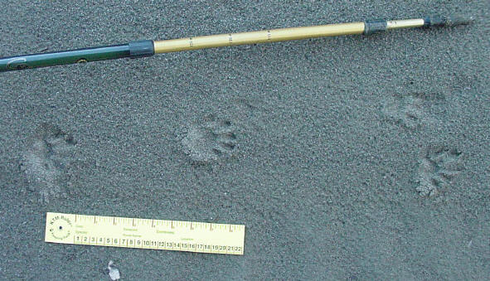
Raccoon in a half bound trail pattern. This raccoon had jumped off a log and hit the ground running.
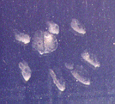
Raccoon track on the window of a vehicle. The raccoon had been trying to get in to get food.
Copyright © Kim A. Cabrera 2004

