Name____________________________________ Summative Date: ____________________
6th Grade Math
The Number System – Rational Numbers Review Guide

- Write the definitions for the following words:

opposite numbers ____________________________________________________________________

absolute value _______________________________________________________________________

2.) What is the opposite of each number below?
a. $-\frac{3}{5}$ _____________ b. 5 _____________ c. - (-7) ___________

3.) What is the opposite of the opposite of -45? ________________

4.) Evaluate: a. $|$ -8 | = ________ b. $|$ 15 | = ________

- Draw a point on the number line to mark the number’s location and label with the original number.
$-\frac{1}{4}$, $.75$, $\frac{2}{ 3 }$ , $-1.25$ $-.5$, $\frac{6}{2}$, $\frac{3}{3}$

-2 -1 0 1 2 3

- Order the following decimals on the number line below. Draw a point on the number line to mark the number’s location and label with the original number.
-2 -1 0 1 2 3
$- \frac{3}{5}$ 2.25 - 0.85 $\frac{20}{10}$ 1.88 $-1\frac{4}{5}$ $\frac{4}{10}$

- What point has the greatest absolute value? _____________________

7.) Mr. Dadante was scuba diving in the Bahamas. He was at -25 feet.
a. Describe the elevation of Mr. Dadante in relation to sea level.
____________________________________________________________________________________

b. Mr. Dadante’s son was standing 2 feet above the water on a boat. What is the difference between Mr. Dadante and his son’s location? ______________________________________________________

8.) Mr. Ehrbar’s thermometer reads -11 °C and Mr. Newsome’s thermometer reads -2 °C .
a. Use absolute value to explain Mr. Ehrbar’s temperature in this situation.
(Think about the definition of absolute value.)

___________________________________________________________________________________

b. Which is the warmer temperature? ________________ How much warmer? ________________
c. Write an inequality to compare these temperatures. ______________________________________

9.) The table below shows the freezing points of different liquids.

Liquid | Freezing Point
Water | $$32$$
Acetone | $$-94$$
Linseed Oil | $$-4$$
Acetic Acid | $$62$$
Oil | -32

- What liquid has the greatest absolute value? _____________________________

- What liquid has the warmest freezing point? _____________________________

- Write an inequality to compare the freezing point of Acetone to Oil. ______________________

10.) Tina believes that -14 and 10 are opposites because one is positive and one is negative. Is she correct? Explain your answer using the definition of opposites.

______________________________________________________________________________________________________________________________________________________________________________________________________________________________________________________________________________

11.) Select all the situations that can be described by the integer -20.
O the temperature rises 20 degrees
O a debit of $20 to your bank account
O an item discounted by $20
O a price increase by $20
O 20 feet below sea level
O a deposit of $20 in a bank account

12.) Select all pairs of points that have a distance of 6 units between them.
A. (2,4) and (-4,4) D. ( -4,-5) and (-2,-5)

B. (3,5) and (3,1) E. ( 0,-6) and (0,0)

C. (-1,3) and (-1,-3) F. (-7,-1 and (1,-1)

13.) The Carousel is located at (10,4) and the Bumper cars are located at (-5, 4) on a coordinate grid map of the Amusement part. What is the distance, in units, between these two points?

____________________________________________________________________________________

- If the Bumper cars were moved and relocated at (4,4), what would be the new distance between the Carousel and Bumper cars?
___________________________________________________________

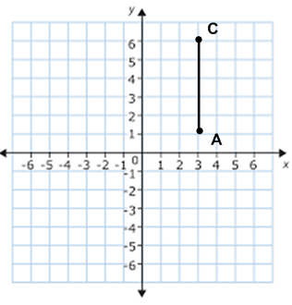
14.) Line CA is one side of the square CAVS, which is located in Quadrants I and II.
a. What are the coordinates of the given vertices?

C= ______________ A= _______________

b. What is the distance from point C to point A?

_________________________________________

c. Plot and label vertices V and S. Then, connect all vertices to prove CAVS is a square. What are the missing coordinates?

V= _______________ S= ______________

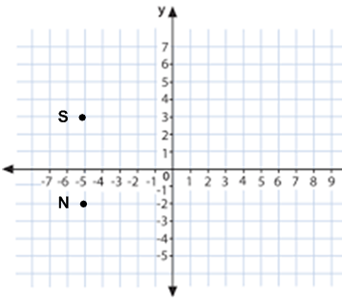
15.) Vertices S and N make up side SN of rectangle SNOW.
a. What are the coordinates of these two points?
S= __________ N= ____________

b. Reflect these points over the y-axis. Connect the points
to create rectangles SNOW. Then, write the coordinates.

O= ___________ W= ____________

c. What is the length of side SN?
__________________________________________

d. What is the length of side NO?
___________________________________________

