River Otter
Lutra canadensis
Tracks and sign  Range: Most of U.S.  Habitat: Rivers and streams, ponds, lakes  Size: 30 pounds  Young: 2-3 born in late spring  Tracks: Five toes on both front and hind feet, webbing sometimes shows  Scat: Sometimes loose, contains fish scales, bones, parts of prey  Stride: 6-14 inches  Diet: Fish, small mammals, shellfish, snakes, turtles, birds, eggs, amphibians | Narrative  River otters are playful members of the weasel family who love to frolic in the water. They are common in rivers and are a joy to watch.  Otters can remain submerged for several minutes. They have valved ears and noses to keep water out. The fur is warm and thick. Since they spend a significant amount of time in the water, their tracks aren't often found.  The best places to look for tracks are muddy river banks. They have five toes on the front feet and five toes on the hind feet.  Their toes are partially webbed, which helps them swim. Tracks in mud sometimes show this webbing. The claw marks are so close to the toes, they give the toes a characteristic pointed appearance.  Otters are well-known for their intelligence and their playful antics. They are excellent fishers, but also will eat small mammals, fish, shellfish, snakes, turtles, birds, eggs, amphibians, and lampreys. They feed primarily on amphibians and will range up to five miles up and down-river each day while hunting.  The tail drag is sometimes visible in an otter trail. Often, their prints are found in groups of four.  Otter scat commonly contains fish scales and is often found on prominent landmarks near water, including rocks, stumps, and boat docks.  Otters roll on river banks and leave a musky scent. Dens are dug into banks, with underwater or above ground entrances. Nests are made inside the den out of leaves, sticks, and grass.  Otters will often travel overland, far from water. They are active during daylight.  Otters have two to three pups in late spring. Adult otters can weigh 30 pounds.

River Otter Tracks and Sign
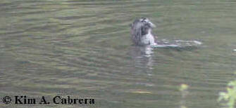 | 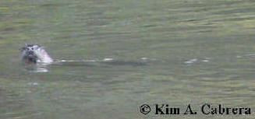
River otter swimming in a river
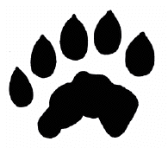  2.5 in. L x 3 in. W | 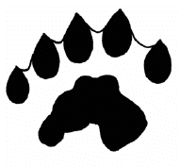  3 in. L x 3.5 in. W
River otter tracks. Webbing does not always show up in the prints.
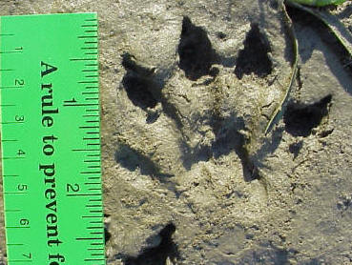 | 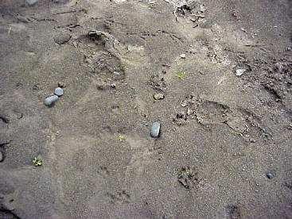
Perfect river otter tracks showing all toes and webbing. | Tracks of a river otter, raven, fox, and person. Otter trail is on the middle right.
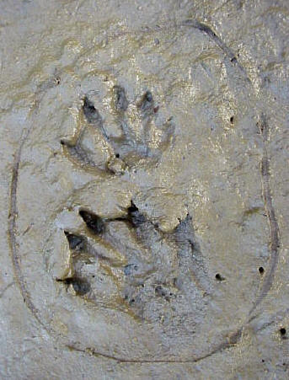 | 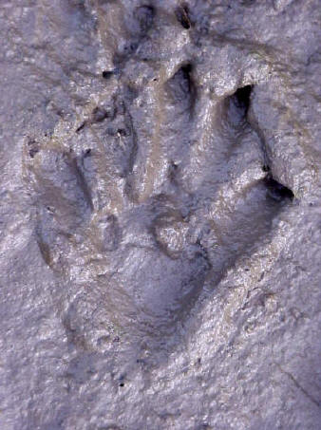
Pair of river otter tracks. The hind track is below the front one and shows good detail. | River otter hind track with clear webbing showing. The heel left an imprint, which does not always happen.
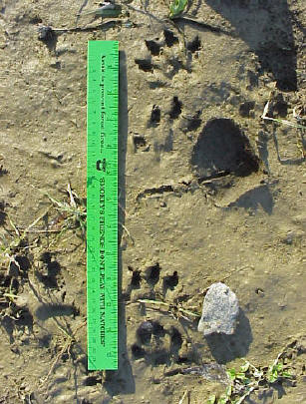 | 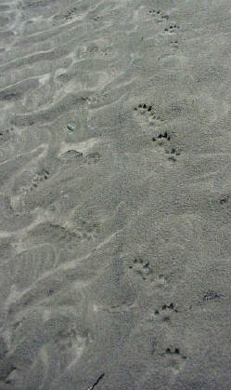
A set of river otter tracks in mud with ruler for scale. The hole on the right is where a rock was picked up. | River otter trail on sandy bank. Tracks to the left are those of a raccoon.
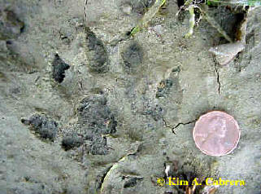 | 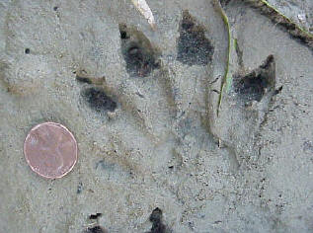
Otter tracks in different substrates
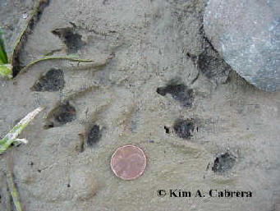 | 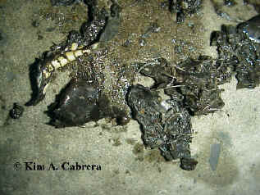
Pair of otter tracks | River otter scat containing remains of a snake.
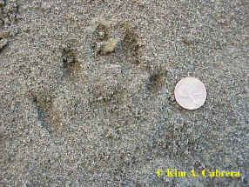 | 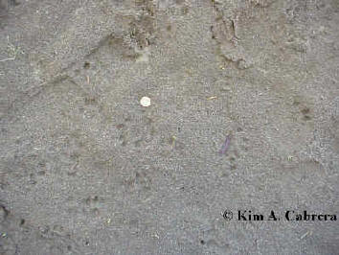
Otter track in coarse sand | Otter trails in sand
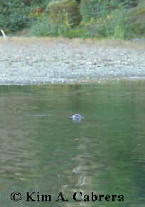 | 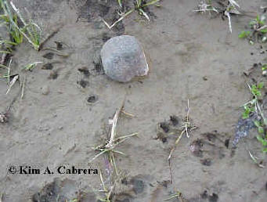
Otter in the river | Set of otter tracks in mud
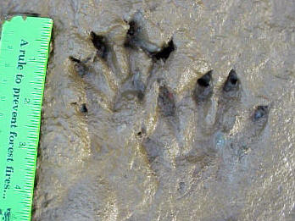 | 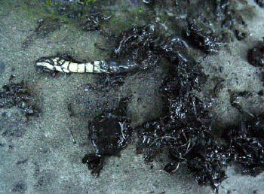
Pair of river otter tracks. | River otter scat picked apart to show contents.
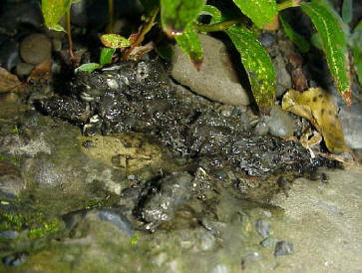 | 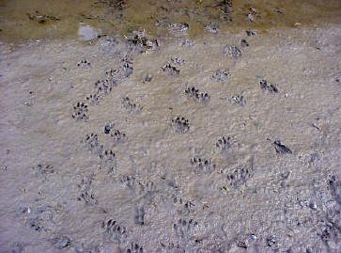
River otter scat deposited on a rock on the shore. | Several river otter trails lead into the water.
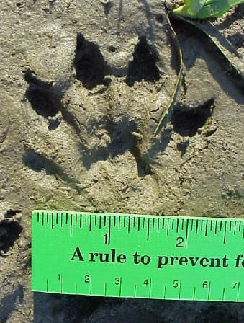 | 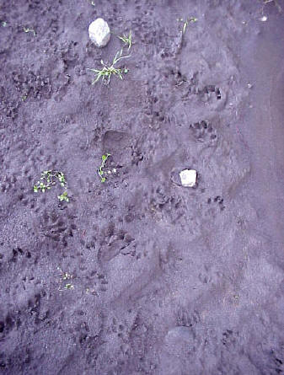
Perfect otter track in mud | Trails of several otters
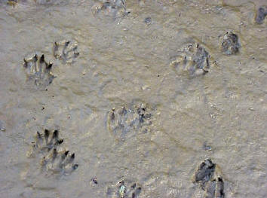 | 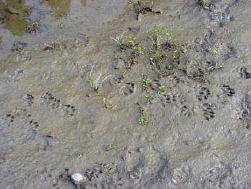
Otter tracks in deep mud | Trails of several otters along the water's edge.
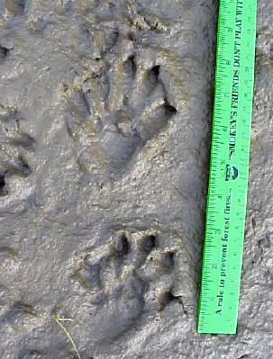 | 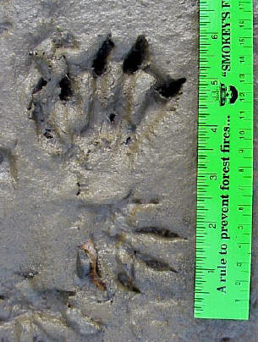
Otter tracks in mud, showing good detail | Very nice detailed track. Raccoon tracks in lower half of photo.
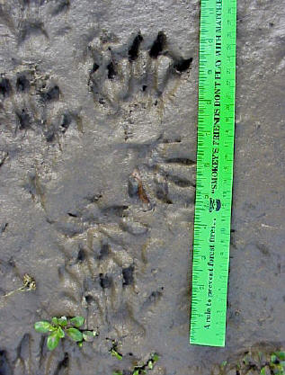 | 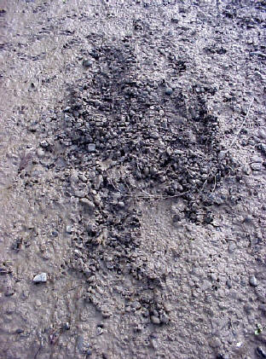
River otter and raccoon tracks. The otter's toes are more robust and webs sometimes show. Raccoons have bulbous finger tips and skinny toes. Otters have thick claws at the end of their toes. Raccoon claws are smaller. | Scraping by a river otter. Otters sometimes scrape like this, then deposit scat or urine. This is a way of communicating with other otters.
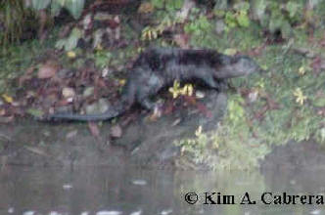 | 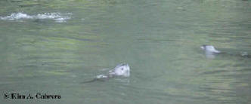
Otter on river bank | Three otters hunting in a deep pool.
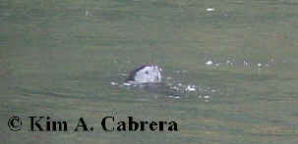 | 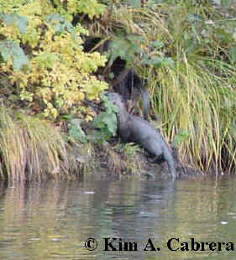
Otter hunting in water | Otters on the bank
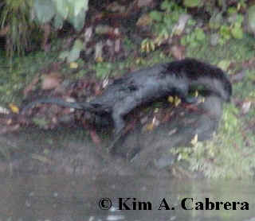 | 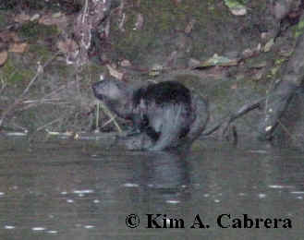
An otter exploring a river bank
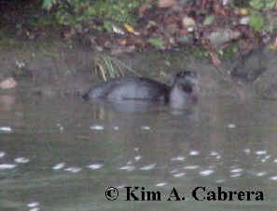 | 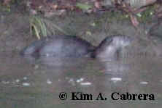
Otter at water's edge
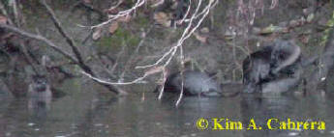 | 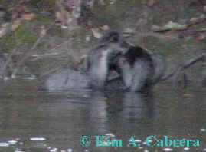
Family group of otters
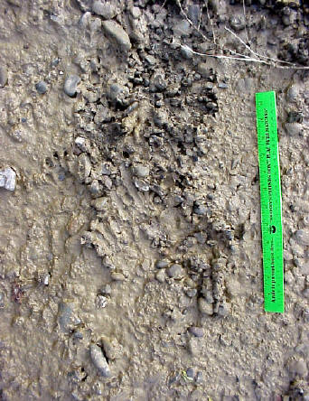 | 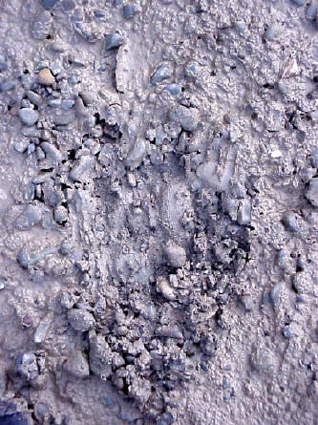
Otter scrapes
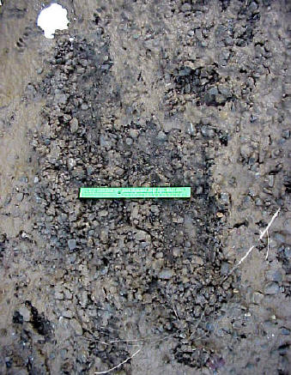 | 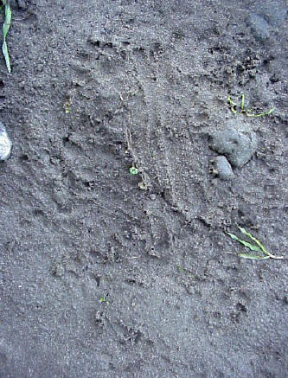
Otter scrapes in different substrates
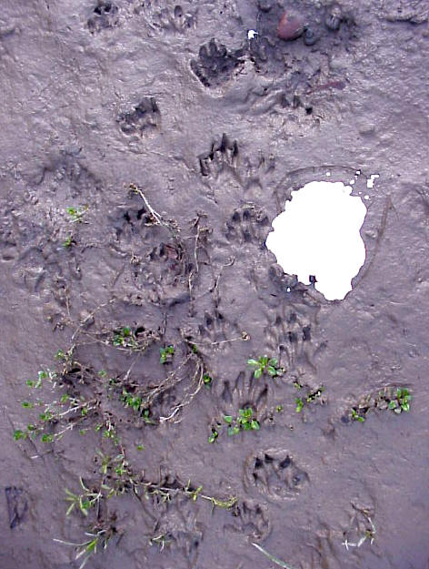
Otter trails with one of the tracks being cast in plaster of Paris.
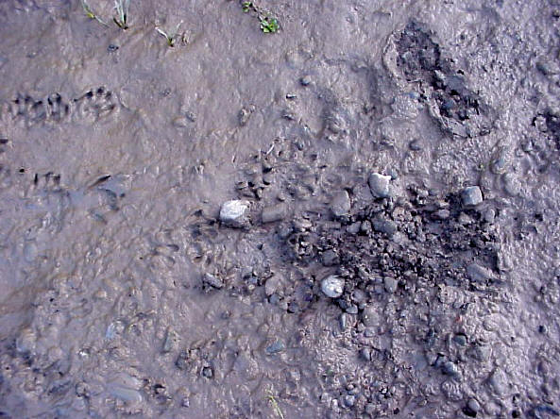
Otter tracks and scrape
Video Clips
Otters swimming and hunting
Otters swimming
Copyright © Kim A. Cabrera 2004

