Name: _________________________________________ Date: ______________________ Period: _______
I can use maps, globes, and other geographic tools to gather, process, and report information about people, places, and environments.

I can explain that maps are created for specific purposes and represent the context in which they were created.

I can use a maps coordinates of latitude and longitude to identify the absolute locations of different places.

What should I do?
- Read through/study/understand the following pages in my notebook:
  - Map vocabulary part 1
    - Can I read the word and know the definition?
    - Can I read the definition and know the word?
  - Maps
    - Can I identify the different types of maps by reading the definition?
    - Can I identify the different types of maps by looking at a picture?
  - Map vocabulary part 2
    - Can I read the word and know the definition?
    - Can I read the definition and know the word?
  - Continents and oceans map
    - Can I name and find all 7 continents and 5 oceans on a blank map?
  - Climate map
    - Can I name and describe the different climate zones?
    - Can I identify the following lines: Arctic Circle, Antarctic Circle, Tropic of Cancer, Tropic of Capricorn, and Equator?
  - Hemispheres
    - Can I identify the hemispheres and which lines separate them?
  - Latitude and longitude notes
- Practice plotting coordinates on a map (practice map sheet is attached)

**REMEMBER** check Mr. Yas’ website for extra resources to help you study

Types of Maps
Match the type of map to its definition.
- Physical B. Population Density C. Product D. Vegetation
E. Topographical F. Political G. Climate H. Economic
Activity

- __________ shows boundaries and locations of countries, states, and major cities
- __________ the plant growth of an area
- __________ shows the average monthly or yearly weather conditions
- __________ amount of people that live in an area relative to the space occupied by them
- __________ type of physical map that shows elevation (how high a place is above sea level
- __________ shows the geographic features of an area (seas, islands, mountains, lakes, rivers, deserts)
- ___________ the natural resources in an area and the products made in that area
- ___________ shows information about land use, which is how people use land to meet their needs. It will also sometimes show the locations of important resources.

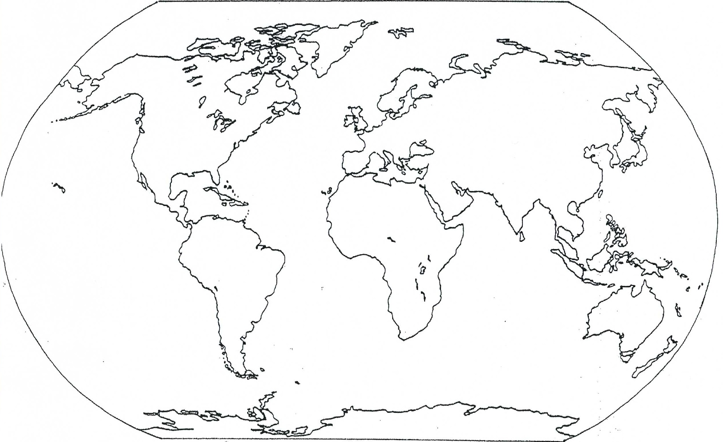
Label the seven continents and five oceans.
Vocabulary
Fill in the blanks with the correct vocabulary word.
- Lines of ______________________________ run east and west but measure north and south.
- Lines of ______________________________ run north and south but measure east and west.
- The most important line of latitude is the ____________________ which measures 0°.
- The most important line of longitude is the _______________________________ which measures 0°.
- _________________________ is weather in a place over a long period of time.
- _________________________ is another name for lines of longitude.
- _________________________ is another name for lines of latitude.
- ______________________ is a name for the supercontinent that existed millions of years ago.
- A ________________________ explains what each symbol represents on a map.
- A __________________________shows how much a map has been reduced from the area it represents. It tells what each distance on the map represents in real life.
- A ___________________________ shows where each of the cardinal directions are.
- Someone who makes maps is called a ________________________________.
- When you give a location in relation to another place you are using _______________________ location.
- Giving a location based on coordinates is using _____________________________ location.
- The top boundary of the tropic region is known as the ______________________________ and measures 23.5° North.
- The bottom boundary of the tropic region is known as the _____________________________ and measures 23.5° South.
- The region above the 66.5° North line is known as the ___________________________.
- The region below the 66.5° South line is known as the ___________________________.
- There are 24 _______________ for each hour of the day. They run with the lines of longitude.
- The _________________________________________ establishes where days begin and measures 180°.

Fill in the chart using the words below – are the terms latitude or longitude?

Equator Lines measure north and south Tropic of Cancer
International Date Line Tropic of Capricorn Arctic Circle
Time zones Lines measure east and west Antarctic Circle
Latitude | Longitude
Maximum is 90° Maximum is 180° Climate
Lines run north and south lines run east and west Prime Meridian

Plotting Practice

Plot the following points on the map. Put a dot on the map with the correct letter next to it.
- 40° S, 60° W F. 0°, 0°
- 60°N, 100°E G. 0°, 20°E
- 80°N, 30°W H. 15°N, 80°W
- 30°N, 40°E I. 42°N, 143°E
E. 51°S, 65°E5 J. 7°S, 74°E

