Math 4 Name_________________________

**Semester 1 Exam Review**

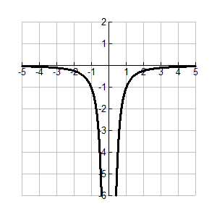1. **Function Families**

Given a function or graph, find the domain, range, symmetries, degree and type of function family.

Domain: Range:

Symmetry: Type of function:

2. **Function Operations**

Given two functions, calculate arithmetic operations and the composition of the functions.

 

Calculate the following:

 

 

3. **Parametric Equations**

Use parametric equation to construct a graph. Convert parametric equations to rectangular form.



Graph the equations over the interval  then convert the equations to rectangular form & simplify.

4. **Chunking/*u*-substitution**

Solve for *x*.



5. **Number Line Analysis**

Solve the inequality below.



6. **Arithmetic and Geometric Sequences and Series including Sigma Notation**

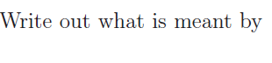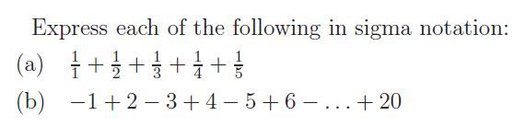

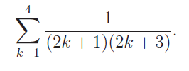

Find the 12th term of the sequence 3, 8, 13, 18, ……

Fill in the missing blanks of the arithmetic sequence 9, ___, ___, ___, 37

7. **Matrix operations**

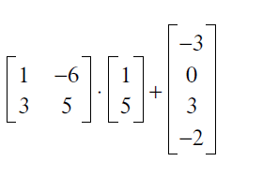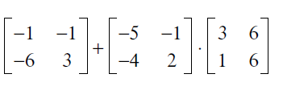 Simplify each.

Use matrices to solve the system.



8. **Rational Functions**

1. Use limit notation to describe the behavior of *j*(*x*) near its vertical and horizontal asymptotes. It would also be nice if you could draw a sketch of the function as well.



2. Add, subtract, multiply or divide the rational expressions below. Simplify your answer.



a. b.



c. d.

Determine the values of the properties below. Write “none” if one does not exist. The domain is for the original function.

3.  4. 

*Domain:_______________* *Domain:_______________*

*x-intercept(s):_______________* *x-intercept(s):_______________*

*y-intercept: _________ y-intercept: _________*

*horizontal asymptote(s):_______________* *horizontal asymptote(s):_______________*

*vertical asymptote(s): _______________ vertical asymptote(s): _______________*

*oblique asymptote:_______________ oblique asymptote:_______________*

*hole: _____________ hole: _____________*

9. **Unit Circle**

Yeah, know all the values around the Unit Circle.

10. **Law of Sines and Cosines**

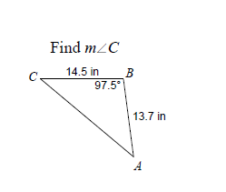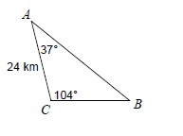 Find Solve all missing sides and angles.

11. **Trigonometric Simplification**

Remember: 

**\*\*\*As always, study your worksheets and tests/quizzes in addition to working through the problems in this review.**