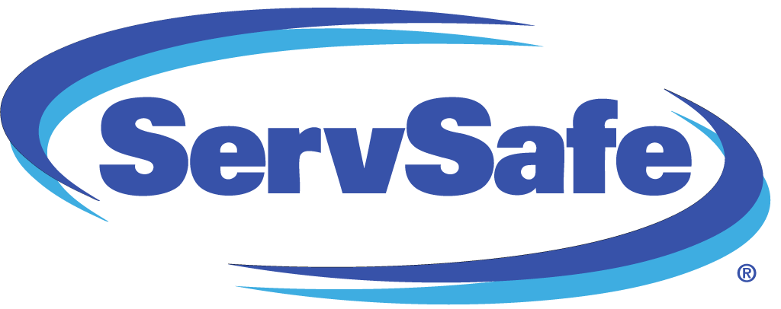State Version: Ohio
Languages: English/Spanish/Simplified Chinese/Korean/Vietnamese
Exam Type: Three attempts at the online exam are included
Certificate: The ServSafe Food Handler Ohio Certificate is valid for three years
The ServSafe Food Handler® Ohio Online Course and Exam has been approved by the Ohio Department of Health, ODH #89-17, for food service operations and retail food establishments that need Level One Training. At CEVEC, we provide a 3-4 day training that entails an interactive online course. Upon completion of this program the student will need to print off the Certificate of Achievement and have a copy available for review by the local Health Department.
ServSafe Food Handler® Ohio Online Course and Exam is a comprehensive solution that delivers consistent food safety training to employees. This ensures the same food safety principles are delivered each and every time.
• Sections can be completed in approximately 10 minutes.
• Color photographs from the learners point of view helps reinforce food safety concepts
• Enhanced assessment can be taken at the completion of training to measure if employees have the minimum competency in food safety knowledge.
• Once the course has been purchased and launched, participants can select to take the course in English, Spanish, Simplified Chinese, Korean or Vietnamese.
Covers five key areas:
• Basic Food Safety
• Personal Hygiene
• Cross-Contamination & Allergens
• Time and Temperature
• Cleaning and Sanitation
The National Restaurant Association's ServSafe Food Safety training program is widely recognized and respected in the foodservice industry. Here's why.
- Uses quality materials and exams created by foodservice and regulatory experts exclusively for the foodservice industry
- Reinvests proceeds from programs back into the industry
- A single source, one-stop shop for both food safety training and the certification examination
- Delivers up-to-date regulatory information
- Provides support from foodservice subject matter experts available to answer questions
- Offers flexible online, classroom, in-unit and one-on-one training and examination options

