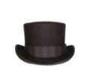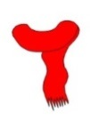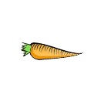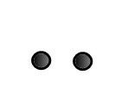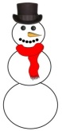

One day I decided to build a
First I made a large
Next I made a medium
I placed it on top of the large one.
Then I made a small
I placed it on top of the medium one.
It was time to make the snowman’s face.
I used two black buttons for
I used six smaller black buttons for a
His nose was a
It was time to dress the snowman.
On his head, I placed a black
Around his neck, I tied a red
Finally, I named my snowman. His name was

