WAVES, SOUND AND LIGHT STUDY GUIDE

Chapter 8 Section 1:
- What is the difference between mechanical and electromagnetic waves?Mechanical waves are periodic disturbances that must pass through matter/medium. Mechanical waves are longitudinal (sound) waves, seismic waves, and ocean waves. Electromagnetic waves are a disturbance, which does not require a medium, or matter in order to transmit energy; can travel even through a vacuum; and caused due to varying electric and magnetic fields. Mechanical waves are transverse waves such as radio waves, microwaves, infrared, visible light, ultraviolet, x-rays, and gamma rays.

- Give 3 examples of electromagnetic waves.
Visible light, gamma rays, radio waves
- Draw and label a transverse AND longitudinal wave.
Transverse Wave
Longitudinal Wave | 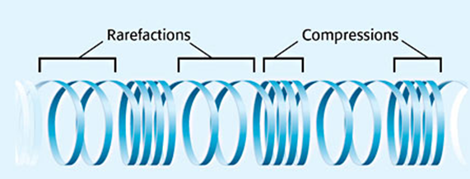
- What is a surface wave?
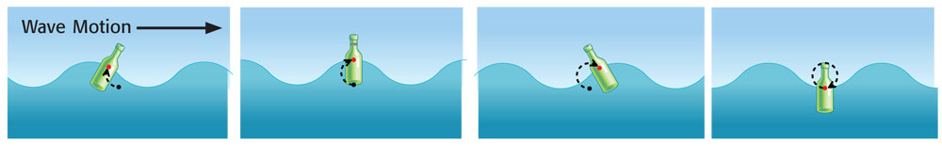
Surface waves look like transverse waves, but the particles of the medium move in circles rather than up and down; a combination of transverse and longitudinal waves.

Chapter 8 Section 2:
- List and define the 3 properties that all waves have?
- Amplitude - the largest distance a wave moves away from the rest position.
LARGER AMPLITUDE = MORE ENERGY
- Frequency - The number of waves that pass a certain point in a given amount of time; Measured in HERTZ (Hz); HIGHER FREQUENCY = MORE ENERGY
- Wavelength - The distance between any 2 corresponding points on a wave. For example, the distance between 2 crests in a transversal wave or 2 compressions in a longitudinal wave. SHORTER WAVELENGTH = MORE ENERGY

- If wavelength increases, what happens to the frequency?
If wavelength increases, frequency decreases.
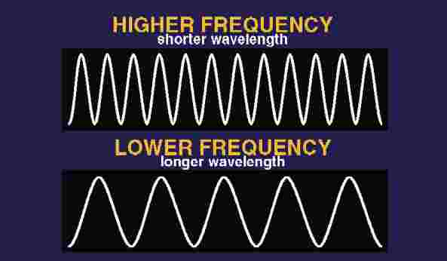
- What unit is used to measure frequency?
Frequency is measured in Hertz (Hz).
Chapter 21 Section 1:
- What is sound? A wave caused by vibrations and carried through a substance. Sound waves travel in all directions away from their source. Most of the sounds that you hear travel through air at least part of the time. But sound waves can also travel through other materials, such as water, glass, and metals.
- Is sound a longitudinal or transverse wave?
Sound is a longitudinal wave.
- Is sound a mechanical or electromagnetic wave?
Sound is a mechanical wave because it must travel through a medium.
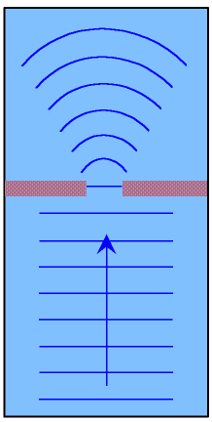
- What is diffraction?
Diffraction is the bending of waves around a barrier or through a opening. The amount of diffraction of a wave depends on its wavelength and the size of the opening or barrier.
- What is the speed of sound?
344 m/s in air, 1482m/s fresh water, 12000m/s diamond
- a) Does sound travel fastest through a solid, liquid, or gas? b) Why is there a difference in speed through different mediums?

- Sound waves travel faster in solids than they do in liquids than they do in gases. (Speed of Sound = Solid > liquid> gas)
- Because molecules in a solid medium are much closer together than those in a liquid or gas, allowing sound waves to travel more quickly through it. In fact, sound waves travel over 17 times faster through steel than through air.

Chapter 8 Section 4:

- How are frequency and pitch related?
Pitch is highness or lowness of a sound; depends on frequency of sound wave.
High pitch=high frequency
Low pitch=low frequency

- How are loudness and amplitude related?
Loudness is a measure of how well a sound can be heard. The larger the amplitude, the louder the sound, and the smaller the amplitude, the softer the sound
Loudness is measured decibles.
100 dB will damage a person’s ears.
- What is the Doppler Effect? b) Give an example
      - The Doppler Effect is the apparent change in the frequency of a sound caused by the motion of either the listener or the source of the sound.
      - 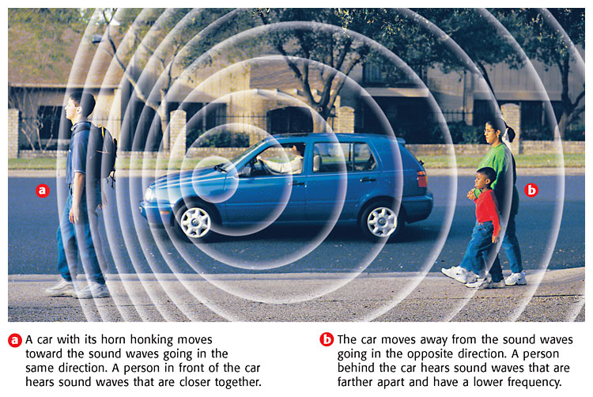

Chapter 8 Section 5:
- What is an electromagnetic wave?Electromagnetic waves are a disturbance, which does not require a medium, or matter in order to transmit energy; can travel even through a vacuum; and caused due to varying electric and magnetic fields.
- What is the speed of light? 300,000 km/sec; 186,000 mi/sec
Chapter 8 Section 5:
- Draw and label an electromagnetic spectrum.
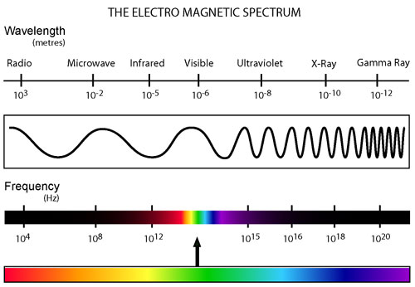
- What colors are included in visible light? b) What colors have the longest and shortest wavelength?
a) Roy G. Biv – Acronym for Red, Orange, Yellow, Green, Blue, Indigo, & Violet.
b) Largest to Smallest Wavelength.
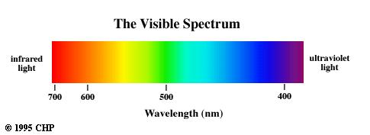

Chapter 8 Section 6:
- What is transparent?
TRANSPARENT-light is transmitted through easily

- What is translucent?
TRANSLUCENT-transmits and scatters light
- What is opaque?
OPAQUE- does not transmit light
Examples:
TRANSPARENT | TRANSLUCENT | OPAQUE
Saran-Wrap | Wax Paper | Aluminum Foil

- What determines the color of an object?
The color an opaque object appears depends on the colors of light it reflects.

