Fox Squirrel

The fox squirrel is one of four squirrel species in Ohio; gray, red, and flying squirrels are the other three. Of the four, the fox squirrel is the largest. Fox squirrels were not originally inhabitants of Ohio. The extensive, heavily wooded forest of pre-settlement Ohio was not their preferred habitat. Only when settlement cleared some of the dense woods away and provided open areas and fewer dense woodlots did the fox squirrel start to make Ohio home, moving into the area from the geographical Midwest prairie edge.
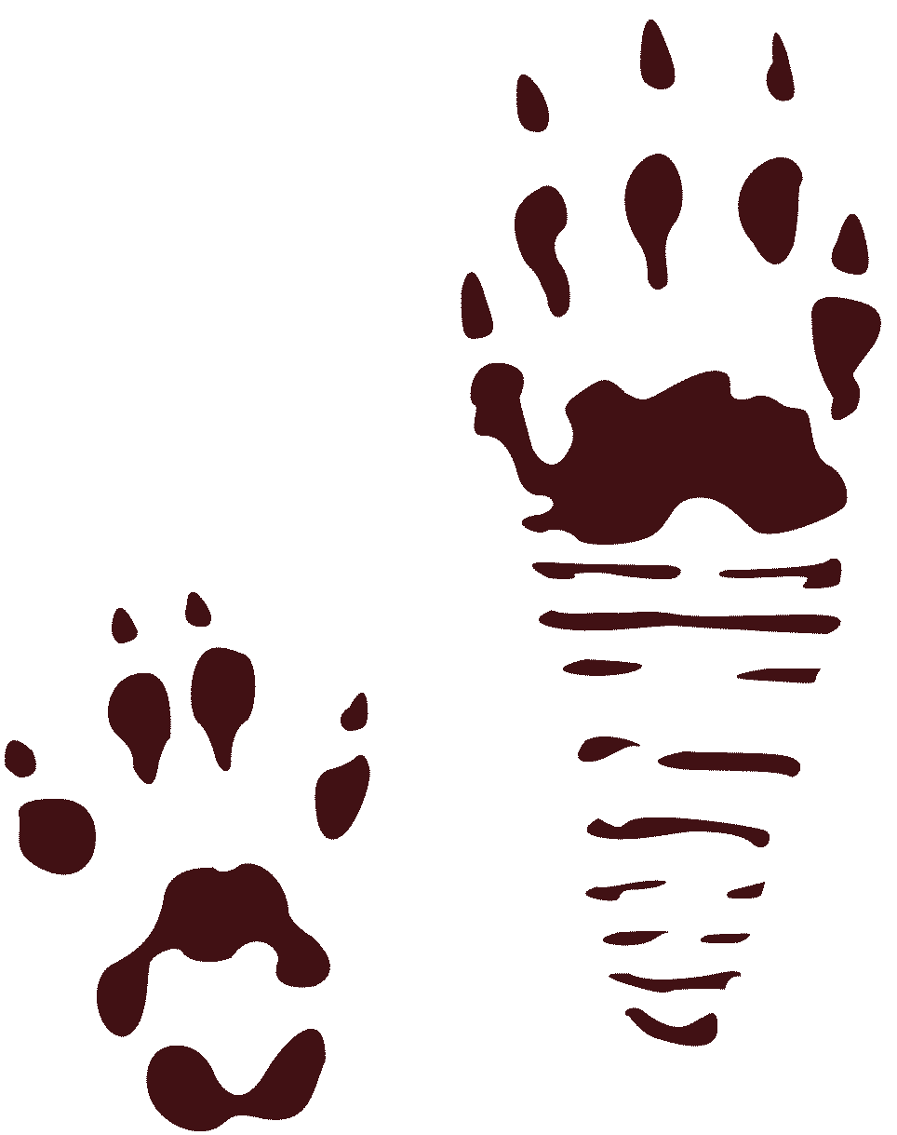

Fox Squirrel Track
(Click track to enlarge)

Fox Squirrel  Sciurus niger  At-a-Glance  • Mating: Polygamous  • Peak Breeding Activity: At two periods: December-February & May-July  • Gestation: 44 days  • Young are Born: February-April and June-August  • Litter Size: 2-5, 3 average  • Young Leave Parents: 14-15 weeks  • Number of Litters per Year: 1 or 2, multiple litters are usually produced by females 2 years old  • Migration Patterns: Year-round residents  • Typical Foods: Nuts of hickory, oak, and beech; fruits of blackberry, dogwood, wild cherry, and wild grape; corn; buds of maple, elm and willow; and insects | Description  The fox squirrel is much more orange in appearance than the gray squirrel with which it is sometimes confused. Its body is a yellowish- gray with reddish-yellow cheeks, face, and feet. The belly is pale yellow to orange in color. Tufts behind the ears and the tips of its tail are yellowish-brown. The tail itself is a reddish-orange with a mixture of dark gray or black hairs throughout.  Habitat and Habits  The primary range of the fox squirrel is in the woodlot country of agricultural western Ohio. These woodlots are 10 to 20 acres in size with a sparse understory and separated from one another by large acreages of agricultural croplands. Fox squirrels make use of hickory, oak,beech, black walnut, maple, elm, and buckeye trees for food and shelter. Timber management practices that create broken stands of middleaged and mature trees provide the needed den and food sites for fox squirrels.  Like gray squirrels, fox squirrels use two types of nests: leaf and den. Leaf nests are constructed from leaves and twigs and are located in the crotches of tree branches. Dens are formed in hollow tree trunks or branches. Nests are used for shelter and rearing young.  Reproduction and Care of the Young  Male fox squirrels initiate the chase of the female that leads to mating. Fox squirrels are polygamous, meaning the male will mate with more than one female. The male will play n role in rearing the young. Female fox squirrels carry the young for about a month and a half (44 days). The young are born blind and will rely on their mother’s milk for at least the first five weeks of life--this could be significantly longer as young fox squirrels generally don’t leave the nest to forage on the ground until they are about three months old.

Red Squirrel

Red squirrels store conifer cones in middens, or piles, instead of burying them like their larger cousins do. The middens made by red squirrels can be up to 30 feet across and 1.5 feet deep!

Red Squirrel Track
(Click track to enlarge)

Listen

Red Squirrel  Tamiasciurus hudsonicus  At-a-Glance  • Typical Foods: seeds, nuts, eggs, and fungi | Description  The red squirrel has a uniformly yellowish or reddish coat and a whitish belly. Its tail is bushy.  Habitat and Habits  This squirrel prefers coniferous and mixed forests. It is often found around structures.  Reproduction and Care of the Young  Red squirrels breed April-May and August-September. They nest either in tree cavities or branches. Two to seven young are born per litter after gestation periods of 38 days.

Southern Flying Squirrel

The flying squirrel is the most common squirrel in Ohio. Because they are nocturnal and seldom seen, most people don't recognize that they live with flying squirrels.
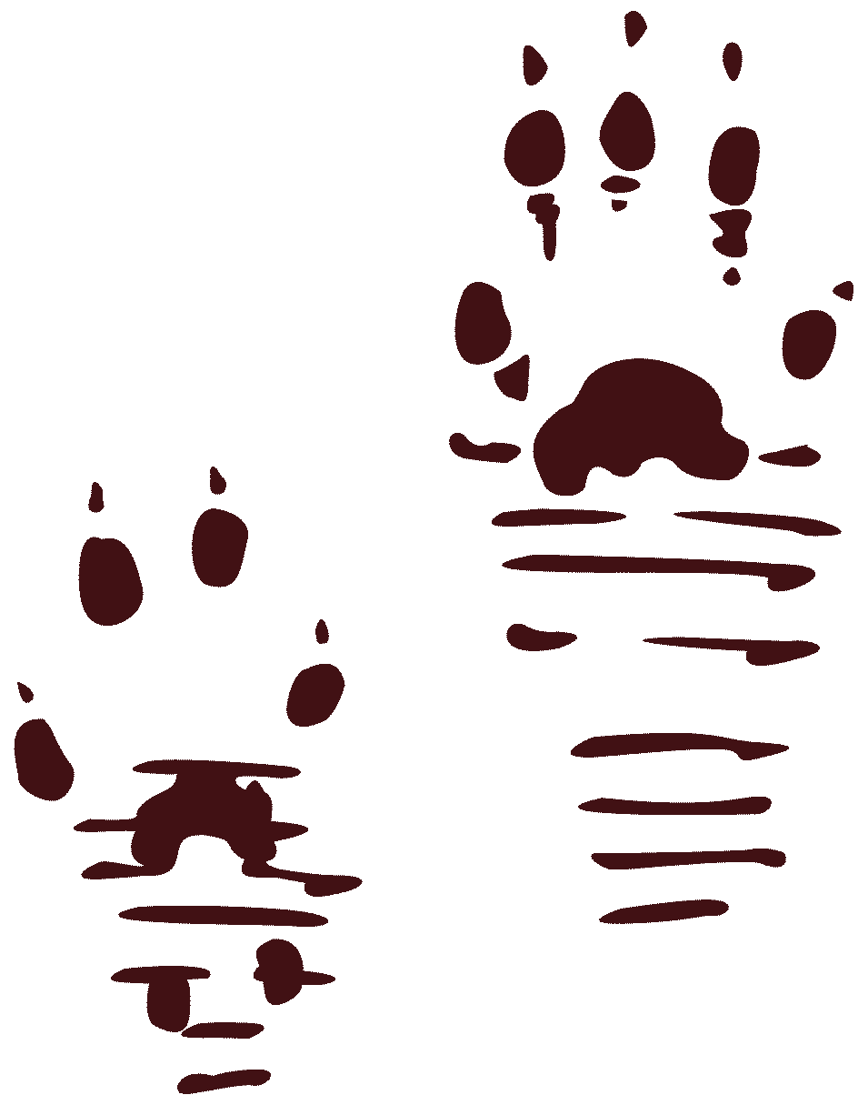

Southern Flying Squirrel Tracks

Southern Flying Squirrel  Glaucomys volans  At-a-Glance  • Typical Foods: omnivorous: eats foods like nuts, seeds, fruits, moths, bark, mice, eggs, and insects | Description  Flying squirrels are easily distinguished by a “gliding membrane,” which is a flap of loose skin that extends from wrist to ankle. When outstretched, this skin allows the squirrel to glide from tree to tree. The fur is an olive-brown color on the upperparts and white on the underparts.  Habitat and Habits  They prefer to live in woodlands or forests of deciduous or mixed deciduous-coniferous trees. Flying squirrels make their nests in the hollows of trees.  Reproduction and Care of the Young  Breeding takes place twice a year, once between April and May and again between August and September. After a gestation period of about 40 days, two to six young are born.

Ohio Division of Wildlife
Life History Notes
Gray Squirrel
Scientific Name: Sciururs carolinensis carolinensis
Sciurus carolinensis pennsylvanicus

Introduction

The gray squirrel was one of the most populous species of wildlife in Ohio at the time of settlement. Gray squirrels had extensive habitat in the state taking advantage of the widespread forests in Ohio. Early historical records speak of gray squirrel populations so dense that “...it took a month for an army of squirrels to pass.” In fact, gray squirrels disrupted early agricultural efforts in the state to such an extent that Ohio law required each taxpayer to turn in a quota of squirrel skins along with his tax payment. But as the human population grew and more land was cleared, and elimination practices continued, gray squirrel numbers began to dwindle. By 1885, hunting laws were enacted restricting the hunting seasons and bag limits for the gray squirrel.
The gray squirrel is one of four squirrel species in Ohio; fox, red, and flying squirrels are the other three. There are six subspecies of gray squirrels in the United States; two of them S. c.carolinensis and S. c. pennsylvanicus reside in
Ohio. Gray squirrels are found from the Atlantic Coast to central Montana and Texas, and in southern Ontario, Manitoba, and Saskatchewan, Canada. In Ohio it is found in all 88 counties, although numbers are significantly higher in the southeastern and south-central portion of the state and less in the western and northeast.

Description

As its name indicates, the gray squirrel is predominately gray in color. These gray hairs may have orange tips that will give the animal a reddish cast. Its belly is more of a grayish-white or a rusty color. Many gray squirrels have a white trim on the back of the ears and a strawcolored ring around their eyes.

Habitat and Habits

Gray squirrels prefer large expanses of wooded areas of hardwood trees. Timber management practices that create stands of middle-aged and mature trees provide the squirrel the most food and den sites. As such, most of Ohio’s gray squirrel population is found in the unglaciated Hill Country of southeastern Ohio. But many are also found in the state’s cities in neighborhoods and parks with large trees. Oak, hickory, beech, walnut, buckeye, tuliptree, maple, sassafras, and flowering dogwood are the trees that are found in the gray squirrel’s preferred habitat. Gray squirrels will take shelter in leaf nests they have constructed or in tree dens. Leaf nests are made of twigs, leaves, and sometimes grasses and scraps of paper and cloth. They are usually one to two feet in diameter with an interior cavity of four to five inches. The mass of leaves at the top of older trees in your backyard that is revealed in the fall when trees are bare is a squirrel nest. Gray squirrels are more social than their fox and red cousins; several Publication 95 (1099) gray squirrels may share a shelter nest. Dens are about 20 feet above the ground, in a hollow trunk or limb that is at least 15 inches in diameter. Den entrances are three to four inches wide. Cavities are lined with leaves. Gray squirrels do not hibernate in the winter; if there is heavy snow cover and/or frigid temperatures, the squirrels will take cover in their den for an extended period of time. However to make it through the winter the gray squirrel must get out and find food. Much of that winter food is the acorns and other nuts the squirrels buried during the year. Retrieving them is not a function of memory, but smell. Many of the nuts buried are never recovered and contribute to maintenance of woodlands.

Gray Squirrel
Sciurus griseus
Tracks and sign  Range: West coast  Habitat: Oak woodlands  Size: About 20 inches long, including tail  Young: 4-6 per litter  Tracks: Front track -five toes, hind track - four toes  Scat: Small pellets, 3/8 inch long  Stride: 6-30 inches  Diet: Nuts, berries, insects, fungi, larvae, vegetation | Narrative  Gray squirrels are common on the west coast. They have large bushy tails and gray fur, which is shed in a molt during the spring and fall. New fur grows to replace the old.  Since they love to eat acorns, they are found commonly in areas where oaks grow. They also eat nuts, berries, fungi, larvae, vegetation, and insects. The call is a hoarse bark. They make their bulky nests high up in trees from leaves, sticks, and bark. In winter, they find shelter in tree hollows. Gray squirrels do not hibernate. They are active year-round. during winter, they often feed on food they stored earlier in the year. They will bury acorns and other foods in caches throughout their territory and later dig them up to eat.  Their tracks show four toes on the front foot and five on the hind foot. Clear tracks may sometimes be found along river edges, where the animals come down to drink.  The best time if year to see them is in the fall, when they are busy gathering and storing acorns for winter. Gray squirrels will scold intruders into their territory. They sit high on branches and make a chirring sound that is easily recognizable.  Gray squirrels can breed when they are about a year old. The young are born with no fur and their eyes are closed. Usually, four to six young are born per litter.  A gray squirrel nest is called a drey. It is built with sticks, leaves, and the inside is lined wit softer materials.

Gray Squirrel Tracks and Sign
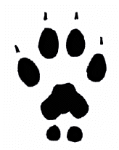  1.75 in. L x 1.25 in. W | 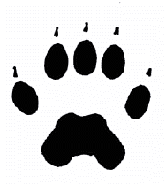  3.25 in. L x 1.5 in. W
Front track  Front tracks show four toes. Sometimes the two small heel pads are visible. | Hind track, not showing heel mark  The long heel mark is not always visible. Hind tracks usually show five toes.
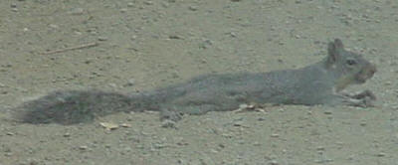 | 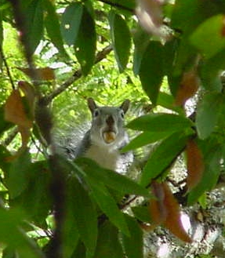
Hot gray squirrel  On a very hot day, this squirrel tried to cool off by laying out on the dirt of an unpaved road. | Gray squirrel  Gray squirrel with mouth full of acorn it is taking somewhere to store.
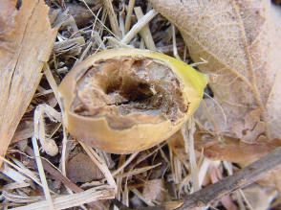 | 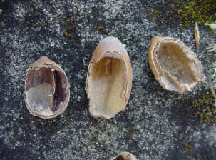
Acorn opened by gray squirrel  The squirrel did not finish eating the acorn because it dropped the acorn and didn't climb down to retrieve it. | Acorns opened by gray squirrel  These are black oak acorns.
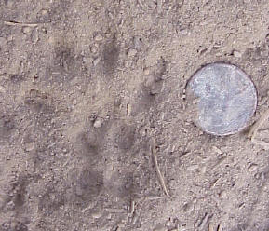 | 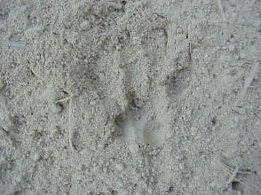
Front track in dust  The two hind heel pads are visible. Penny for scale is 3/4 inch across. | Partial track in dust  Squirrel tracks don't always show claw marks.
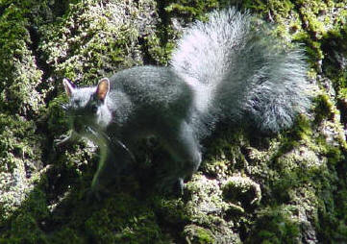 | 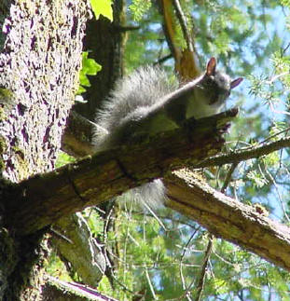
Gray squirrel on tree  Squirrels are very agile climbers. To get from tree to tree, they often jump and catch the branches of the next tree in mid-air. | Gray squirrel  Looking down from a perch on a branch. Squirrels are very alert and will often call out warnings when they see people coming.
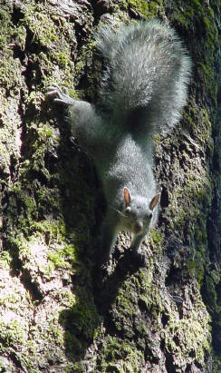 | 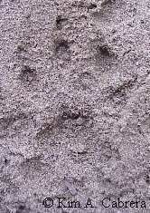
Climbing down a tree head first  Squirrels seem to easily navigate up and down trees, even upside down. Notice the position of the hind foot. | Front track  This front track in dust shows all the details, including claw marks.
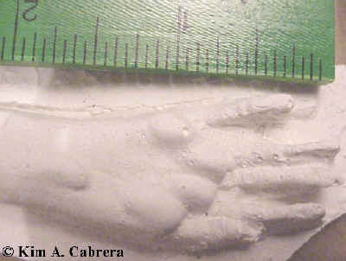 | 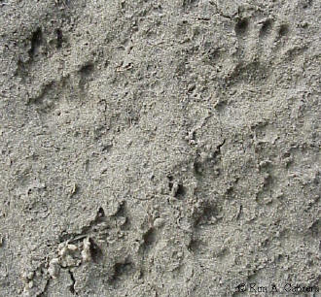
Plaster cast of hind track  The long heel does not always leave an imprint in the tracks. Hind feet have five toes. | Set of all four squirrel tracks  The hind tracks landed ahead of the front tracks. Hind tracks are the pair at the top of the photo. Front tracks are the pair at the bottom. Direction of travel was from bottom to top of the photo.
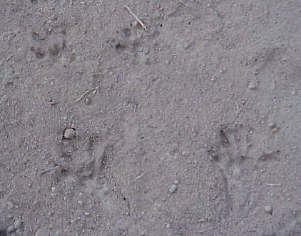
Another set of four squirrel tracks
This squirrel was moving slowly. The hind tracks did not overstep the front tracks. In this photo, the hind tracks are at the bottom and the front ones are at the top. Direction of travel was from bottom to top of the photo.
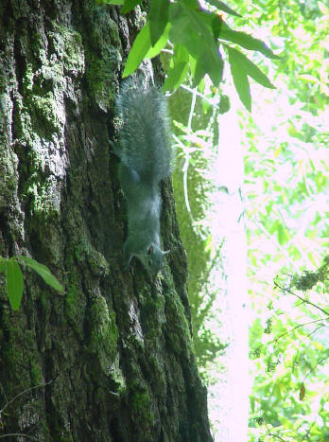 | 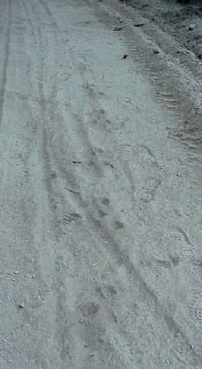
Squirrel heading down a tree  The long gray tail helps them balance. Claws help them grip when climbing. | Squirrel trail pattern in dust  The squirrel was traveling from the top toward the bottom of the photo.
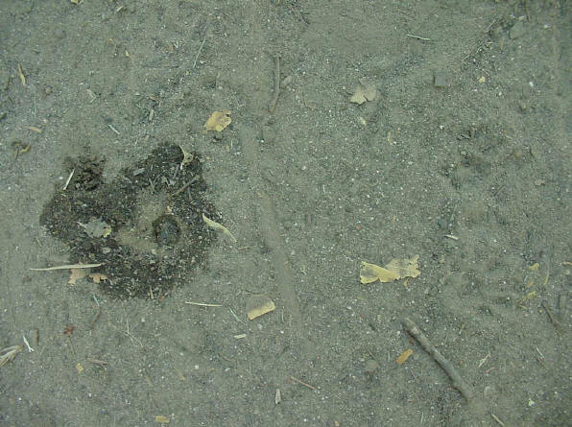
Squirrel tracks and urine stain
Gray squirrel tracks on right indicate the maker of this urine stain. This marking was found in the middle of a path.
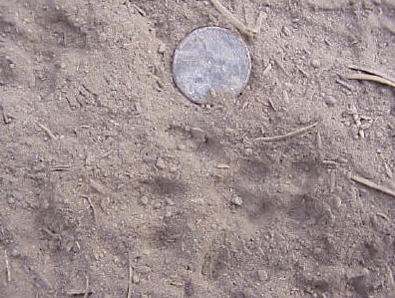 | 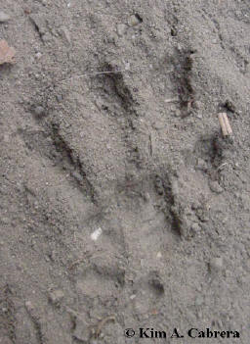
Front track showing four toes and pads behind heel pad.  Penny (for scale) is 3/4 inch across. | Front track showing all four toes and additional pads behind heel pad. Some claw marks are visible.
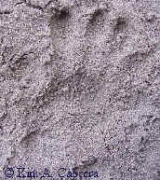 | 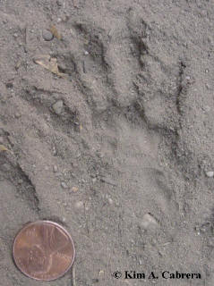
Hind track in damp soil. | Hind track in dusty soil. Heel left more of an imprint here.
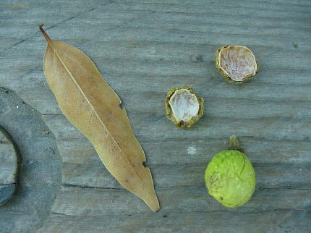
Bay nut opened by gray squirrel. Leaf and whole nut show what they normally look like.
Copyright © Kim A. Cabrera 2004

