|  |
| --- |
| STAGES OF DEVELOPMENT |

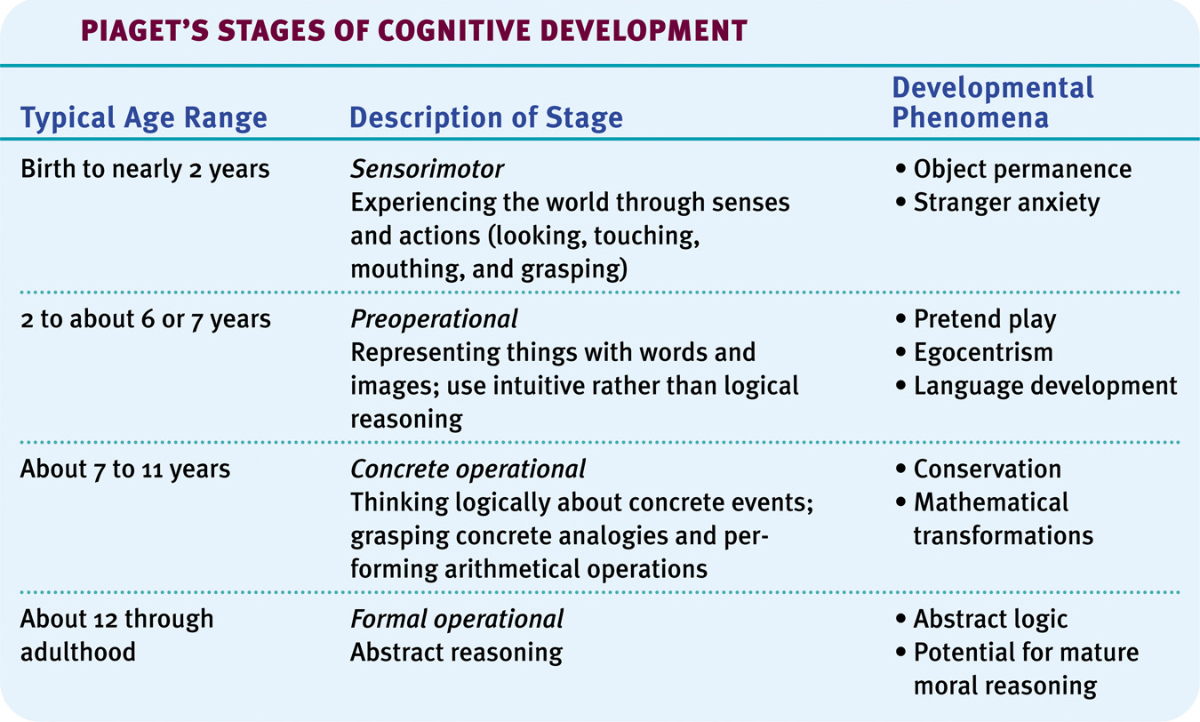

|  |  |  |
| --- | --- | --- |
| **KOHLBERG's THEORY OF MORAL DEVELOPMENT** | | |
|  |  |  |
|  | |  |  | | --- | --- | | Level One: **Pre-conventional Morality** | Stage 1: Punishment-Obedience Orientation | | Stage 2: Instrumental Relativist Orientation | | Level Two: **Conventional Morality** | Stage 3: Good Boy-Nice Girl Orientation | | Stage 4: Law and Order Orientation | | Level Three: **Post-Conventional Morality** | Stage 5: Social Contract Orientation | | Stage 6: Universal Ethical Principle Orientation | |  |
|  |  |  |

**ERIK ERIKSON’s 8 STAGES OF HUMAN PSYCHOSOCIAL DEVELOPMENT**

